Siobhan Dickens, Trinity School, Croydon
Museum Project
Final Report to Historical Association, 31 August 2012
Summary of the Project
The focus of this project was to create a temporary, ‘pop up’ museum at Trinity School, open to all pupils, staff and parents, curated by pupils and comprised of artefacts loaned by members of the school community. This was not a local history project; parents, staff and governors were encouraged to loan a very wide range of artefacts so as to highlight the ways in which the personal histories of people connected to the school have connected with major historical events, changes and processes across the UK and the globe.
Timescale
The focus of the project between September 2011 and Easter 2012 was training pupils in museum curation (undertaken in partnership with the Horniman Museum), soliciting artefacts from the school community, and undertaking curatorial work to interpret the artefacts and plan the way in which they would be displayed. All preparations were undertaken in the first half of the Summer Term, with the Museum opening for two and a half weeks in the second half of the Summer Term.
Overall Evaluation
Overall, we are absolutely delighted with the Museum Project, and are deeply grateful to the HA for funding it. We are very proud of the final outcome, which felt highly professional in nature, despite being undertaken on something of a ‘shoestring’ budget (some photographs are included below). The artefacts loaned were incredibly diverse and fascinating, ranging from banknotes from Germany during the Hyperinflation of the early 1920s, a signed edition of Einstein’s Theory of Relativity, items from the Chinese Cultural Revolution, letters (signed by Baden Powell) relating to the death of a young soldier in the Boer War, Roman lamps, pottery, coins and a brooch, to a pop art scooter owned by Paul Weller. This naturally created an exhibition which was partial, as we could only cover the History elicited by the artefacts, but which, for visitors, was highly engaging, unique and thought-provoking. Artefacts were loosely organised into three themes: War & Conflict; Daily Life; The Power of Ideas. Within this, interpretation cards were provided, but visitors were equally encouraged to explore and consider the artefacts without reference to these cards. Younger visitors were encouraged to undertake ‘discovery trails’ which invited them to consider objects in detail, and to make connections between items. As a result, while some visitors took a quick glance at the artefacts on a ‘whistle stop tour’ most engaged in some depth with all or part of the exhibition, many feeding back that the personal nature of the artefacts helped them to connect with history that had previously felt distant.
The two events we held were very popular and certainly got the whole school community talking, and thinking, about history, historical interpretation and the role of evidence in not only understanding the past but also in how history will be interpreted in the future.
If we undertake the project again we would make some changes:
- Begin curatorial work later. It is not really necessary to spend two and a half terms curating the project and in fact this had the negative effect of losing momentum. We found a regular weekly meeting of 45 minutes not to be the best way of undertaking the curatorial work as it was difficult for pupils to make connections and fully extend their thinking. A smaller number of longer sessions were far more fruitful in delivering high quality interpretive outcomes.
- Provide more opportunities for researching and curating elements of the museum to whole classes, or a larger group of pupils on extra-curricular days. This would increase buy-in to the project, be more efficient, and also allow more pupils to benefit from the skills and understanding being developed.
- Make more use of links with external Museum and Archive partners. This was difficult due to reticence from the school management team to allow pupils time out of school on more than one occasion. We would consider weekend activities, ‘remote’ contact via webchats etc. and inviting more visitors to come to us so as to really capitalise on the exciting opportunities created by such a partnership.
- Ensure that there was an administrative colleague assisting the teacher’s organising the project. In the second half of the Summer Term this was more or less a full time job for two teachers, and really needed a larger project team.
- Consider opening the Museum at a different time of year so as to avoid the very busy end of term period where some pupils and teachers were not able to participate due to conflicting commitments.
Impact on Pupils’ Skills in the areas of Historical Evidence and Interpretation
It was clear from the outset that this project put pupils out of their ‘comfort zone’ in terms of historical enquiry. In class, where they conduct enquiries or use evidence, they are typically doing so within a fairly defined context of either a specific period or a clearly defined theme or unit. The Museum Project required them to make sense of evidence which often came with no contextual information at all, and was likely to come from a period of history or a part of the world of which they had no prior knowledge. In this context, it was clear that even pupils who are usually very confident interpreting historical evidence in class found their work challenging, but usually enjoyably so. Pupils used a very wide range of research skills to find out about an artefact, ranging from using special interest websites (e.g. Roman coins, gas masks etc.) to interviewing other pupils, parents or staff about an object or a period of history. Pupils were, by and large, very successful in situating an object in its historical context via their research, and became confident talking about areas which fell far outside their areas of study. A key learning for us as teachers was that we need to allow pupils, as part of their normal every day history studies, to work more frequently with evidence without being provided with defined and levelled contextual information and very structured guidance questions otherwise they will never really be doing history and their skills in using evidence will in fact remain limited.
In terms of interpretation, some pupils found this concept relatively challenging, while others very quickly grasped the nature of a museum as an interpretation of history. Our staring point in ‘teaching’ in interpretation was to look at the range of questions one might ask about an artefact, and how the questions we ask of an object essentially steer our interpretation of it, and would influence the choices we made about displaying it and connecting it with other objects. Many of the pupils curators found it quite challenging to abandon a fairly rigid linear thinking about the artefacts (they should be displayed in chronological order; all the weapons should go together). We did not always in these cases, being honest, develop a successful strategy to help them move outside the boundaries of fairly one-dimensional thinking about each artefact and this is certainly an area on which we will be focusing as a Department in the year ahead. If we did the project again, more time would be spent planning more structured activities to develop pupil’s appreciation of interpretation. The pupil curators visits to other Museums, particularly the Horniman Museum, did open up a very helpful dialogue about the interpretive choices that Museums make, and this is certainly one area of pupils’ training we would build on next time.
The Discovery Trails we planned for visitors to the Museum were more successful in developing pupil visitors’ understanding of the multiple ways in which an artefact could be interpreted. Pupils were invited to select themes (levelled by age and ability), for example, conflict, women, society, power, technology, and were asked to identify artefacts they felt belonged in this theme and give a brief explanation of why. They were then asked to consider how they would display the artefacts if they were putting together an exhibition on that theme. Pupils were usually then paired off, working on different themes and then giving each other a tour of the museum based on their theme. This seemed to help pupils realise that there were multiple ways of interpreting objects from the past, and that a historical narrative is created through the choices the author makes about inclusions and exclusions. This is a teaching strategy we feel we can build on in our schemes of work.
Overall the work of both the museum curators and the pupil, parent and staff visitors raised as many questions as it answered. These issues will be explore further in the article for Teaching History, and are also key departmental research priorities in the year ahead.
Evaluation Against Expected Outcomes
1. Raising the profile of History within the school, and its extra-curricular value
This outcome was well met. The Museum proved extremely popular, with the vast majority of pupils in the school visiting at least once. There was good take-up from subject teachers in History, English and Drama of the opportunity to book lessons in the Museum, and moderate take up from Form Tutors of the opportunity to use it in Registration. Every pupil in years 6-10 participated in an assembly promoting the Museum loosely focused on the theme ‘History Matters’. This was also the theme of the week for pastoral activities. The Museum stimulated dialogue about History around the school, among pupils and staff, and between pupils and their parents. Two high-profile and popular events were held in association with the project; a lecture by Professor Sir Richard Evans, Regius Professor of Modern History at the University of Cambridge, and the Official Opening by Dr Xerxes Mazda, Head of Learning, Volunteers and Audiences at the British Museum.
The next stage for academic year 2012-13 is to capitalise on the momentum created from the Museum Project to create a sustained increase in interest in extra-curricular History activities and the maintain the higher profile of the subject around the school.
2. Development of gifted and talented pupils’ historical skills in handing evidence and in historical interpretation, as well as transferable skills such as team working, organisation, independent research, communication skills
This aim was moderately met. The opportunity to join the curatorial team was made available to all pupils on the basis of interest rather than ability, which ensured a dedicated team developed. If we were to undertake the project again we would target specific pupils, in addition to issuing a general invitation, to ensure that we had greater representation of the most gifted historians. We did not work closely with the Gifted and Talented Coordinator when planning this project, and this perhaps led to missed opportunities as regards using the Museum to provide very specific stretch and challenge for more gifted pupils. Nonetheless, for those that did take part, either as part of the curatorial team, or, after the museum opened, as part of a workshop/lesson or general visit, we did see evidence that their skills in handling historical evidence and understanding the issue of interpretation did improve (see above).
Pupils highlighted the transferable skills they gained from the project, for example Anthony in Year Nine commented: “I believe that after doing the activity I have realised that anything can be researched and found. Whereas before I believed that some things just couldn’t. My researching skills have also improved and I believe that I will research more often from now on.”
3. The development of stronger links between at least two local secondary schools who do not currently have any working partnerships, in the area of History.
This outcome was not met, due to difficulties establishing a link with a partner secondary school. A decision was taken to focus on development of primary school links, where there seemed to be more appetite to make a connection.
4. The development of connections with local primary schools through school visits, which can then be developed to enhance pupil progression from KS2 and 3 and support subject specific provision within primary schools.
This outcome was very well met. In total over 200 primary school pupils, largely in Years 5 and 6, visited the Museum, from six main local primaries. Arrangements have been made with two of these to meet early in the academic year 2012-13 to plan and implement initiatives in History, and interest has been expressed by the other four which will be followed up at the beginning of term. This promises to be a very exciting area for development for our Department over the year ahead.
Year Five pupils commented:
“Thank you for helping us learn to be proper historians!” – Kate
“I liked the display because I got lost in all the History” – Maddie
“I loved being detectives and finding information going to search for artefacts and rushing back to record them and trying to remember all the facts.” – Mia
“The activities were really fun because they got me thinking really hard.” – Ellie
5. The development of links with local museum services in the Croydon/Beckenham/London area, which can be developed through further projects.
This aim was well met, with a strong link being created with the Horniman Museum, and a link being created with the British Museum. The next step is to build on those links to create longer term partnerships.
6. The promotion of History as a worthwhile career as well as an interesting subject (via school magazine, assemblies, VLE/school website, History Societies at both schools, and word of mouth).
This outcome was moderately met. The Museum Project certainly created a sense among pupils (via the highly professional, yet ‘pop up’ nature of the project) that Museums were dynamic, evolving places, as opposed to ‘dusty’, static institutions, however there is no clear evidence at this stage that this has had a knock on effect on pupils’ career aspirations. Pupils that volunteered for curatorial work were to a large extent self-selecting, and tended to be those (particularly among the older pupils) who had already developed an interest in this area. Take-up amongst Sixth Formers was lower than expected, probably due to a range of conflicting extra-curricular and examination commitments. Some follow up will be conducted with the Careers Advisor at the start of the new academic year to identify ways in which the Museum Project can be capitalised on from a careers perspective.
8. The potential to develop this project as a regular initiative, or to develop other flagship History projects, to develop pupils’ historical thinking and the profile of the subject.
There is strong interest from pupils, parents and staff in undertaking the project again, and we are very keen to learn from our ‘first attempt’ to improve the project next time (see above). Due to the need to have fresh artefacts each time, we are provisionally envisaging undertaking the project every other year. We have been fortunate enough to be able to retain some of the artefacts loaned, which will be being used as a basis for Independent Extended Projects in Year Nine, and as a basis for classroom activities and investigation. A more modest version of the Museum Project has been incorporated in the Junior Form (Year 6) Scheme of Work from September 2012.
9. The development of sustainable links with the school and local community, thus opening up a huge resource in terms of historical evidence and experience.
This outcome has been very well met. We are delighted to have been able to form a link with the local branch of the Historical Association via the project, and are looking forward to co-planning some events. We have also elicited substantial interest from ‘Old Boys’ in being more involved in sharing their personal histories with pupils. This has already resulted in a visit from one Old Boy, who shared his experiences about World War Two in Croydon, and has donated to us a wealth of artefacts from the 1930s and 1940s to use with pupils. We believe this area has significant potential to enhance pupils’ learning in History. We have also formed closer links with the School and Whitgift Foundation Archives, and are exploring potential opportunities to use the archives to enhance historical enquiry.
10.The development of pupil resources regarding the interpretation and use of artefacts in historical investigation, particularly with a focus on local/personal history, which can be disseminated in both partner schools and to the wider teaching community via the HA, TES Connect etc.
This outcome has been very well met. We have developed a range of resources which we will be disseminating internally and externally in academic year 2012-13. Several primary school teachers who visited have expressed a desire to use some of the resources and strategies we used with pupils in their classrooms on a more regular basis.
11.The value of the project would be evaluated and findings written up in Teaching History to disseminate them as widely as possible to the History community. Copies of the report/article would also be disseminated to relevant museum services and other partners, to stimulate interest in such initiatives.
This outcome is still to be met; the article is underway and will be sent to Teaching History in the Autumn Term 2012.
Budget
The project was complete on-budget, with some cross-subsidisation of printing costs from the Departmental budget, and additional funding being made available from the School’s discretionary income for the speaker’s travel expenses and the catering provided at the two events with external speakers.
The main costs were for display cases. The actual costs would have been much higher had we not been able to loan high specification display cases from the Whitgift Foundation. The second largest cost was printing, which was done in-house to keep costs as low as possible, but nonetheless cost a little more than expected due to our desire to produce very high quality displays. We also made a fairly substantial investment in fabric to cover library bookcases and transform the space into a museum.
Date | Item | Cost
28/09/11 | Joan Lewin Bursary | £1,000C
15/12/11 | Visit to Horniman Museum – Curator Training | £72
11/06/12 | Display Cases (Ikea) | £394.91
11/06/12 | Display Fabric (Asiya Haziz; EBay) | £174.99
15/06/12 | Display Signs (Photobox) | £52.97
09/07/12 | Mannequin (Displayfix) | £7.98
09/07/12 | LED Lighting for Display Cases (Bargain Billies) | £24.19
09/07/12 | Stands/Display Card Holders (Amazon) | £24.19
31/08/12 | Miscellaneous colour printing and laminating costs (Posters, Brochures, Display Cards, Worksheets) – completed in-house | £246.99*

* The actual cost was higher than this but has been cross-subsidised from the departmental budget

Appendix: Photographs
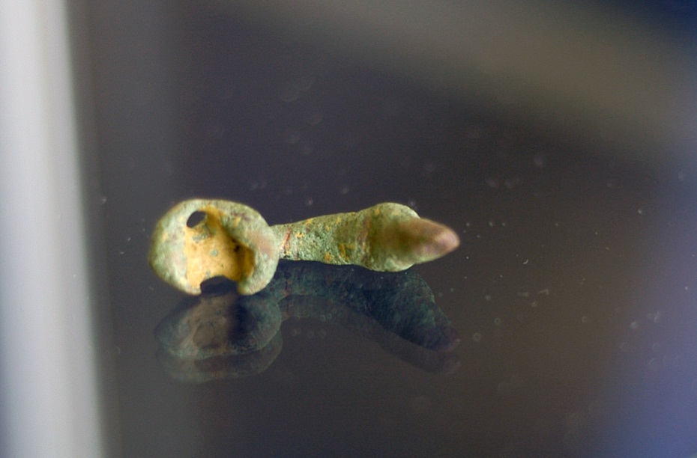
Roman Trumpet Brooch
Year 6 Pupils investigating Roman artefacts
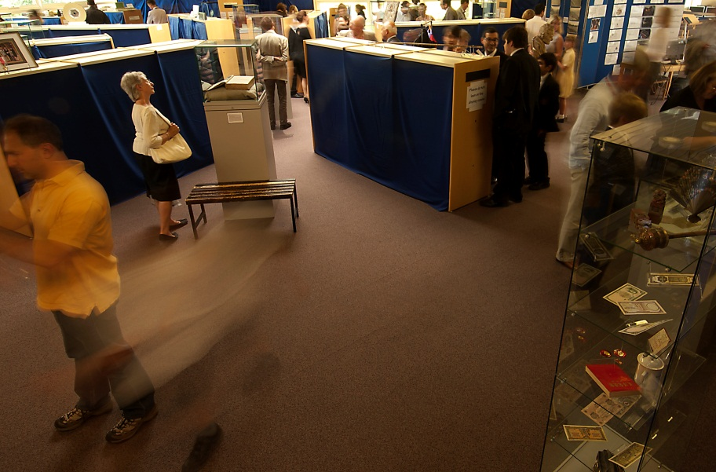
Visitors to the Museum on the Day of the Opening Ceremony
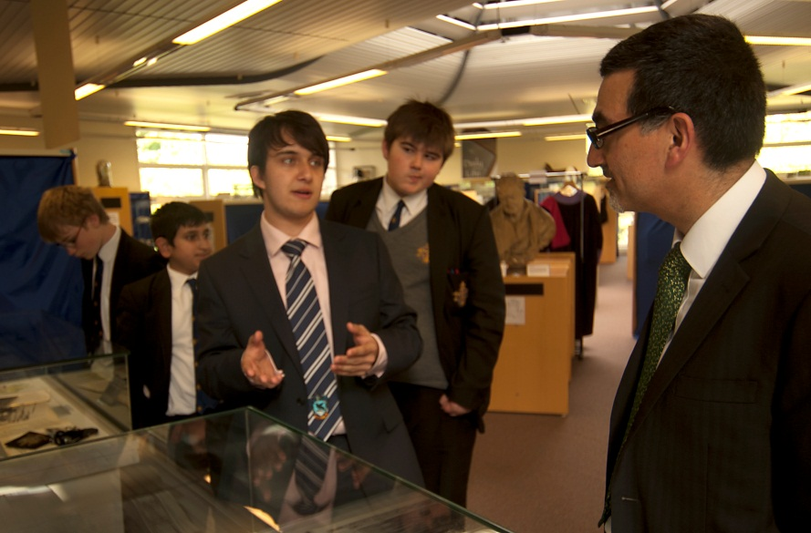
Dr Xerxes Mazda, British Museum, discussed artefacts relating to African History with Ronan Brennan, Year 12 and Will Brady, Year 9.
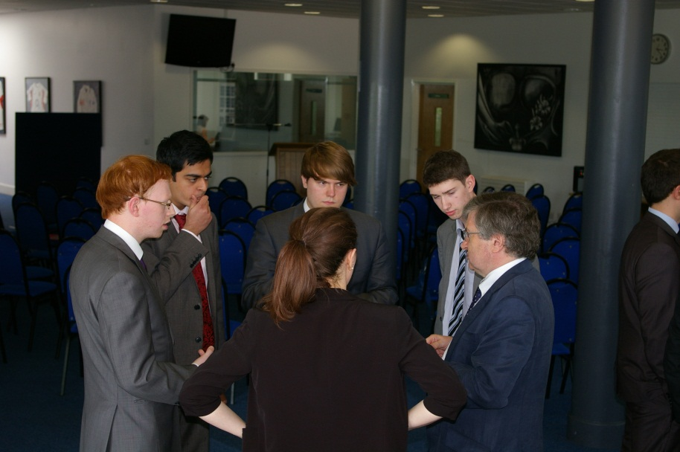
Professor Sir Richard Evans discusses history with Upper Sixth Pupils with places to study History at University.
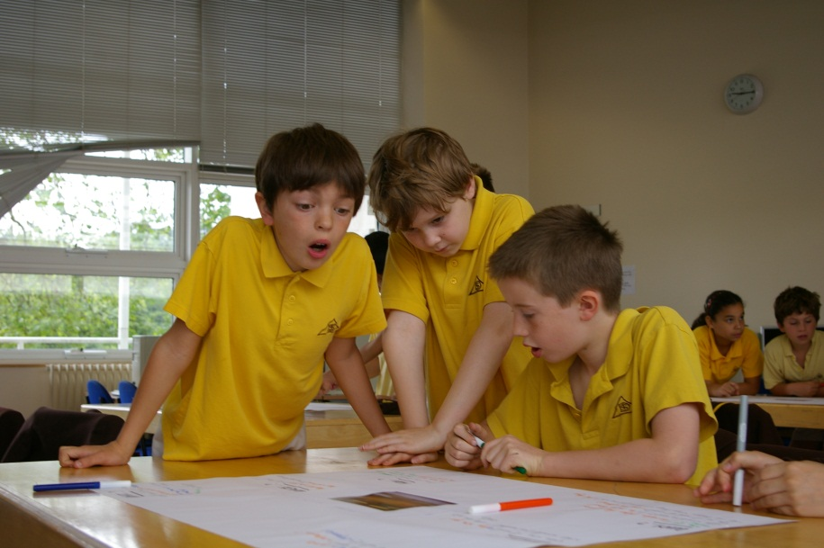
Pupils from St David’s School develop provisional answers to questions written by classmates about a ‘mystery object’
Appendix 2: Press Release Dated 22/06/12
Trinity Pupils Curate ‘Pop-Up’ Museum
Pupils at Trinity School handling Roman objects dating back to AD 200 as part their Museum project
On Monday 25th June 2012 Trinity School, South London, is launching a highly professional temporary museum curated by its pupils. It is made up of over 200 items loaned by the school community and remains open until 11th July. Highlights include Roman objects dating back to AD 200, letters from the trenches of World War One, banknotes from Germany during the hyperinflation of the 1920s, a signed second edition of Einstein’s Theory of Relativity, and commemorative plates from the Chinese Cultural Revolution.
The project has received prestigious backing. It is being funded by the Historical Association and students have been trained in partnership with the Horniman Museum. It will be opened by Dr Xerxes Mazda, Head of Learning, Volunteers and Audiences at the British Museum, with a keynote lecture from Professor Sir Richard Evans, Regius Professor of History and President of Wolfson College, University of Cambridge.
Nick Gibb MP, Minister for Schools, describes the project as “an innovative and engaging way to increase an understanding of history for pupils and the wider community”. It takes history out of the classroom and away from textbooks. Pupils are doing real historical research with a meaningful output. Students are developing core transferable skills in areas such as research, team work, communication and ICT. Several hundred children from local primary schools will be visiting the museum while it is open, doing workshops that will develop their understanding of how historians use evidence.
“Projects like this are exactly what our education system needs to ensure that the next generation continues to engage with the past,” comments Tristram Hunt MP, History Lecturer and Television Presenter. Students are best able to enjoy history when you solicit their imagination. “I have been simply enthralled by every one of the two hundred or so items that have been loaned to us. More rewarding than anything else has been the number of pupils who have told me the project has led them to find out about their family history for the first time, and what they have discovered has amazed and inspired them,” explains Siobhan Dickens, History Teacher, leading the project.
Many pupils see museums as dry, dusty and static, filled with artefacts that have little connection to their lives; this venture challenges that assumption by making the museum fresh, personal, relevant and dynamic. “I really enjoyed this project. I’m much more likely to notice the historical objects around me now, and much more interested in visiting museums,” says Archie, Year Nine. This innovative project not only increases pupils’ connections with their own past, but is inspiring them to connect with our country’s rich history in a new way.
Ends
Further photos
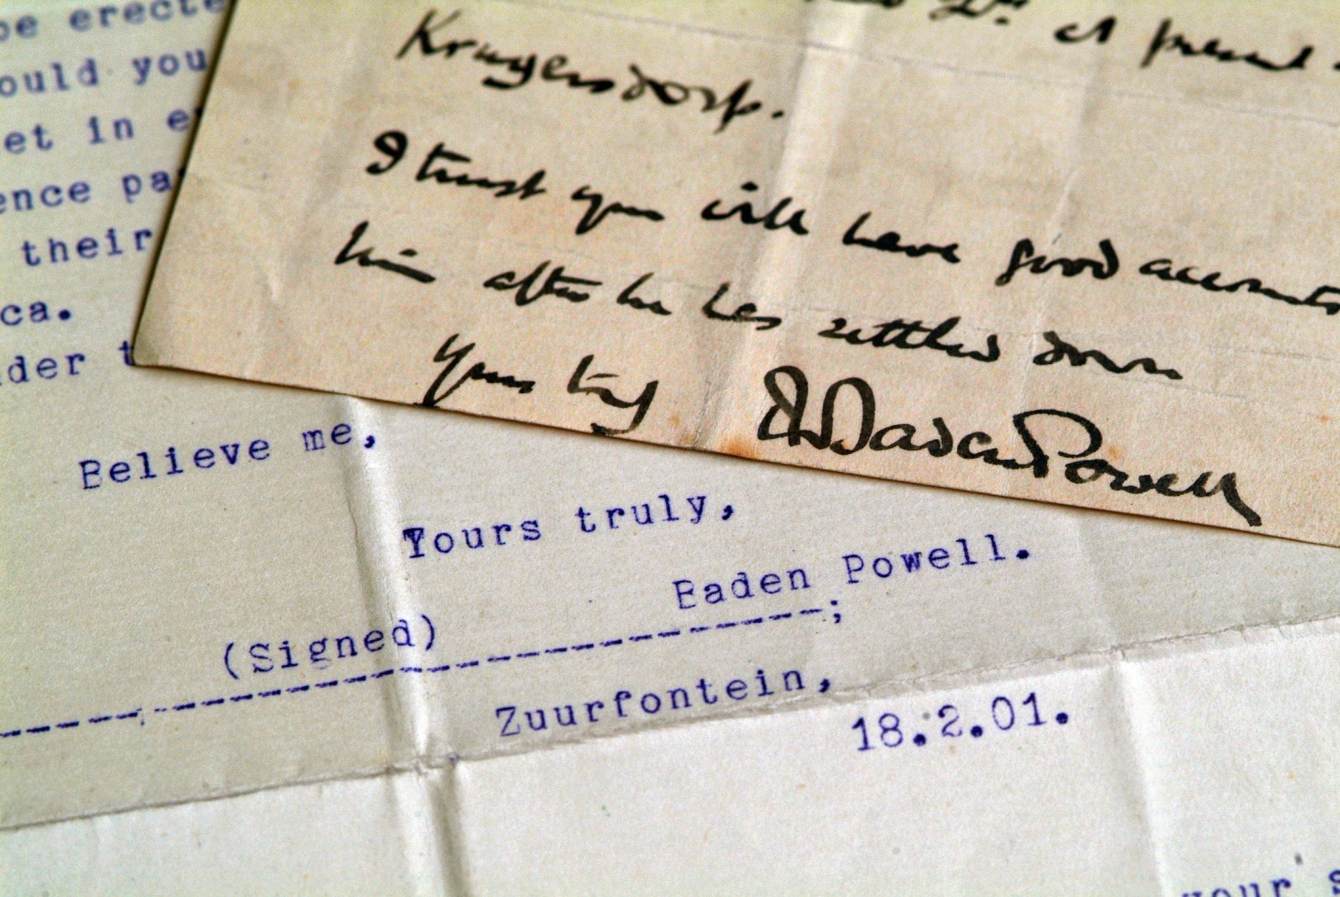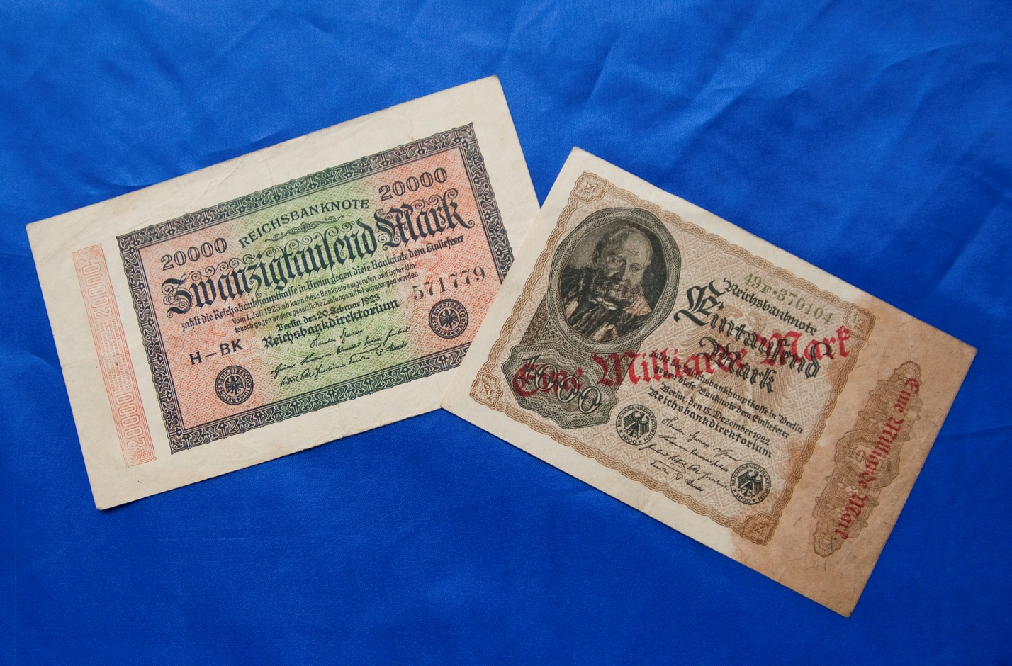
Letters from Lord Baden-Powell (later founder of the Scouts movement) offering his condolences to a mother on the loss of her son during the Boer War
German banknotes from the Weimar Republic during the hyperinflation of the 1920s. The 2000 Mark note has been hurriedly over-stamped as 1,000,000 Marks

Further quotes by Siobhan Dickens, History Teacher and Project Leader
- “To hold in your hands a rolling pin used to make Winston Churchill’s dinner, or a letter written home from the trenches of Ypres, is a very special experience. I expected we would mostly see modern history items loaned, but we have some incredible objects dating back to Tudor England and even the Roman Empire”.

Further quotes by pupils
- “After doing the project I have realised that anything can be researched and found out about, if we ask the right questions. Whereas before I believed that some things just couldn’t. My researching skills have really improved.” – Anthony, Year Nine
- “I realise now that the objects people have in their homes can be just as historically valuable as the ones in the museum, but they are just not aware of it” - Jacob, Year Nine

