Trinity Pupils Curate ‘Pop-Up’ Museum
Pupils at Trinity School handling Roman objects dating back to AD 200 as part their Museum project
On Monday 25th June 2012 Trinity School, South London, is launching a highly professional temporary museum curated by its pupils. It is made up of over 200 items loaned by the school community and remains open until 11th July. Highlights include Roman objects dating back to AD 200, letters from the trenches of World War One, banknotes from Germany during the hyperinflation of the 1920s, a signed second edition of Einstein’s Theory of Relativity, and commemorative plates from the Chinese Cultural Revolution.
The project has received prestigious backing. It is being funded by the Historical Association and students have been trained in partnership with the Horniman Museum. It will be opened by Mr Xerxes Mazda, Head of Learning, Volunteers and Audiences at the British Museum, with a keynote lecture from Professor Sir Richard Evans, Regius Professor of History and President of Wolfson College, University of Cambridge.
Nick Gibb MP, Minister for Schools, describes the project as “an innovative and engaging way to increase an understanding of history for pupils and the wider community”. It takes history out of the classroom and away from textbooks. Pupils are doing real historical research with a meaningful output. Students are developing core transferable skills in areas such as research, team work, communication and ICT. Several hundred children from local primary schools will be visiting the museum while it is open, doing workshops that will develop their understanding of how historians use evidence.
“Projects like this are exactly what our education system needs to ensure that the next generation continues to engage with the past,” comments Tristram Hunt MP, History Lecturer and Television Presenter. Students are best able to enjoy history when you solicit their imagination. “I have been simply enthralled by every one of the two hundred or so items that have been loaned to us. More rewarding than anything else has been the number of pupils who have told me the project has led them to find out about their family history for the first time, and what they have discovered has amazed and inspired them,” explains Siobhan Dickens, History Teacher, leading the project.
Many pupils see museums as dry, dusty and static, filled with artefacts that have little connection to their lives; this venture challenges that assumption by making the museum fresh, personal, relevant and dynamic. “I really enjoyed this project. I’m much more likely to notice the historical objects around me now, and much more interested in visiting museums,” says Archie, Year Nine. This innovative project not only increases pupils’ connections with their own past, but is inspiring them to connect with our country’s rich history in a new way.
Ends

Further photos
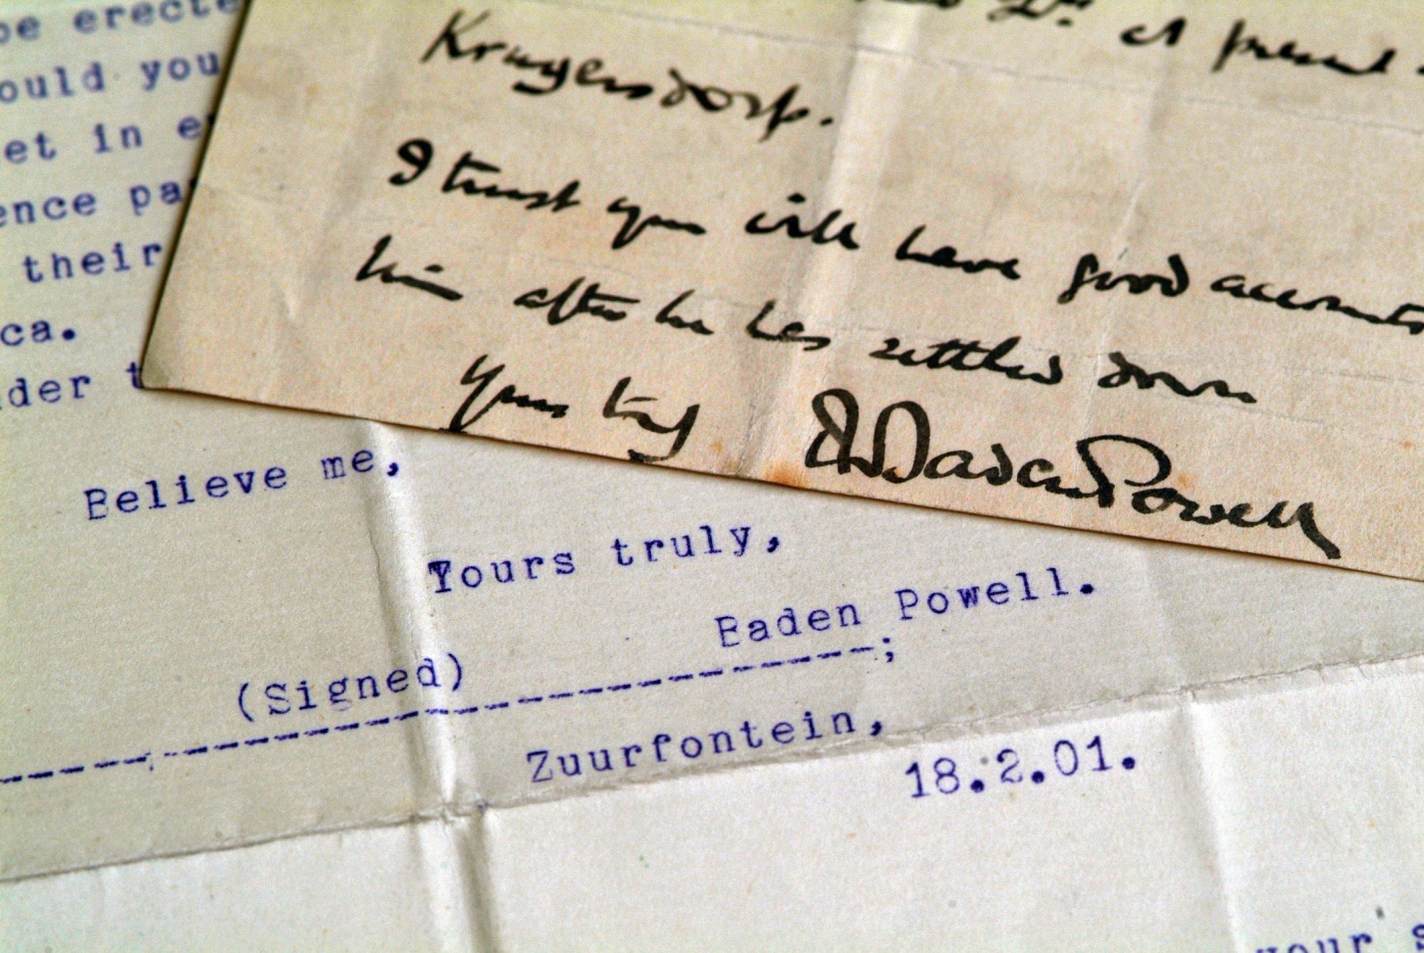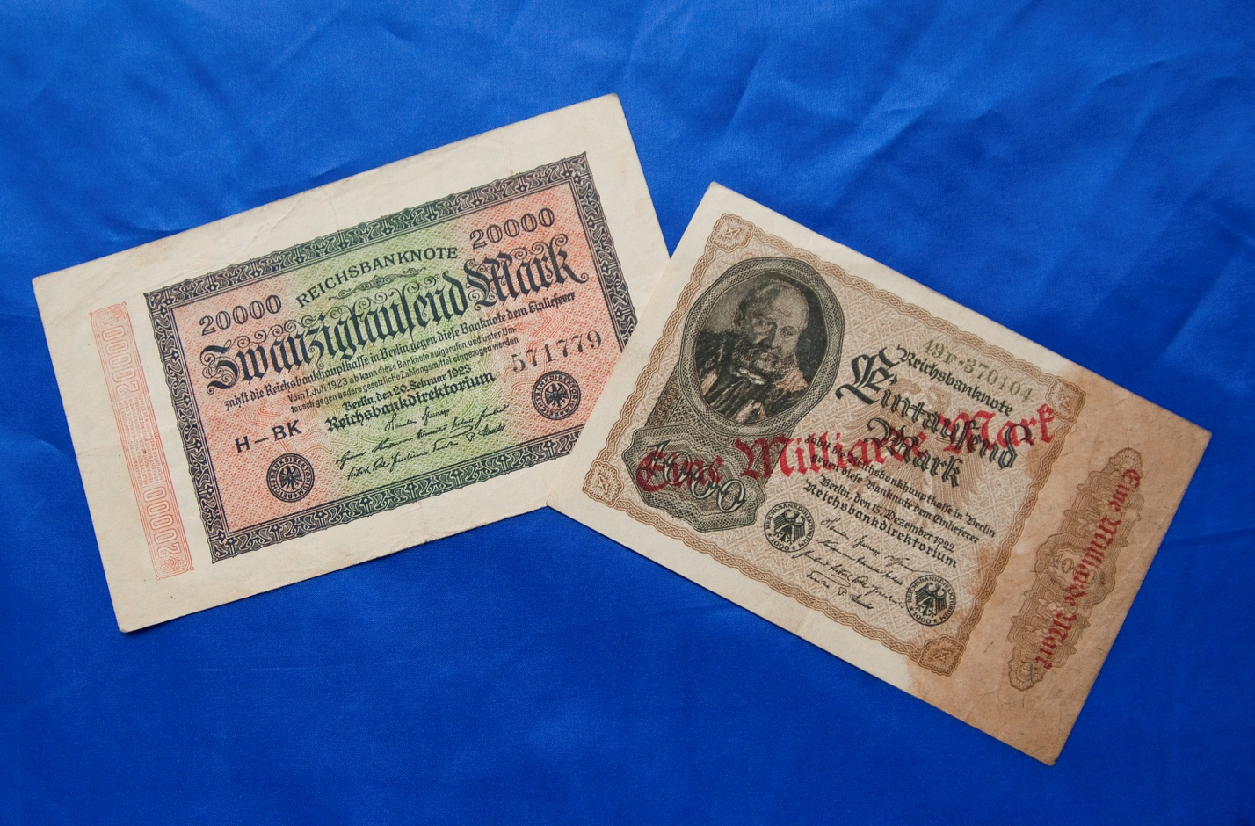
Letters from Lord Baden-Powell (later founder of the Scouts movement) offering his condolences to a mother on the loss of her son during the Boer War
German banknotes from the Weimar Republic during the hyperinflation of the 1920s. The 2000 Mark note has been hurriedly over-stamped as 1,000,000 Marks

Further quotes by Siobhan Dickens, History Teacher and Project Leader
- “To hold in your hands a rolling pin used to make Winston Churchill’s dinner, or a letter written home from the trenches of Ypres, is a very special experience. I expected we would mostly see modern history items loaned, but we have some incredible objects dating back to Tudor England and even the Roman Empire”.

Further quotes by pupils
- “After doing the project I have realised that anything can be researched and found out about, if we ask the right questions. Whereas before I believed that some things just couldn’t. My researching skills have really improved.” – Anthony, Year Nine
- “I realise now that the objects people have in their homes can be just as historically valuable as the ones in the museum, but they are just not aware of it” - Jacob, Year Nine

