Elizabeth I Suitor Cards
1558  King Philip II of Spain  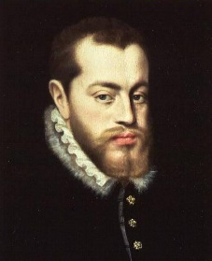  King Philip II of Spain was once married to Elizabeth’s sister, Mary, before she died. Philip sent a proposal of marriage to Elizabeth when she became Queen. Philip was a Catholic and a foreigner, things likely to upset many English people. | 1559  The Kingdom of England  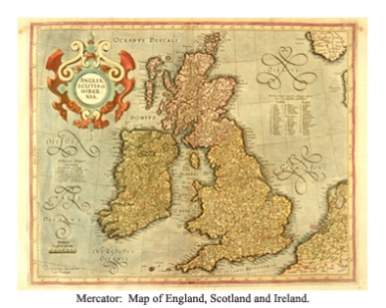  When Parliament pressured Elizabeth to marry she said, ‘I have already joined myself in marriage to a husband, namely the kingdom of England’.  Many people did not want Elizabeth to die unmarried and childless with no Tudor heir to the throne. | 1560  Robert Dudley, Earl of Leicester  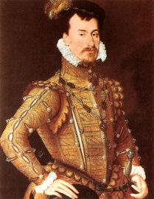  In 1560 Robert Dudley’s wife, Amy, died falling down the stairs. Some people suspected she was murdered so that Robert could marry Elizabeth. The scandal shocked people. Dudley and his father were well-known Protestants. Some Catholics, including the Pope, feared Dudley’s power if he became King.
1579  Francis, Duke of Anjou  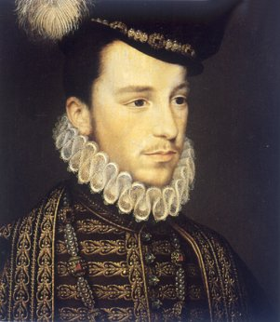  The Duke ruled large parts of France. Francis was 24 and Elizabeth 46 when they began courting. Francis was a foreigner and a Catholic. Elizabeth would have been at risk giving birth at her age. | 1590  Robert Devereux, Earl of Essex  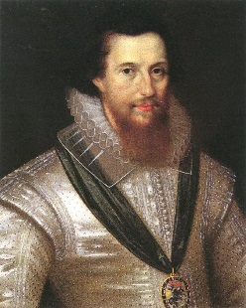  The Earl was a favourite of Elizabeth’s at the end of her reign when she was a much older woman. He fell out of favour with the queen after his military failures in Ireland. In 1601 he tried to overthrow Elizabeth, but he failed and was executed for treason.

