Green – Forward one space Red- Back one space Pass Yellow and Pick up
60 | 59  1603 – Elizabeth dies and James I becomes King | 58 | 57 | 56 1598 – Elizabeth’s close advisor William Cecil dies
51  1588 – The Spanish Armada attacks England | 52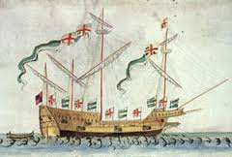 | 53 | 54 1590 – Earl of Essex becomes a favourite of Elizabeth Pick Up | 55
50 | 49 | 48 | 47  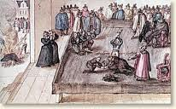 | 46  1587 – Mary Queen of Scots executed
41 | 42 1579 – Duke of Anjou plans to marry Elizabeth Pick Up | 43 | 44 | 45
40 | 39 | 38 | 37 | 36  1569 – Pope Pius excommunicates Elizabeth
31 | 32 | 33 1560 – Robert Dudley widowed and free to marry  Elizabeth Pick Up | 34 | 35
30 | 29 | 28 | 27 | 26  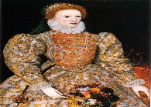
21 1559 – Elizabeth states she is ‘married to England’ Pick Up | 22 | 23 | 24 | 25
20 | 19 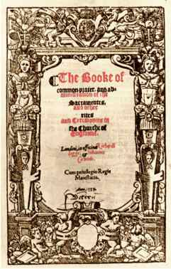 | 18  1559 – Elizabethan Settlement | 17 | 16
11 | 12  1558 – Elizabeth becomes Queen | 13 | 14 | 15 1558 – Philip of Spain sends proposal to Elizabeth Pick Up
10 | 9 | 8 | 7  1536 – Elizabeth’s mother executed | 6
1  1533 – Elizabeth born | 2 | 3 | 4 | 5

