Can I sort the different religious ideas Elizabethan Protestants and Catholics held?

Catholic 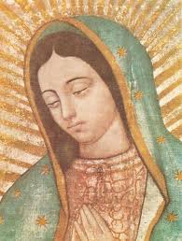 | Protestant 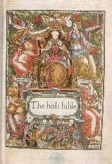 | Your compromise
Bible and sermons should be read in Latin  The Pope should be head of the church | Bibles and sermons should be read in English for everyone to understand  The sovereign should be head of the church | Bible and sermons should be read in English and Latin  An experienced bishop who believes in Catholic and Protestant ideas should be made head of the church

