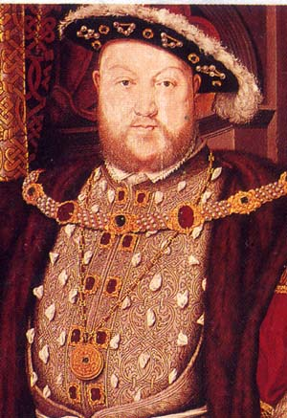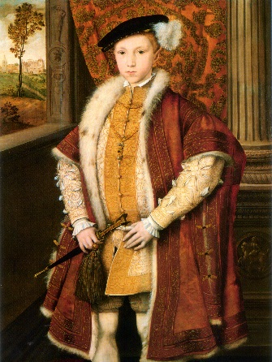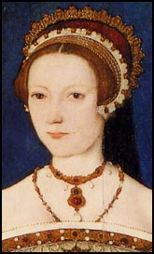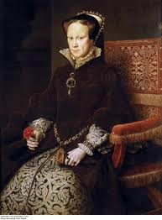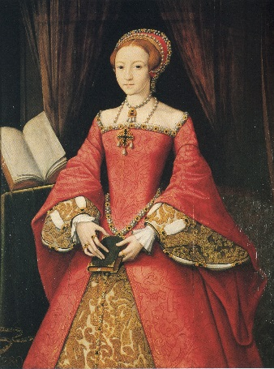
1509 Henry VIII 1547 Edward VI 1553 Lady Jane Grey 1553 Mary I 1558 Elizabeth I
‘English Catholic’ Protestant Protestant Catholic Protestant
______________________________________________________________________________________________________________________

1536 – Dissolution of the monasteries (the closing down of Catholic monasteries)
1536 – The Pilgrimage of the Grace (Robert Aske marches south with Catholic rebels opposed to the religious changes)
1549 – Act of Uniformity (imposed a single standard form of Protestant worship across England)
1549- The Western and Kett’s rebellions (Catholic rebels opposed to religious changes)
1554 – Wyatt’s Rebellion (Protestant rebellion against Mary)
1556 – The burning of Cranmer (Archbishop of Canterbury for Henry VIII and Edward VI)

