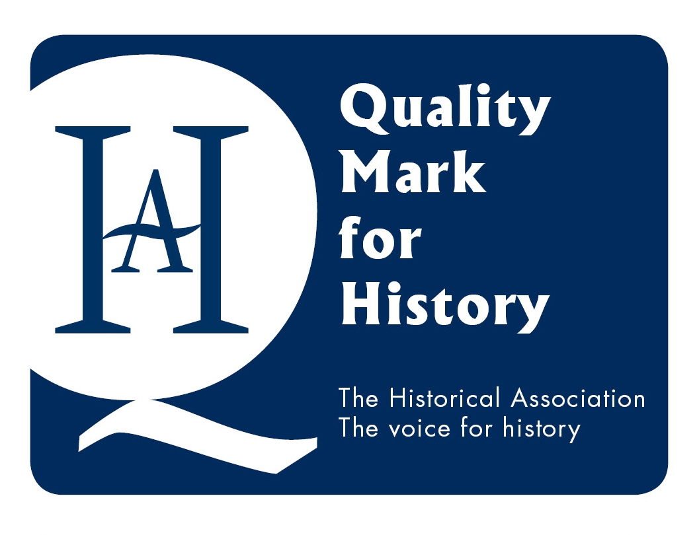

Quality Mark: Self-Audit
1. Outline: Context of the School
1. Outline the context of the school and any factors that influence the way in which history is taught. Briefly explain the main priorities in your improvement/development plan, and how they reflect the context in which you work.

The school is a small independent Quaker day and boarding school for girls. The Quaker ethos informs the school’s approach to the curriculum. There is an emphasis on independence, global thinking and history takes its part in this. The management of the school is Quaker led and encourages creativity and initiative from staff and students. The answer to departmental ideas tends to be ‘Yes, great, go for it!’ Geographically we are close to the centre of York. This, and our small size, means that we are able to take advantage of the fantastic historic resource on our doorstep that is the City of York. Particularly at 6th form level, there are a range of nationalities represented; though most international students arriving new to the school at 6th form do not take History A level. This is due to requirements of parents and funders and/or linguistic capacity, as well as student preference. The range of ability is fairly broad, although most students are able to achieve A*-C in 5 GCSEs; some can only do this with a lot of support.
The current academic development plan for the school is:
- Raising the standard of all teaching to that of the best: history staff have been involved in delivering INSET to support this.
- Progressive curriculum planning from KS2 to KS3. The Senior School History staff are taking a lead in working with the Junior School coordinator to support the development of history in the Junior School.
- Development of risk taking: we have taken this into account in our student reflection work, the Investigating York course and we use our departmental blog in part to help build a culture of curiosity.
- Global Thinking curriculum expansion: this has informed curriculum planning and the projects that we are involved in (see later).
- To increase parental involvement in teaching and learning: our main vehicle for this is our blog.

2. Learning and Achievement in history.
2a. Please enter the grade you feel best describes your current situation and indicate how you know this.

Learners’ achievement and standards in their work | Outstanding | Good | Requires improvement
 | Yes
Evidence: | 2013 GCSE: 47% - A* and 76% - A (those same girls got 28% - A* and 63% - A across all their subjects)  2013 AS: 50% girls got A (the same girls averaged 46% A across all their subjects)  2013 A2: 86% girls got A*/A (the same girls averaged 64% A*/A across all their subjects)

2b. How well do learners achieve in history taking into account progress related to starting points and capabilities, current standard of work , trends over time and targets in relation to other similar schools?
We do not track data as in maintained schools, but figures for previous years would show a similar pattern to the above. We work with individual students as they have needs. Hard work from students and close liaison between History, Learning Support and EAL Support leads to success. For example:
- EAL: 2 students with a little spoken and written English at the start of Year 10 got C and A in GCSE History at the end of Y11 in summer 2013.
- SEND: Sept Y7 with a chronological reading age of 8 has had simplified the text to read and been encouraged to talk through tasks with a partner before starting them. Her written work has been scaffolded to allow her to produce some extended writing. In class she is given protected thinking time to allow her to process the answer to a question and thus participate in class discussions. Her confidence has increased enormously.
It is often the case that individual students do very well in History in relation to their other subjects. Examples from the cohort of summer 2013:
- A student with dyslexia who got her only A in A2 History.
- A student with dyslexia and dyspraxia got one of her 2 A*s in GCSE History.
- A student with a lot of emotional burdens got one of her 2 As at GCSE History.
The Department works with Careers to enable students to study history in further education. This includes providing opportunities and support for personal statements and interviews. In recent years historians have moved on to the universities of their choice, including Oxbridge.

2c. On the basis of your evaluation, what are your key priorities for developing pupil achievement in history? Bullet point your key priorities.

Develop a formal baseline test for early in Year 7 to guide new work on progression.

3. Quality of Learning and Teaching

3a. Please enter grades that best reflect your current situation in history

 | Outstanding | Good | Requires improvement
Quality of learning and teaching | Yes
Quality of the curriculum and other activities | Yes
Quality of care, guidance and support for learners | Yes

3b. What is your evaluation of the quality of learning and teaching in history?

- how well teaching meets the needs of the full range of learners and course requirements;
- the suitability and rigour of assessment in planning learning and monitoring learners’ progress;
- the diagnosis, and provision for, individual learning needs;
- the involvement of parents and carers in their children’s learning and development.

Staff have received outstanding grades in recent observations. (Example at C1.1) SLT regard history as a flagship department and initiatives in history are held up as examples to be adopted across the school. (Ex. at C2.5) Staff work hard to connect with EAL, Learning Support, the School Library and Heads of School in order to understand and meet the needs of specific learners. (ints can be arranged e.g. with Learning Support) As active organisers and teachers in the City of York Independent State School Partnership, staff know how to stretch the able and interested. Many students enthuse about history and are keen to do more in their own time. Students successfully go on to university to study history. Parents and carers are involved in their children’s learning via direct contact and via the department blog at www.mounthistoryroom.wordpress.com (see parents’ page). Staff are available for individual support and tuition as need arises.

3c How well does the history curriculum and other activities meet the range of needs and the interests of learners?

- the extent to which the history curriculum or activities match learners’ needs, aspirations and capabilities, building on prior attainment and experience;
- how far the curriculum meets external requirements and is responsive to local circumstances and local contributions;
- how far the history curriculum develops key concepts and processes and aids progression in these
- how far the history curriculum enables independent learning and encourages transferable skills across other curriculum subjects
- the extent to which enrichment activities and, where appropriate, extended services such as local historical groups, archives, libraries, museums or course providers contribute to learners’ enjoyment and achievement.

See above. Staff work hard to find out the specific interest areas of learners and to modify the curriculum where possible to account for this. Raising aspiration is a constant theme, through suggesting listening and viewing, books, lectures, exhibitions, events, to organising projects with other schools and educational visits. We aim to model being crazily enthusiastic about history and its relevance.
Being in the City of York as historians is like being a child in a sweet shop. We are constantly grabbing opportunities to take part in local events, bring people in, connect with the universities, the archaeological trust, the local museums, York Minster etc. (Ref Section 5)
Our schemes of work and lesson plans have at their heart the development of historical thinking. We want students to be confident in their understanding and practise of the discipline. Lessons are enquiry focused, we use source material as evidence to develop our own interpretations about enquiries as a habit. We make this explicit in our teacher talk and encourage students to become confident in talking and thinking as historians. Likewise, we make the use of historical scholarship in class explicit and encourage ‘History Reading for Fun’ (see library). We are at the forefront of thinking in the city about historical progression, what it looks like and how it can happen. We give a lot of thought and time to how to get better and better and helping students to make progress. There is never such a thing as a finished Scheme of Work! (Example at C3.1)
We have planned courses from Years 7-13 which aim to give students a broad understanding of humanity and the modern world. Within the various constraints of time, exam specifications etc we aim to give students an experience of history in all its breadth and depth.
From the Investigating York course in Year 7, which seeks to be a humanities based course that develops key skills, to individual tutorials with 6th formers about Personal Enquiries, we focus upon independent learning and transferable skills. Our thinking has been influenced by the ideas of ‘growth mindset’ theory and these very much fit the Quaker ideas about education, which we seek to espouse. A huge amount of time spent knowing each individual student enables us to do our best to see them as a person, and not just someone in our history classroom. We try to get to know them so that we can help them to develop transferable attitudes, skills and aptitudes. (C3.3)
We organise a vast range of enrichment. Every year does fieldwork and we have local, national and international networks that we use to provide opportunities for our students. Here is a sample of some of what is going on in 2013-14 so far:
Y7 – to the Treasurer’s House and questioning the curator at the Yorkshire Museum as part of a module on Roman York, finds sorting archaeological remains from Hungate local dig, visiting the Jorvik Viking Centre, a joint project with art on the stained glass of York Minster, presentation skills using The Minster as a resource for research, out into the local streets studying different architectural styles. Local politics through time course working on a pilot for the Mansion House HLF bid. Piloting memory boxes for WW1 Minster stories and linking this with the military graves in York cemetery as prep for the July 2014 Creative Arts Festival.
Y8 – day visit to Wilberforce House slavery museum to research for historical fiction and to debate the abolition of slavery. Entry to the HA historical fiction competition.
Y9 – day visit to Beth Shalom holocaust memorial centre. Year 9 have provided an exhibition on their attitudes to studying WW1 for a local community centre.
GCSE historians – are making a film in an after school club about how we memorialise the Western Front working with the editor of Historiana (the Euroclio project), are researching women who died in WW1 and are commemorated in York Minster for an exhibition for the Minster and local Quakers, are journalists on the conscientious objection as a peace and education project (see below) and are presenting at the 83rd Anglo-American conference on this. Have a fieldtrip to the Western Front joint with Millthorpe School.
All GCSE students (not just historians) have a two week enrichment peace and history education project about conscientious objection in today and in WW1.
6th form students – an after school study course on the theme ‘Why Europe?’ with our partner school near Berlin and joint with Millthorpe School in York. Students prepared and led their own tour of Berlin in December and have made a short film. This was the 4th collaboration of this partnership in as many years. Historical Association lectures in local schools, including ours, on A level topics.
Years 9-11 also have the chance to take part in history City of York ISSP masterclasses on the psychology of memory run by Mount staff. Years 7-10 are part of the whole-school WW1 creative arts festival in which the history department are taking a full role. This includes asking all the school community about the impact of WW1 on their family and a Fortnightly Focus bulletin on the war published across two terms by history and the school librarian to enable all students to have a basic overview of the conflict.
We also use the blog to flag up local events that students might want to take part in e.g. University of York public lectures. (Section 5)

3d How well are learners guided and supported?

- The extent to which the history curriculum is designed to safeguard welfare, promote personal, moral, social and cultural development and enable learners to make good progress;
- the quality and accessibility of advice, guidance and support for learners;
- the extent to which the history curriculum is inclusive of all learners, including vulnerable groups.

See above. The way the school works means that we regularly discuss all students as individuals with colleagues. We take seriously our role in wider social and cultural development as the above box helps to illustrate. We also engage in local politics and encourage students to discuss the news etc. We work closely with the careers department to give early and best advice about applications and future prospects. We aim to be both ever optimistic and appropriately realistic about student achievement. We keep up-to-date with latest requirements for university entry and maintain our own contacts in a wide-range of universities, including Oxbridge. We are part of the whole school aim to make the Mount a School of Sanctuary for everyone. Feeling fundamentally safe and happy is crucial to learning and risk taking. We know who the vulnerable students are in our classes, because we are part of the school’s outstanding pastoral care system. This means that we can make sure that what we plan and teach is inclusive, sensitive and appropriately challenging.

3e. On the basis of your evaluation above, what are your key priorities for developing learning and teaching?

1.) Develop further student independence by increasing further the use of active reflection on progress.

2.) Develop further opportunities for students to define historical enquiries.

3.) Review the KS3 progression work trialled this year, both in terms of student feedback and also national and City of York collaborative work with colleagues, and amend as required for next year.

4.) Place a greater emphasis on being knowledgeable as an important part of historical thinking, both within and across time.

Leadership and Management of the Subject

4a: Grade Please enter the grade that best matches your current situation
Effectiveness and efficiency of leadership and management in history  Evidence | Outstanding  Yes | Good | Requires improvement
Enthusiasm for history in the school.
Results.
Being up-to-date with current debates and using professional judgement to apply these within school, to brief SLT and to champion history.
Reputation of school for history locally and wider.

4b What is your evaluation of the overall effectiveness and efficiency of leadership and management of history?
- how effectively coordinators, leaders and managers set clear direction leading to improvement and promote high quality and status of history within the school and the community;
- how effectively performance is monitored and improved to meet challenging targets through quality assurance and self-assessment;
- how well equality of opportunity is promoted and discrimination tackled so that all learners achieve their potential (i.e. inclusion)
- the adequacy and suitability of staff, specialist equipment, learning resources and accommodation;
- how effectively and efficiently resources are deployed to achieve value for money;
- how effectively links are made with other providers, services, employers and other organisations to promote the quality and enjoyment of learning in history.

Staff share a clear aspiration and plan for the development of history. Our ethos is one of constant reflection, improvement and connection. We see ourselves as always learning and trying to improve.
This is communicated to SLT and effective negotiations take place, where relevant.
Reviews of each key stage are held every summer. Specific issues arising are addressed within year.
Inclusion – staff are also instrumental in the School of Sanctuary movement and committed to the Quaker ethos, as well as being history teachers.
Specialist staff teach history, rooms are large and well resourced. Books and stock are very adequate and staff work hard to keep themselves up-to-date and to be good stewards of these resources.
Staff are respected as talented professionals by SLT and governers, they are members of the HA (nationally and locally); write and present for SHP, HA, Historiana etc; train teachers as part of the University of York PGCE; are members of the York ISSP Operational Steering Group; advise local museums and attractions on history education; are consulted by other organisations re history teaching e.g. IWM; network with local universities and local history groups. Plus see activities in boxes above for links.
4c On the basis of your evaluation, what are your key priorities for development in leadership and management of the subject?

Plan for possible need for non-specialists teaching.
Early advice to SLT on resourcing of new GCSEs and A level as come on stream.
Set out a plan for KS2 in collaboration with SLT and Junior School.

Overall Effectiveness:

5a: Grade. Please enter the grade the best reflects your current situation in history.

 | Outstanding | Good | Requires Improvement
Overall effectiveness | Yes
Capacity to make further improvement | Yes

5b What is the overall effectiveness of the history provision, including any external links, and its main strengths and weaknesses?

See above. Further comments: History at The Mount makes an impact within and beyond school. We have a reputation for enthusiasm, thinking hard and providing the results students want. Being small means that we are a tight team, we know all our students and we can take advantage of anything on offer around us. Being small means that we are vulnerable to unexpected change, such as staff leaving or illness. Working in a Quaker ethos means that we are very collaborative and equal in our work with a high degree of professional independence. This also means that we discuss everything and sometimes we are pulled in many directions.

5c What has been the impact of any recent steps taken to promote overall improvement in history?

We have increased the amount of peer review and self-reflection and made historical thinking much more explicit. Learners, who have had a changing profile over the past few years, seem to be more confident, so we are content that these steps have been positive.
We have set up the history room blog and this is proving popular with students (especially at revision time), parents and colleagues; as well as being a useful profile for the department.
We have continued to build our networks and contacts and these bring ever more fantastic opportunities for young historians at The Mount.
We have worked hard to understand our own and therefore our students understanding of historical progression in history and we are content that our guidance is more focused than it was previously.
5d What is your assessment of the capacity to make further improvement?

With highly motivated and skilled specialist staff and a very supportive SLT, we are optimistic.
5e How effective are links with other subjects and organisations to promote the enjoyment and learning of history and raise standards?

See above. We seize any opportunities we can to work with other departments and on whole school enrichment. We also do the same for organisations in the city and beyond, as is clear from our answers above. As a small school we are conscious that there is a big world out there and our students need to raise their sights and know what it is like.

5f What steps need to be taken to improve the provision further?

See above priorities. Plus, we need to always communicate well with colleagues in school and beyond. We need to keep up our professional updating, both in terms of subject knowledge as well as history teaching and learning. We need to give ourselves space to be creative and to nurture our enthusiasm.

