Name: _____________________________
DURKIN

Investigating …
Life in York 100 years ago

What was it like to live in York in the early part of the 20th century?
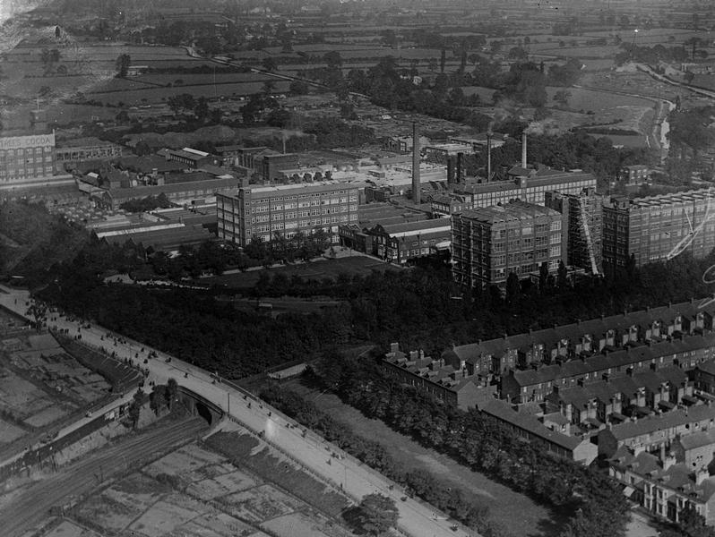
Rowntree’s Chocolate Factory before 1930
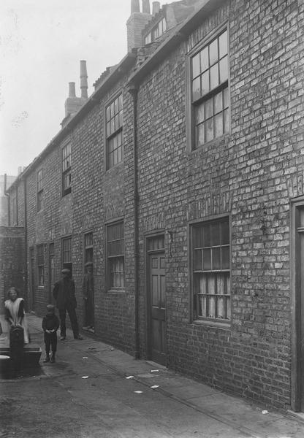
Hungate in 1912

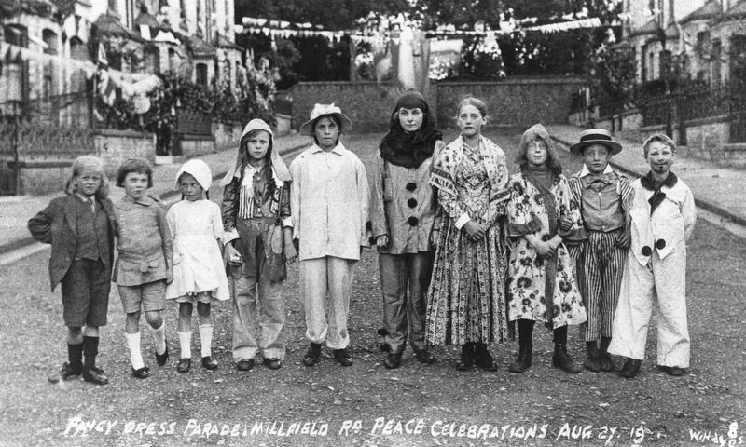
Peace celebration in Millfield Road – August 1918
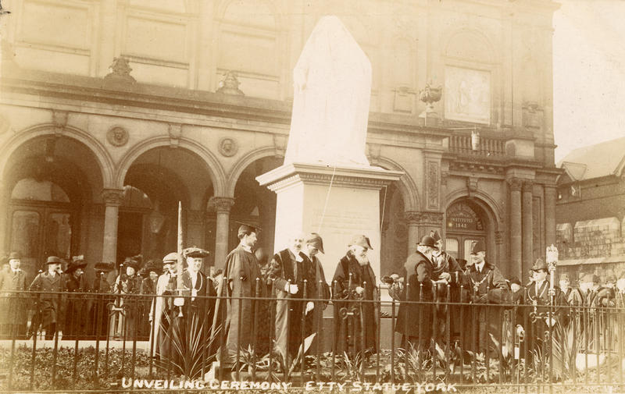
Unveiling the William Etty statue in 1911

We will be out and about in the city investigating a character. Below you will find a map of York. Number all the places we stop and look at. Start with number 1 and work up!
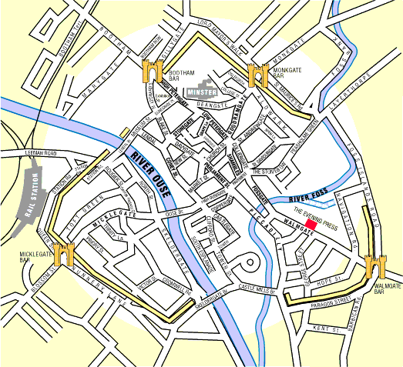
Now put the names of the places next to the numbers below. Add more numbers if you need to:

1
2
3
4
5

6
7
8
9
10

THE TASK
You are going to be investigating the life of a York man called Bartholomew Durkin. You will find out about him using this book and visiting places out and about in the city.
You are then going to work in small groups to produce 2 pages of a textbook so that other students can learn about your character and his world. There will be more information about this later. However, you need to be thinking about collecting information, ideas and images that may be useful.

Think: No picture is known to exist of Bartholomew Durkin
What might this say about the sort of man he was? Why?
________________________________________________________________________
________________________________________________________________________
SO, STARTING AT THE END OF HIS STORY… “HOW DID HE DIE?”
Although no known picture exists of Bartholomew Durkin, you can find a record of his death and where he is buried in just a few seconds by using the internet site www.cwgc.org/search
Here is the record of his death:
 | DURKIN , B | Private | 54125 | 15/03/1918 | Unknown age | Training Reserve | United Kingdom | 170. 20115. | YORK CEMETERY, Yorkshire

Things to write down and find out…

What date did he die? ___________________________________________________

What is significant about the year of his death? _______________________________

Where is he buried? _____________________________________________________

What was (is!) a ‘Private’? _________________________________________________

What else can you learn from his grave record? ________________________________
_______________________________________________________________________

The First World War
The First World War started in August 1914 and lasted until November 1918. Over 1 million British and Commonwealth (men from Australia, India, Canada etc.) soldiers died during this war. Around 1441 York men were killed in action and 9 people died in the 3 Zeppelin raids on York in 1916.
York came under attack later. The most serious of the Zeppelin raids took place on May 2, 1916. The distinctive cigar-shaped shadow of a German airship was spotted over the city at about 10.30pm. For the next ten minutes it dropped 18 bombs, destroying houses, killing nine people and injuring 40 more. Fear of future raids increased and a number of people were subsequently prosecuted for showing lights at night.
From the Yorkshire Museums trust website

Most British soldiers fought on the Western Front; an area of land in Belgium and northern France. Men lived and fought in trenches dug into the countryside, facing German trenches across ‘No Man’s Land’. The diagram may help you to understand this better.
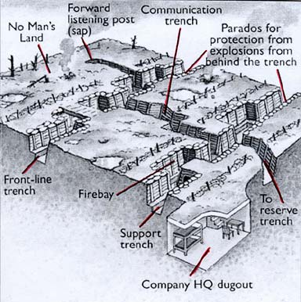
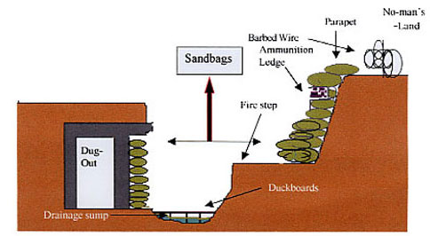

In 1914 and 1915, many British men volunteered to join the army and to be trained to fight. After this time the British government introduced conscription – that means, men were told they had to go and train to fight. We don’t know if Bartholomew Durkin volunteered or was conscripted. However, we do know that when he had his medical he was put in the ‘Training Reserve’. Many men turned up at their army medical test and were found to be not healthy enough to fight. Some were turned away, those who were not too bad were put in the reserve forces in case things got so bad that they were needed to fight on the Western Front. These men were usually unhealthy because they had not had enough nutritious food as small children, and/or because they were brought up in damp and cramped houses, and/or because they could not afford medical care.
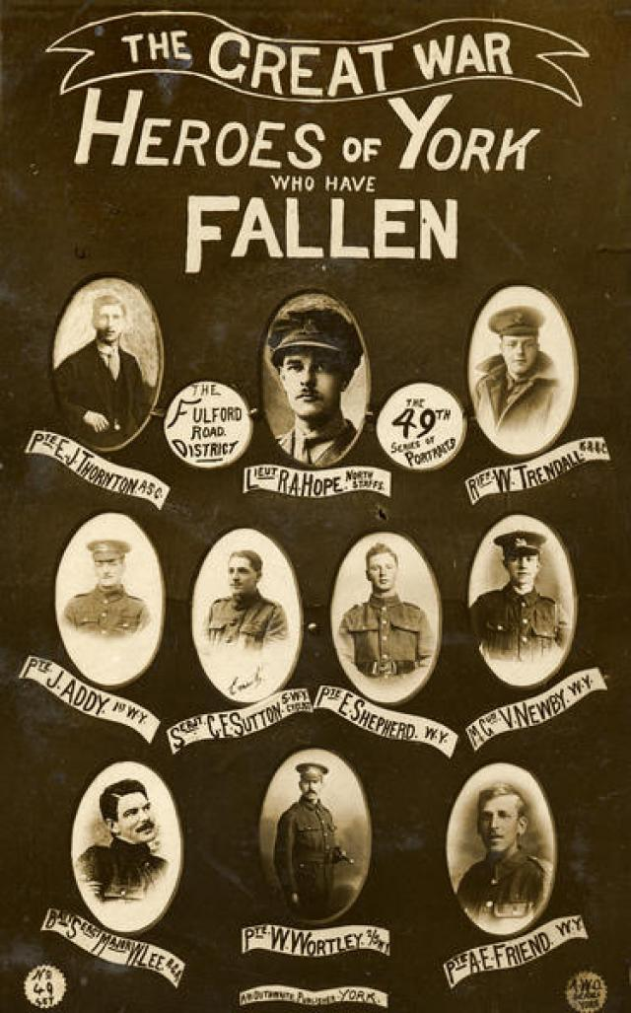
Posters like this were common in World War One. Why would you not expect to find Bartholomew Durkin remembered in this way? _________________________
_______________________________________________
_______________________________________________
SITE 1 – the NER memorial
The North Eastern Railway company war memorial was designed by Sir Edwin Lutyens. He was the most famous architect of his day. He also designed the cenotaph in Whitehall and buildings in India.
The Cenotaph in Whitehall, London 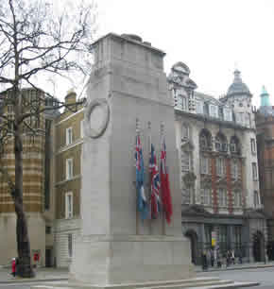

Quietly walk around the memorial - do not climb on it! Write down three things that you observe about it:
- ___________________________________________
- ___________________________________________
- ___________________________________________
Share your thoughts with a friend.

We do not know if Bartholomew Durkin’s name is on a war memorial anywhere. There is not one York City World War One memorial with all the names of the dead. He may have been remembered on the wall of his local parish church, but we don’t know which one that was.
SITE 2 – York Cemetery

Lots of interesting things here! But we’re going to see if we can find Bartholomew Durkin’s grave. We have a clue. All war graves look similar. Most of them are abroad (because that’s where most people died in wartime) and there is a picture of one here. So, we are looking for a grave that looks this colour and shape. His grave is number 183010.
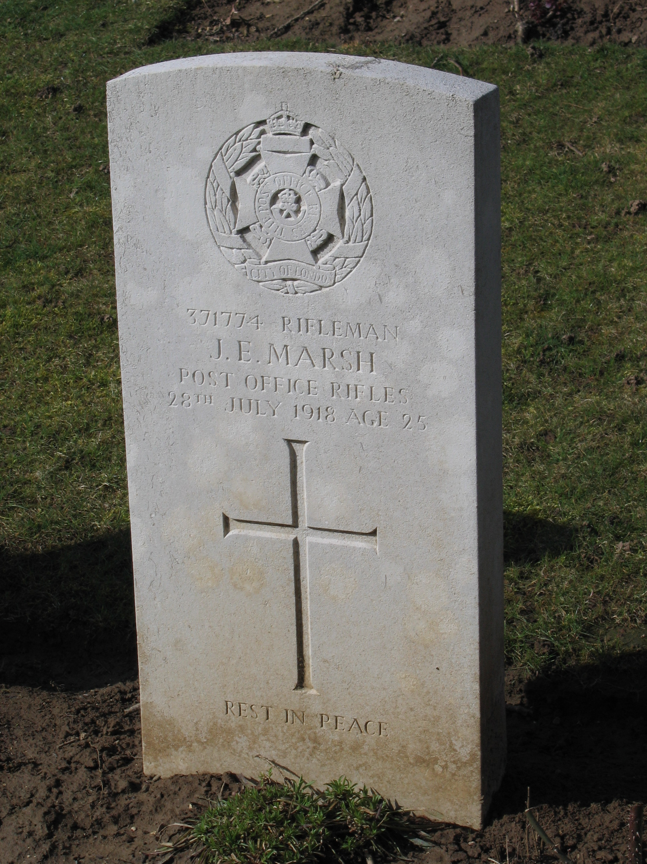
When we find the war grave, draw a sketch of it here and label the key features. (Clue: you’ll find a religious symbol, a badge, the name of the dead person, the age of the person, his number and possible a message.)

A great historical detective moment…!
The York Cemetery register (now in the City of York archives) gives us some more information about Bartholomew Durkin. It describes him as husband of Annie Durkin and the eldest son of Martin Durkin. It says that he lived at 5 Cross Wesley Place, Hungate. He was buried at 11 o’clock on the 20th March. It says he died of gas poisoning aged 31.

We are now going to find the shared grave of some young women who also died in York as a result of World War One.

Write down what you have learnt about them:
_______________________________________________________________________________________________________________________________________________________________________________________________________________________________________________________________________________________________________________________________________________________________________________________
SITE 3 – Fishergate Primary School

SO, IN THE FIRST PART OF THE 20TH CENTURY, YORK PEOPLE’S LIVES WERE SHAPED BY A LARGE AND TRAGIC WAR – KNOWN AS WORLD WAR ONE…
WHAT WAS LIVING IN YORK LIKE FOR SOMEONE SUCH AS BARTHOLOMEW DURKIN?
In the York Archives are the Census results for York
So, what is a census?
A census is a survey of everyone living in the country. It takes place every 10 years e.g. 2011. The information is used to help plan government services. The detail is kept secret for many years and then published. The information is collected house by house.

In the York census for 1891 we can find the following information…
In the parish of All Saint’s, Peasholme Green, York at…
13 Haver Lane lived Martin and Mary Durkin with their children Mary Ann, Bridget, Martin and Bartholomew. They also lived with Mary’s mother, Bridget.
Bartholomew is described as 8 years old and at school. He was the 2nd oldest child.

It seems very likely that this Bartholomew Durkin is the same man who is buried in York Cemetery. Can you think of reasons why?
1 _______________________________________________________________________
2 _______________________________________________________________________
3 _______________________________________________________________________
4 _______________________________________________________________________

Hungate has been the site of a major archaeological dig. This dig has uncovered a lot of information about the area of York in which Bartholomew Durkin was born and lived as an adult. There is also photographic and documentary evidence about the area. Using all this evidence we can work out what Bartholomew Durkin’s life might have been like.
SITE 4 - Hungate
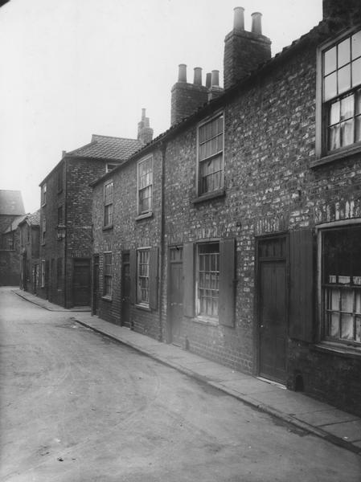
This is a picture of Cross Wesley Place, Bartholomew Durkin’s home address when he died. It was described by the medical officer as one of the narrowest streets in the area. It was 17 feet and 3 inches from side to side.
In pairs, measure out the distance. What do you think about the width of this street?
_______________________________________________
_______________________________________________

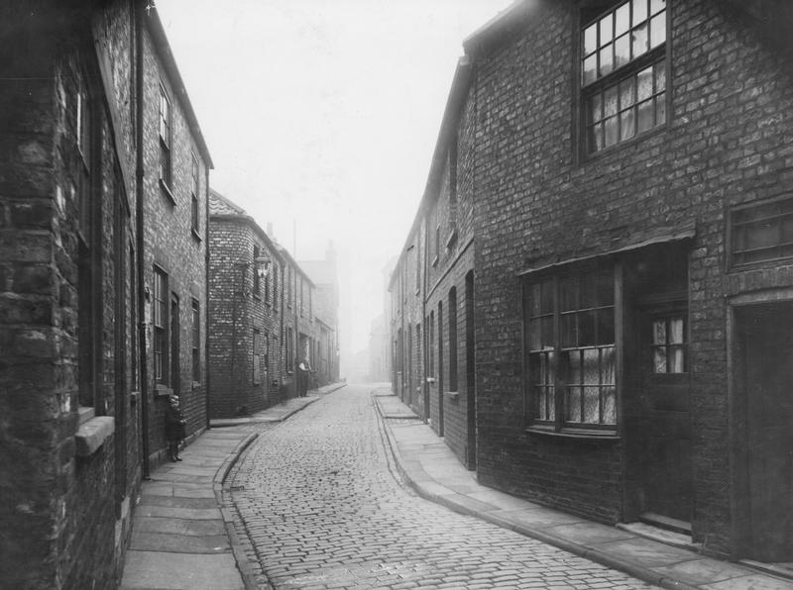
This is a picture of Haver Lane, the street in which Bartholomew Durkin lived in 1891. Most of the houses in the Hungate area had 2 rooms upstairs, 2 rooms downstairs and no bathroom or inside toilet. Some houses had one room upstairs and one room downstairs.
How many people lived in 13 Haver Lane in 1891?
______________________________________
What might be some of the problems of living as a child and an adult in this sort of environment?
____________________________________________________________________________________________________________________________________________________________________________________________________________________________________________________________________________________________________________
Outside toilets
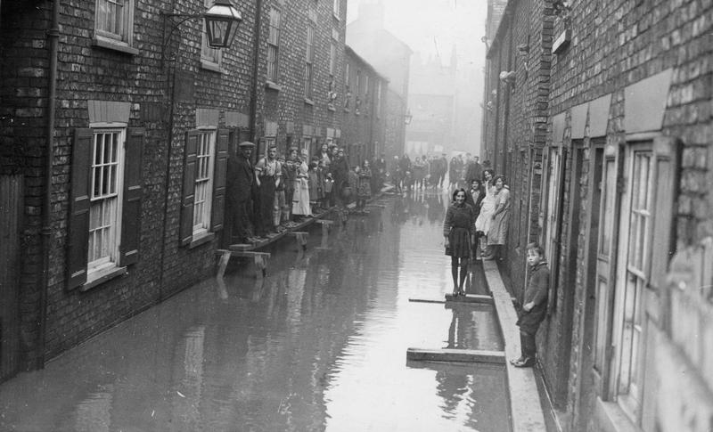
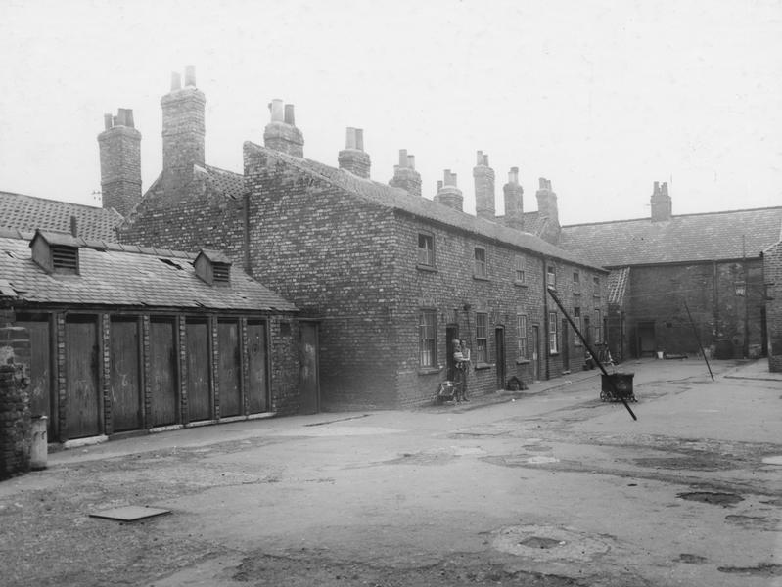
shared by several houses

The river flooded
Lower Wesley Place
WAS NO ONE CONCERNED ABOUT WHAT LIFE WAS LIKE FOR YORK’S POOREST CITIZENS?
Well yes, there were many concerned people and one of them made a HUGE difference to the lives of poorer people across Great Britain, using York people as an example to prove his point.
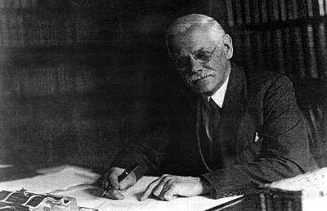
Benjamin Seebohm Rowntree was born in York in 1871. He was the son of the famous Quaker chocolate manufacturer Joseph Rowntree. and Emma Seebohm. He was educated at the Quaker Boys School and as an adult he worked in the chocolate factory as a chemist. On Sundays he taught at the York Adult School. His work with members of the working class at the Adult School combined with a visit to Newcastle in 1895, in which he was shown the living conditions of the poor first hand, made him determined to look into the problem of poverty. In 1897 he began to investigate poverty in York.
In 1901 he published a book which was to change British social policy and influence the Liberal government of David Lloyd George and Winston Churchill. It was called…
Poverty: A Study in Town Life
To research his book Seebohm Rowntree asked lots of detailed questions of York’s poorest citizens living in the most deprived areas. He included Hungate in his study and therefore will have questioned the household Bartholomew Durkin lived in. At the time many richer people in the country thought that poorer people were poor because they were lazy or drank too much. Seebohm Rowntree proved this was not the case. In his book Rowntree showed that many people in York were poor with no chance to change their lives. Winston Churchill read the book and said…

‘I have been reading a book which has fairly made my hair stand on end, written by a Mr Rowntree, who deals with poverty in the town of York. … It is found that the poverty of the people of that city extends to nearly 1/5th of the population; nearly 1/5th had something between 1 ½ and ¾ as much food to eat as the paupers in the York Union [workhouse]. That I call a terrible and shocking thing, people who have only the workhouse or prison as avenues to change from their present situation.’
Winston Churchill, speaking to an audience in Blackpool, 1902
Winston Churchill went on to be part of the Liberal Government which took power in 1906 and brought in the first pensions, school meals, health insurance etc to help poor people.

SITE 5 – The York Adult School

Write down some things you can see that would have been here in 1918:
SITE 6 - Bedern

______________________________________________________________________________________________________________________________________________________________________________________________________________________________________________________
SITE 7 - York Minster

Who can you find on the memorial to the Women of Britain and the Empire?
____________________________________________________________________________________________________________________________________________________________________
SITE 8 – Parliament Street

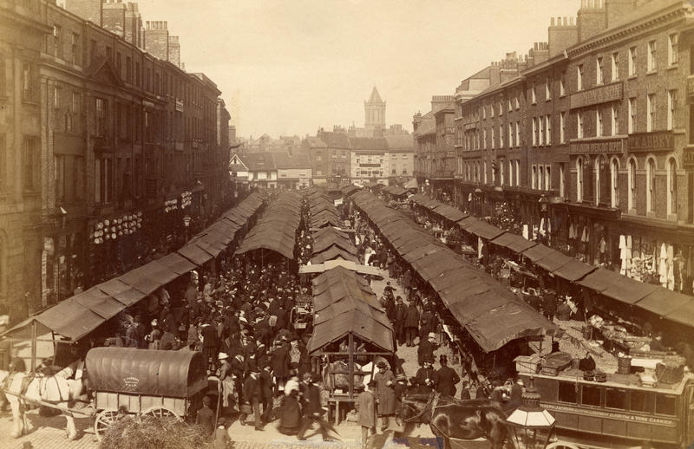
Parliament Street was created in the middle of the 19thcentury. In Bartholomew Durkin’s day it was the site of York’s lively market. Look carefully at the picture and look around you. Write down:
Things the same as now Things different from now

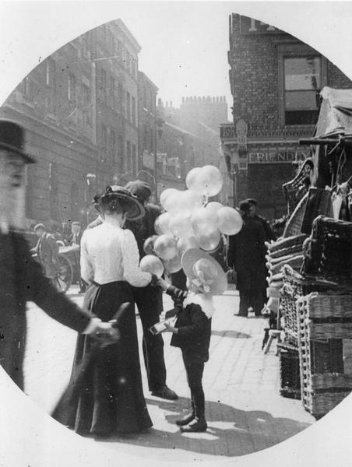
BACK IN CLASS - 1
1. You will hear and see other groups present their work. Listen and look carefully.
2. We will then agree 5 things we have learnt about York life in the early part of the 20th century. Write them down here:
1
2
3
4
5
3. We will then have a class discussion about the similarities and differences between the lives of the 2 characters we have studied. Write them down here:
The Lives of Seebohm Rowntree and Bartholomew Durkin
Similarities Differences

4. We will then discuss what we would find familiar and unfamiliar about York in the early 20th century. Write the ideas down here:
Familiar Unfamiliar

BACK IN CLASS – 2
- You will be given a partner from the other class.
- You will work with one of the textbook pages that neither of you have worked upon.
- Get out of your file our agreed ‘ingredients for really effective textbook pages’.
- With your partner, study the textbook pages and our ‘ingredients’ list. You have to decide how effective you think the textbook pages are. To do this:

1 Write each ingredient down the side of this page
2 Make a note of what you think works really well on the textbook page you are looking at.
3. Make a note of what you think could be improved.
4. Review your list. Overall, do you think the textbook pages have all the ingredients to be really effective? Why? Why not?

Ingredient Works really well… Could be improved…

