|  |  |
| --- | --- |
| WORK | |
| Work on the **plantation** for the **slave owner** | Work at **home** |

PLANTATION

|  |  |
| --- | --- |
| Sugar Cane **fields** | The plantation owner’s house |
| The sugar **factories** | The **church** |
| The slave **homes** | The **woods** |

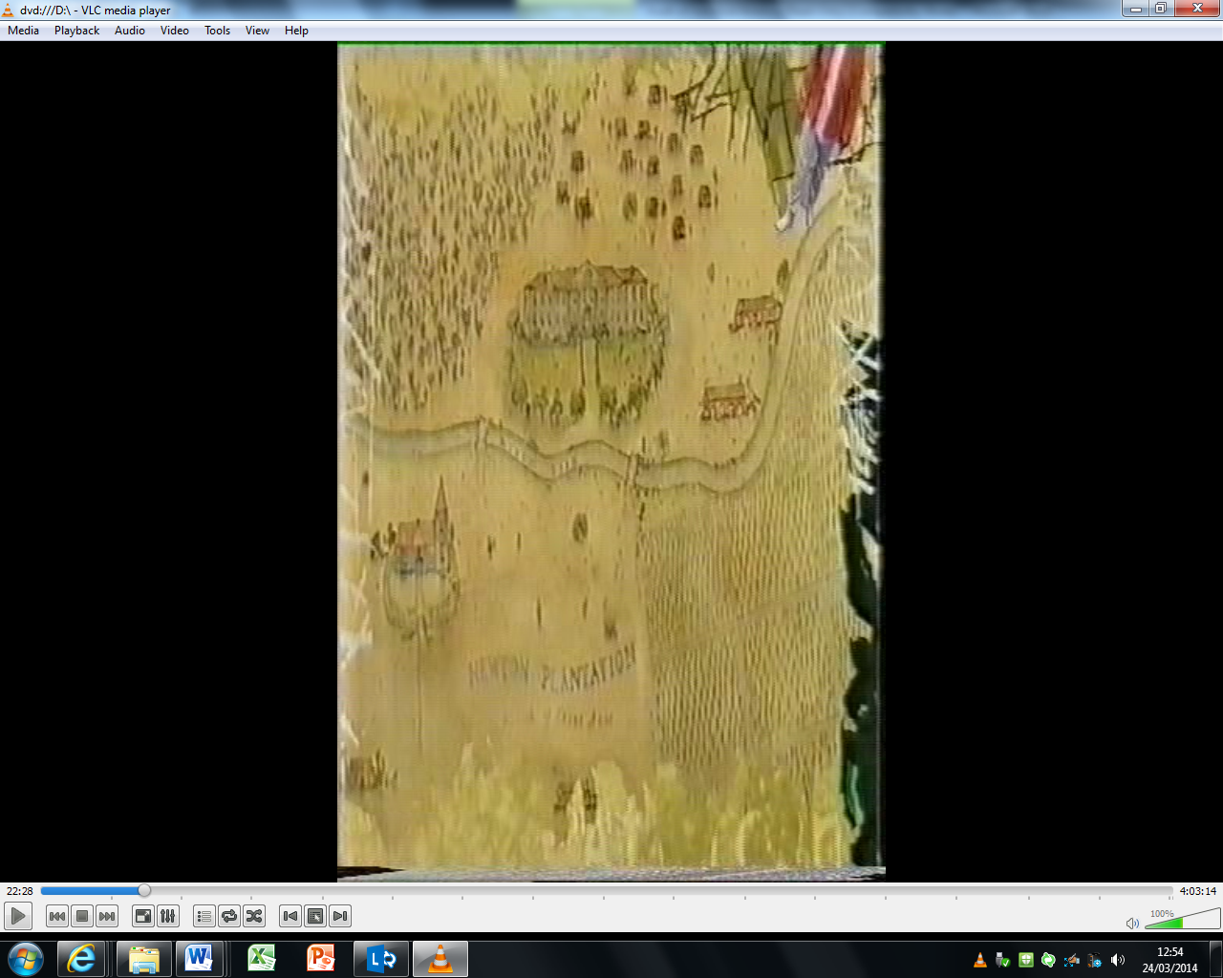

Slaves had rules.

One slave rule was, “You must do as you are told and work hard”

*Can you write a school rule?*

**Peter’s school rule**

“You must_______________________________”

If slaves did not follow the rules they were punished.

PUNISHMENTS FOR **RUNAWAY** SLAVES

|  |  |
| --- | --- |
| WORD | PICTURE |
| Whipping |  |
| Separating families |  |
| Hanging |  |

|  |  |
| --- | --- |
| COMMUNITY - | All of the slaves help each other |
|  |  |

|  |  |
| --- | --- |
| ENGLISH | TRANSLATION |
| Entertainment |  |
| Music |  |
| Fun |  |
| Dance |  |
| Religion |  |
| Church |  |

|  |  |
| --- | --- |
| Entertainment |  |
| Music |  |
| Fun |  |

|  |  |
| --- | --- |
| Dance |  |
| Religion |  |
| Church |  |

C:\Users\andrews\AppData\Local\Microsoft\Windows\Temporary Internet Files\Content.IE5\VK5RNGK0\MC900060019[1].wmf

I entertain the children with Anansi stories

I play the drums with other slaves

C:\Users\andrews\AppData\Local\Microsoft\Windows\Temporary Internet Files\Content.IE5\DYTC1WTZ\MC900437990[1].wmf

C:\Users\andrews\AppData\Local\Microsoft\Windows\Temporary Internet Files\Content.IE5\XYFLAHSY\MC900048042[1].wmf

C:\Users\andrews\AppData\Local\Microsoft\Windows\Temporary Internet Files\Content.IE5\VK5RNGK0\MC900038991[1].wmf

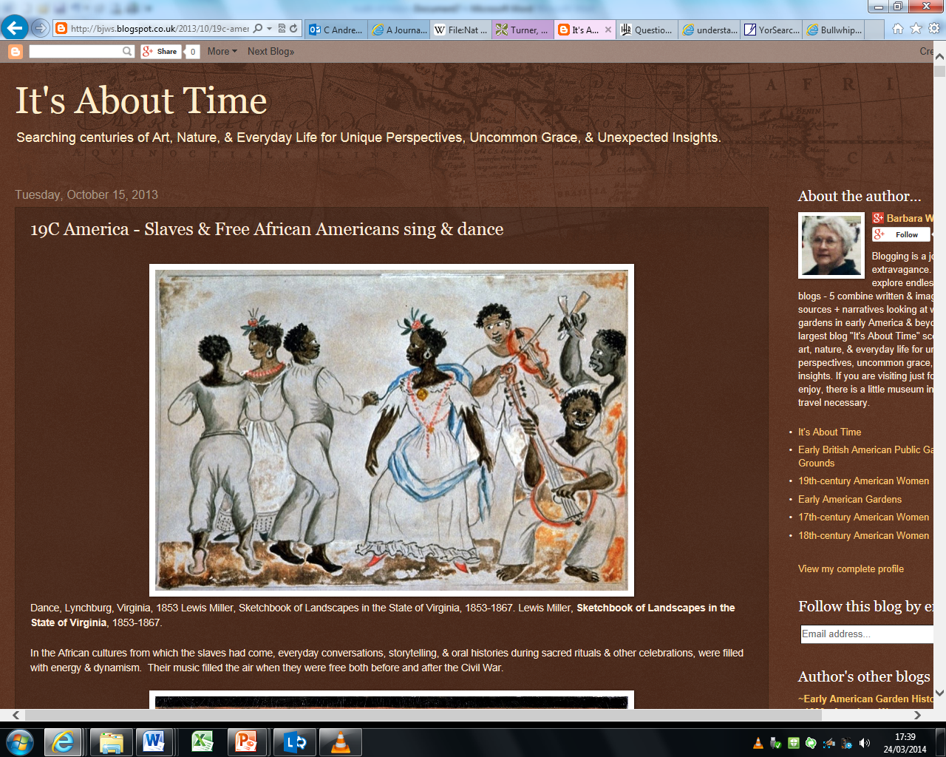

Children had fun playing games

C:\Users\andrews\AppData\Local\Microsoft\Windows\Temporary Internet Files\Content.IE5\MEW1XTKB\MC900232251[1].wmf

Source A

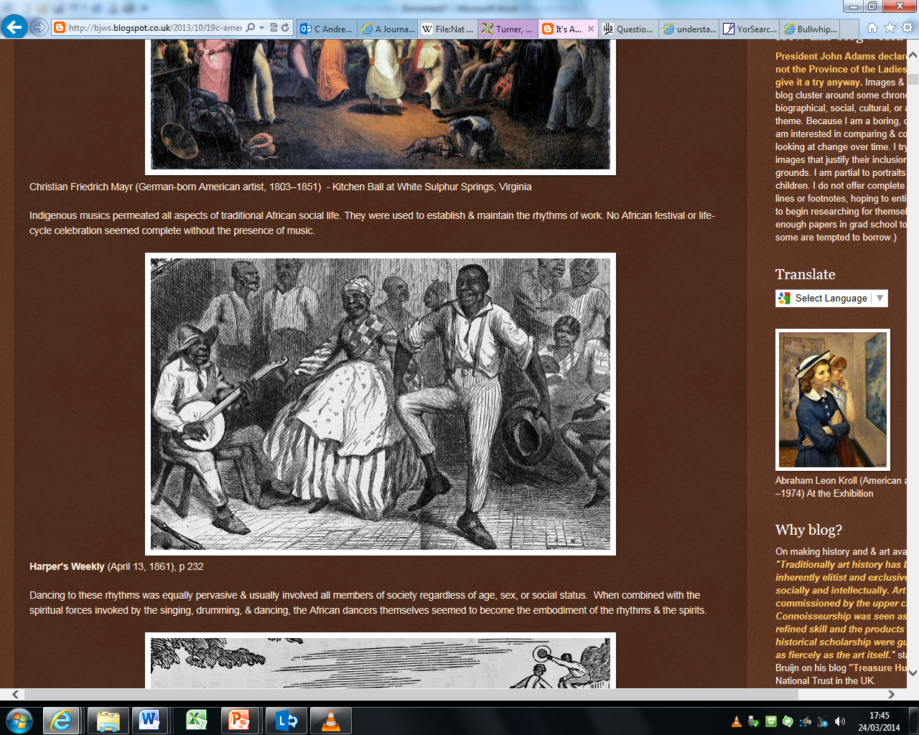

Source B

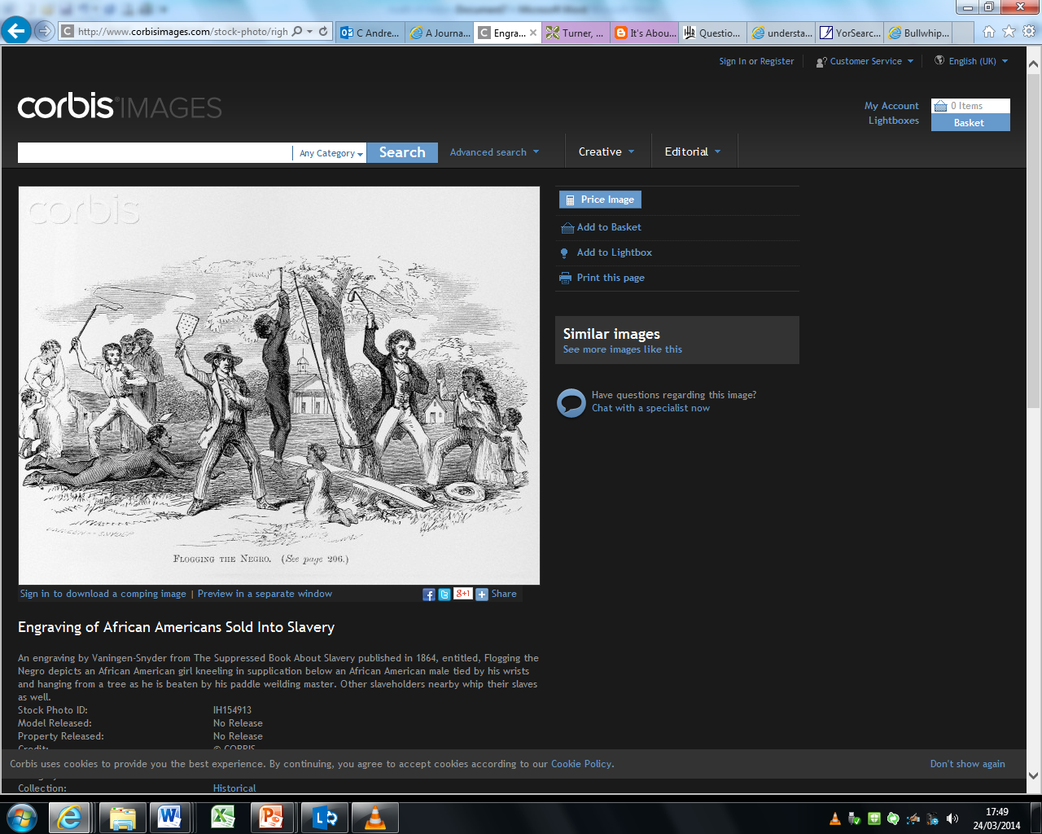

|  |  |  |
| --- | --- | --- |
| Source | Is it a painting, a photograph or writing from a book? | What can you see? |
| A |  |  |
| B |  |  |

I work in the fields

I carry baskets

I cook for my family

I look after **my** animals

I cut sugar cane

I look after the **slave owner’s** cows.

I cut wood for cooking

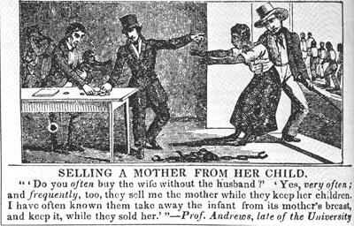[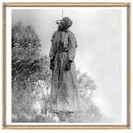](http://www.google.co.uk/url?q=http://slaveforyourself.com/home.html&sa=U&ei=a9c6U86_C8at7Qa7qoHQCA&ved=0CEAQ9QEwCQ&sig2=SnnOnd1Ej4WsvR7s9h-ZYA&usg=AFQjCNH5494ZO0c4FuKNkhv0jZimv3Yx-Q)[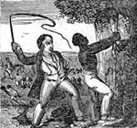](http://memory.loc.gov/cgi-bin/ampage?collId=rbaapc&fileName=08720/rbaapc08720.db&recNum=1)