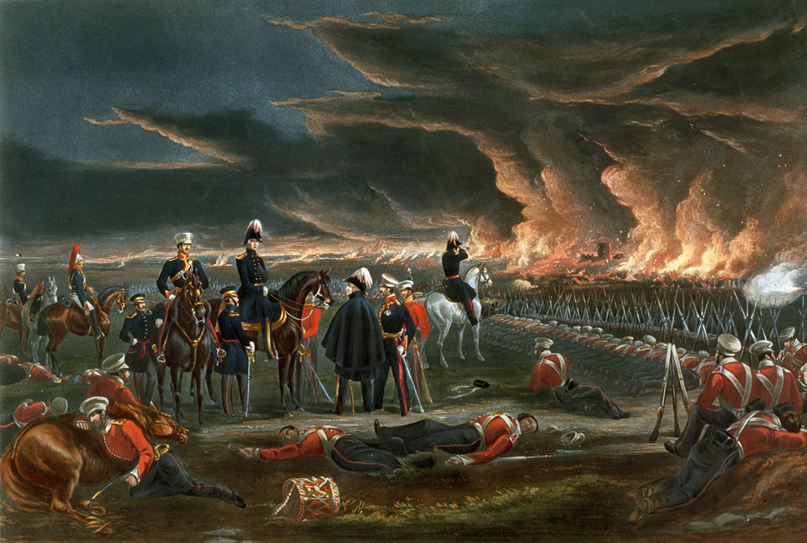
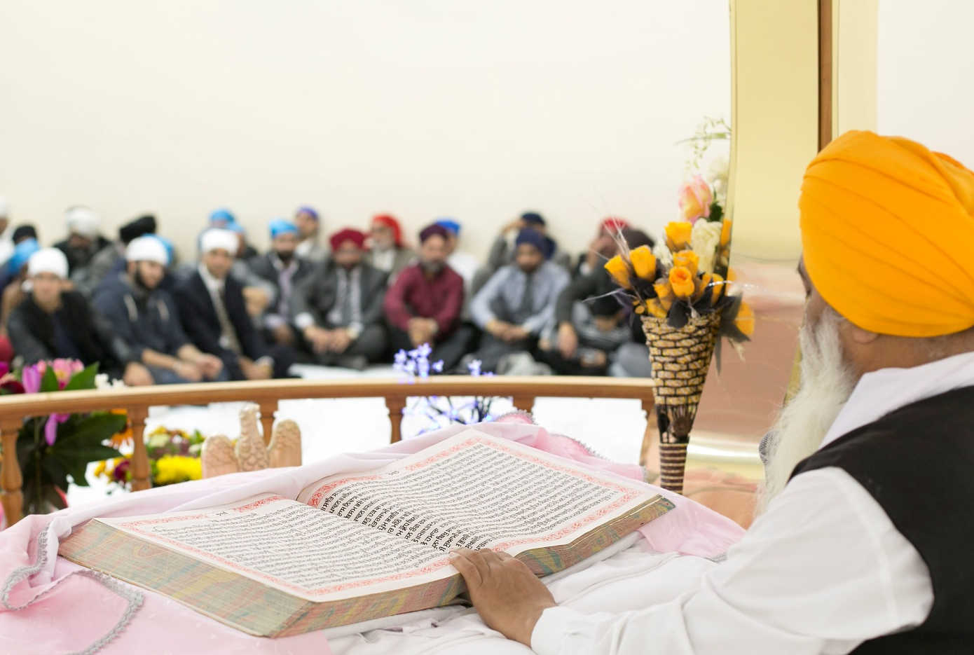
Image 3 (top)
A British Victorian print showing Sir Henry Hardinge, British Governor-General of India and his officers surveying the battlefield at Ferozeshah (a village in Punjab, North India) on the first night of this crucial battle during the first Anglo-Sikh War in December 1845 when British forces faced defeat. The images show exhausted British soldiers sleeping amid the British dead.
Courtesy of the Council of the National Army Museum, London (acc. no. 1971-02-33-165)

Image 4 (bottom)
The Guru Granth Sahib or holy scriptures of the Sikh religion. It contains poetry written by several of the ten Sikh Gurus. It also contains the devotional writings of Hindu and Muslim saints who expressed the same universal message as the Sikh Gurus. It was first compiled in 1604, the same year that the King James's Bible project had begun in Europe.
Courtesy of Navjit Surdhar

