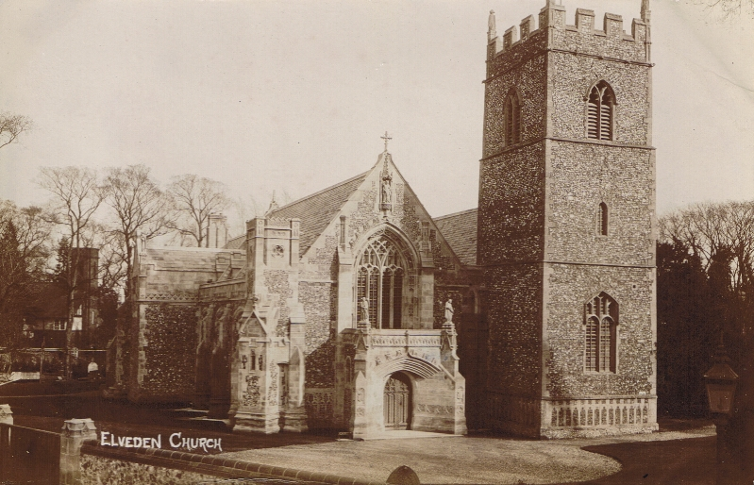
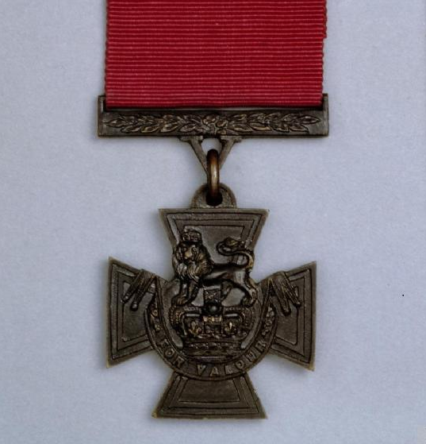
Image 7 (top)
The village church at Elveden in Norfolk where the last ruler of the Sikh Kingdom, Maharaja Duleep Singh was buried in 1893. After his kingdom was annexed by the British he lived in exile on a nearby country estate as an English gentleman. Sikhs from around the world visit his grave to this day.
Courtesy of Peter Bance Collection
Image 8 (bottom)
The Victoria Cross, the United Kingdom’s highest award for military service. In May 1915 on the Western Front in France, Lieutenant John Smyth, a young British officer commanding Sikh soldiers of the British Indian Army was awarded a Victoria Cross for bravery. Eight out of the ten Sikh soldiers who volunteered to accompany him on his dangerous mission of delivering bombs across open land were killed or severely wounded. All of the Sikh soldiers in Smyth’s party were also awarded medals.
© IWM (HU 69722)

