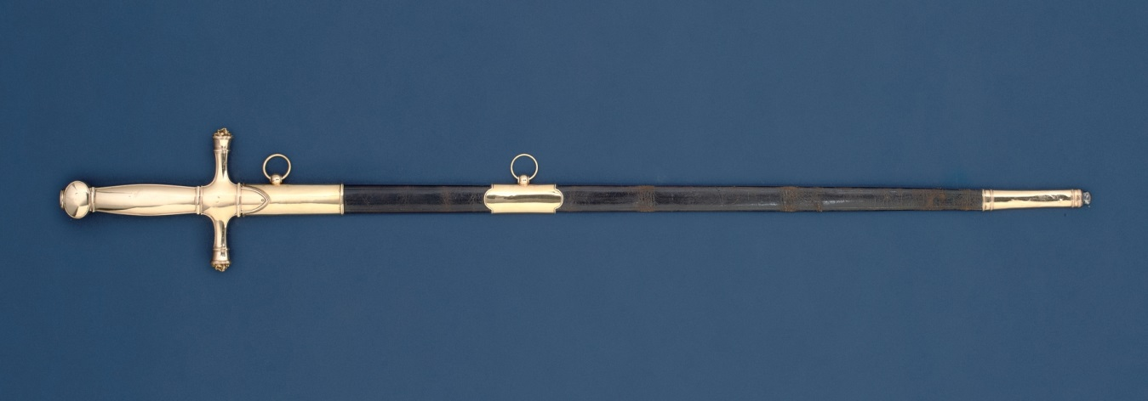
1. The sword of the Duke of Wellington previously belonging to Napoleon the First and given by Wellington to Sir Henry Hardinge, British Governor-General of India. (The Wellington-Hardinge sword, 1809 (metal), Biennais, Martin Guillaume (1764-1843) / Private Collection / Photo (c) Christie's Images / Bridgeman Images)
On the first night of the battle of Ferozeshah “Sir Henry Hardinge (British Governor-General of India) thought it was all up (that the British had been defeated) and gave his sword, a present from the Duke of Wellington and which once belonged to Napoleon (a great French emperor) and his Star of the Bath (a symbol of his knighthood which he wore on his jacket) to his son, with directions to proceed (go to) Forozepor remarking (saying) that if the day was lost (if the British were defeated) he Hardinge must fall (he would end up dying as well).”
General Sir Hope Grant
“Then among many panic set in. The cry of ‘India lost’ was heard from one commanding officer who tried in vain to rally his men. The left attack on the Khalsa (the Sikh army) had failed so signally (completely) that it could not be renewed (started again). The Sikh army had repulsed (pushed back) the British attack. They had driven back Littler (a British general), forced Smith (another British general) to retire, compelled (forced) even Gilbert to evacuate (withdraw from) the position he had gained and had thrown the whole British Army into disorder.
“What was more, they (the Sikhs) had still 10,000 men under Tej Singh (a Sikh general). Had (If) a guiding mind (a Sikh general who knew what they were doing) directed the movements of the Sikh Army, nothing could have saved the exhausted British.”
Colonel George Bruce Malleson
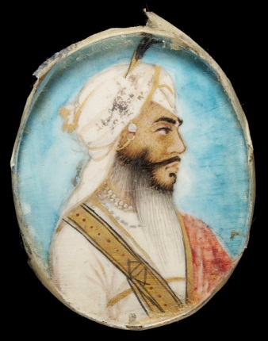
2. General Tej Singh. (© Victoria and Albert Museum, London)
“Darkness, and the obstinacy (stubbornness) of the contest, threw the English into confusion. Men of all regiments arms were mixed together. Generals were doubtful of the fact all of the extent of their own success (did not know whether they were winning or not) and colonels knew not (did not know) what had become of the regiments they commanded or the army which they formed a part… On that memorable night the English were hardly masters of the ground on which they stood… During that night of horrors, we were in a critical and perilous (very weak) state.”
Sir Hugh Gough, Commander-in-Chief in India

“That frosty night the fate of British India trembled in the balance. Truly the night was one of gloom and foreboding (fear of what might happen). Perhaps never in the annals of warfare (the records of war) has a British Army on so large scale been nearer to defeat which would have involved annihilation (complete destruction)… Our exhausted and decimated (badly reduced) divisions bivouacked (camped) without mutual cohesion over a wide area (troops were camped randomly in no particular order).”
General Sir Hope Grant
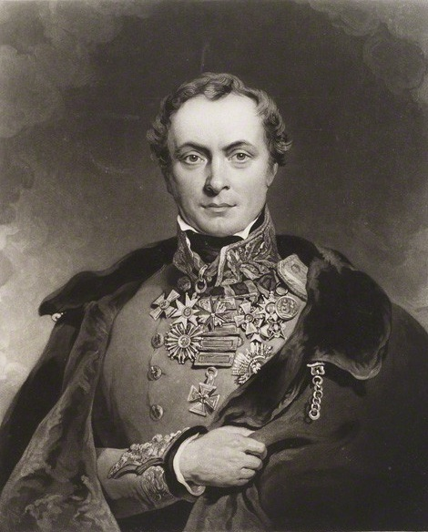
3. Sir Henry Hardinge, British Governor-General of India.
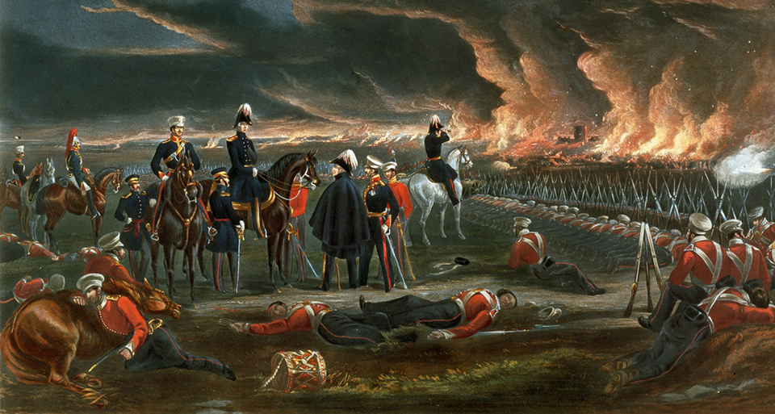
4. The British camp on the first night of the Battle of Ferozeshah - Sir Henry Hardinge is sat on his horse with the tall hat. (Courtesy of the Council of the National Army Museum, London, acc. no. 1971-02-33-165)
“News came from the Governor-General that our attack yesterday had failed, that affairs (the situation) were desperate, all state papers would be destroyed, and if the morning attack failed it would be over (the British would have lost). This was kept secret by Mr Curry and we are considering measures to make an unconditional surrender to save the wounded…”
Robert Needham Cust, Political Assistant
“We (the British government) are astonished at the numbers, the power of combination, the skill and courage of the enemy (the Sikhs).”
Sir Robert Peel, British Prime Minister

“Splendid gallantry (bravery) of our fallen foe (dead Sikhs)”
Sir Hugh Gough, Commander-in-Chief in India

“For though defeated and broken, they never ran, but fought with their tulwars (curved swords) to the last and I witnessed several acts of great bravery in some of their Sirdars (officers) and men.”
General Sir Joseph Thackwell

“Few (Sikh soldiers) escaped, none it may be said, surrendered.”
Sir Henry Hardinge, British Governor-General of India

“We lost lots of men before we got to the enemies principal battery (gun position), for we would push, as it were into the lion’s mouth; When we did reach it the gunners resorted to their tol-wols (curved swords) and we our bayonets, then came the tug of war with clashing steel in earnest…. What a picture of horror I beheld (saw) when we and the Sikhs were straining every nerve to deeds of barbarity (each side trying to fight as ferociously as possible), wholly bent on mutual destruction wielding…swords, bayonets…. These overgrown brutes of artillerymen (the Sikh gunners) had great advantage over us, and they fought with unusual courage, many of their lives being bought at the price of ours (many died killing our men), i.e. when some of our men plunged their bayonets into the Sikhs, they (the Sikhs) held them fast by the sockets (of the bayonets) with their left hands, and cut our men’s heads off with their massive tol-wols; with deep regret I saw several of my comrades thus killed…”
Sikh artillery gunners were men whose “usual stature being from six feet to six feet three inches, muscular and active in proportion.”
From an account of the First Anglo-Sikh war by a British soldier called J. W. Baldwin

5. Elevation drawing of a captured Sikh cannon from the First Anglo-Sikh War. (Courtesy of the Council of the National Army Museum, London, acc. no. 1958-07-75-1)
“Nothing could exceed (be better than) the accuracy of the enemy’s (the Sikhs) fire… Our artillery officers say they never saw anything finer than the way their Horse Artillery were brought up to the edge of the river and formed up. No nation could exceed them in the rapidity (speed) of their fire…”
Letter from a British officer quoted in the Illustrated London News (27 January 1849)

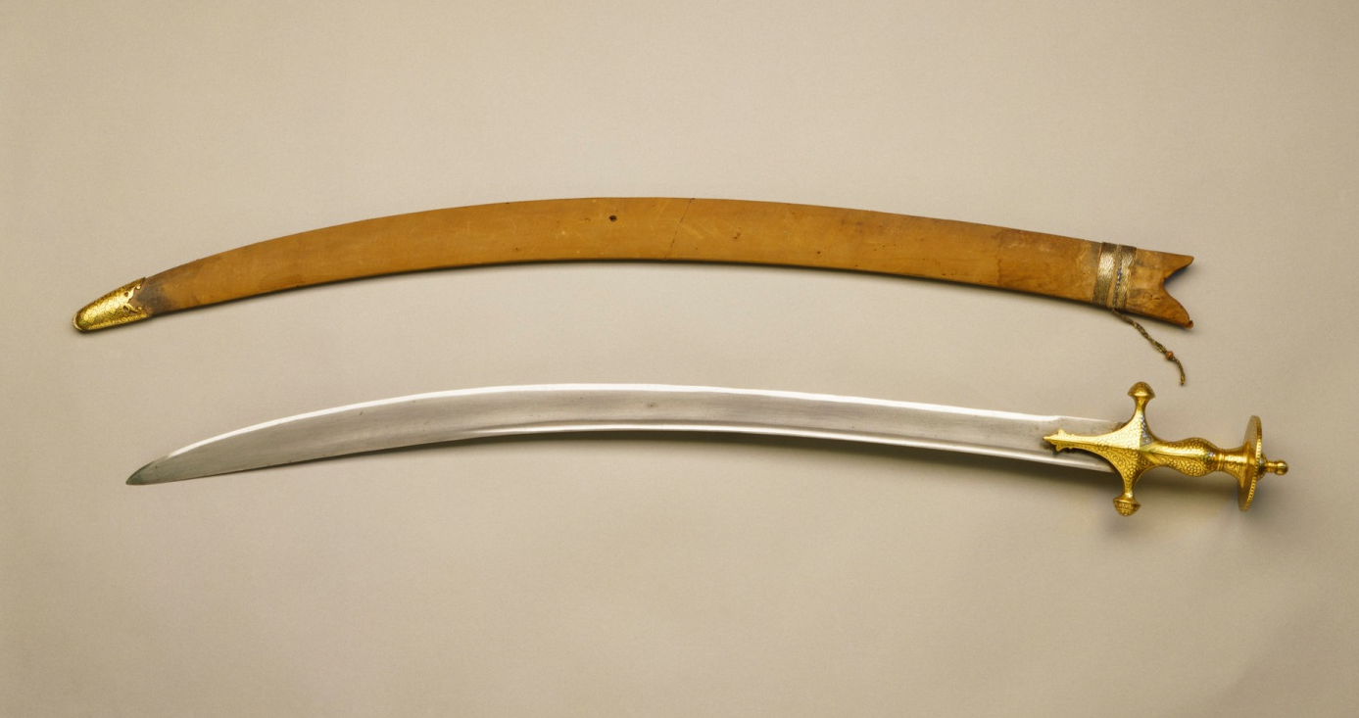
6. A sword (talwar) and scabbard typical of the kind used by Sikhs during the Anglo-Sikh Wars. (Royal Collection Trust/© Her Majesty Queen Elizabeth II 2014)
The turbans worn by Sikhs during the Anglo-Sikh wars were an effective buffer (barrier) against British sword blades:
“The [Sikhs] wore voluminous thick puggries (turbans) round their heads, which our blunt swords were powerless to cut through, and each horsemen had also a buffalo-hide (leather) shield slung on his back. They evidently knew that the British swords were blunt and useless, so they kept their horses still and met the British charge by laying flat on their horses’ necks, with their heads protected by the thick turban and their backs by the shields; and immediately the British soldiers passed through their ranks the Sikhs swooped round on them and struck them backhanded with their sharp, curved swords, in several instances cutting our cavalrymen in two.”
Sergeant William Forbes Mitchell of the 93rd Sutherland Highlanders writing about the Battle of Ramnagar during the Second Anglo-Sikh War

