How well were Sikh (and other Indian troops) really treated in British hospitals?
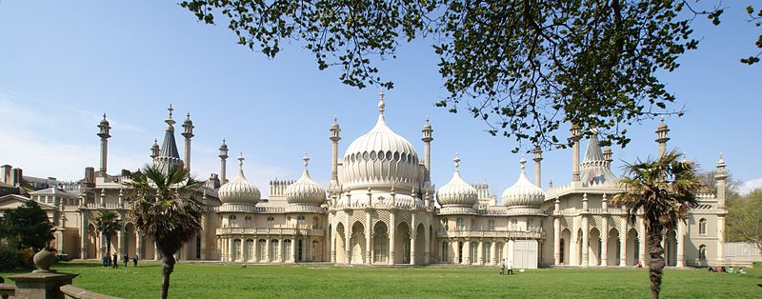
1. The Royal Pavilion in Brighton today.
When the British Indian Army fought on the Western Front in 1914 and 1915 wounded Indian soldiers were first treated behind the lines. Later on some were brought back to Britain to be treated.
The former royal palace in Brighton called the Royal Pavilion was turned into a military hospital for Indian patients (it was thought that the Indian style of the building would make them feel at home). Special care was taken of their needs, for example separate Hindu and Muslim water taps were set up in every room, soldiers of different religions were fed their usual special diets, squat lavatories (which Indian soldiers were used to) replaced western-style toilets, and places of worship for the different religions were created.
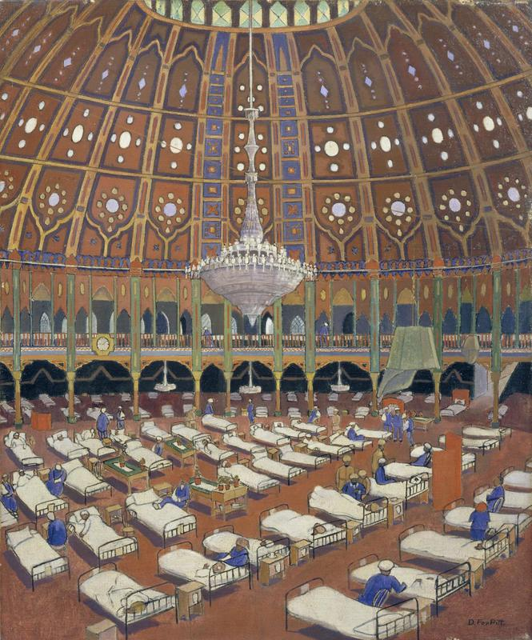
2. Indian Army Wounded In The Dome Hospital, Brighton. (© IWM (Art.IWM ART 323))
The dead were treated carefully according to religious custom. Hindus and Sikhs were cremated and Muslims were buried in a special graveyard built near the Woking mosque.
Members of the Royal Family were frequent visitors and took time to speak to each patient individually with the help of an interpreter.
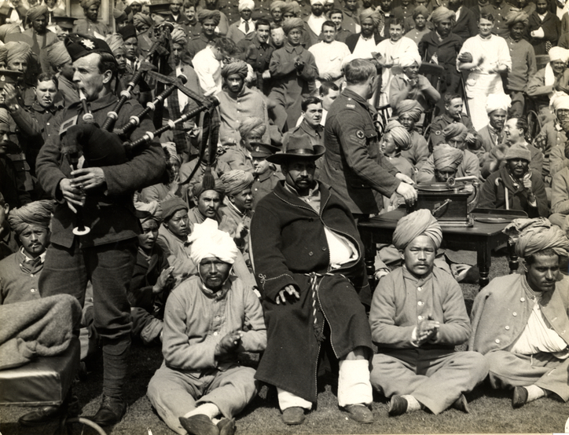
3. Wounded Indian soldiers at the Royal Pavilion enjoy a gramophone concert. (© British Library (Photo 24/21))
Local British people were very excited by their strange visitors (most would never have seen Indians before). Gifts were given and special outings were organised for the patients, even to London. Local Christian clergymen requested permission to visit the wards. In one or two cases local women went out with Indian men.

But…
Wherever possible, white British nurses were not allowed to care for sick Indians in Britain itself. Where this did happen occasionally, in Brighton for example, and where British local women went out with Indians, the British authorities thought it was a scandal.
Relationships between Indian men and white women might break down the barrier between Indians and the British. It might make Indians think that they were equal with British people and demand independence when they went home.
In the larger military hospital in Brighton called the Kitchener Indian Hospital, Colonel Bruce Seton was ruthless in keeping control.
He wrote that some Indians were “the sweepings of Bombay” (the Indian city of Mumbai) and claimed that they were always drunk. Also, that the friendliness of some local British women was a temptation to his patients.
As a result, Seton:
- banned most Indians from leaving the hospital and making visits to Indians elsewhere;
- placed barbed wire around its boundaries and posted Military Police to prevent escapes;
- punished anyone found “breaking out” with “two dozen lashes” (of a whip);
- reduced rations;
- delayed permission for Indian patients to return home to India in case this encouraged serving soldiers to deliberately get wounded.
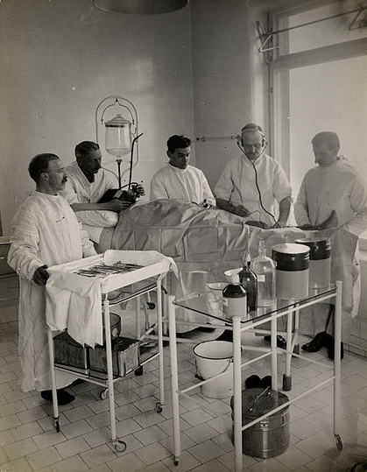
4. Doctors at the Kitchener Hospital in Brighton operate on a wounded Indian soldier. (© British Library (Photo 24/7))
Relations between Seton and his patients became so bad that one Indian soldier tried to murder him. After this incident, rules at the hospital were relaxed.
There were rumours in the British Army that Indian soldiers were deliberately getting themselves wounded to escape the miserable fighting conditions on the Western Front.
Seton wrote a secret report investigating the claims carefully but did not find enough evidence to prove that they were true.
On day visits as tourists Indian patients were always carefully escorted.
The British authorities took care of Indian customs to partly avoid the Germans accusing them of treating their soldiers badly.
Local Christian clergymen were stopped from visiting Indian patients in case the Germans claimed that the British were trying to force their Indian soldiers to become Christians.

