How did Hardit Singh Malik become a pilot during the First World War?
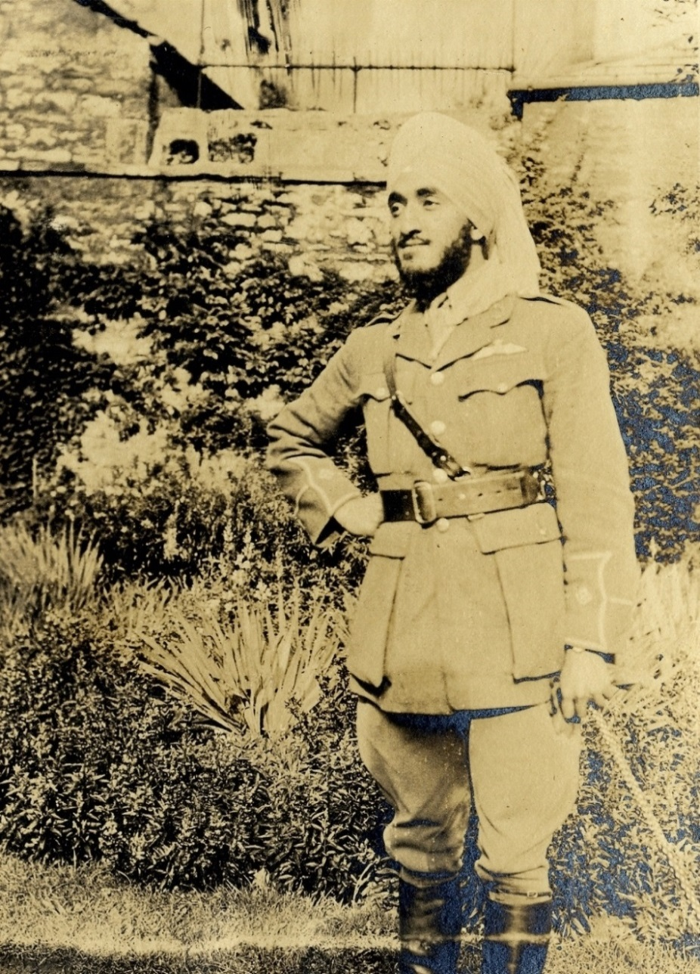
1. Hardit Singh Malik in his RAF uniform at his college in Oxford University, 1918. (Balliol College, FF Urquhart Album 7.63G)
A Sikh who fought alongside the British during World War One was Hardit Singh Malik. He was the first of four Indians who joined the Royal Flying Corps, which later became the Royal Air Force.

But…
At first Hardit Singh, who was studying at Oxford University, tried to join the British Army as a commissioned officer (that is as a lieutenant not a non-commissioned officer like a sergeant or corporal) like his friends were doing. He was rejected twice because it was British policy at the time that no white soldier could be commanded by a non-white officer.
After finishing at university Hardit Singh volunteered with the French Red Cross. In France he applied to join the French Air Force which did not ban non-whites from commanding white men. He was accepted and wrote a letter with the good news to one of his teachers at Oxford University. That teacher contacted a senior officer in the Royal Flying Corp to ask why Hardit Singh could not be an officer so that he could fly with white British pilots in the Royal Flying Corp. They came to a special agreement and Hardit Singh became a pilot.
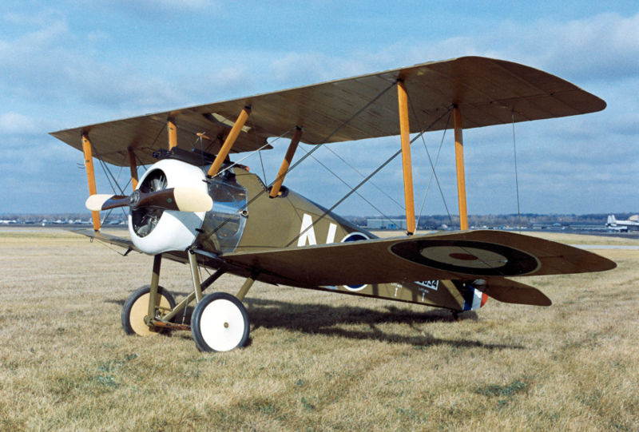
2. A British aircraft of the First World War.
Despite this Malik was still not allowed to command whites though.
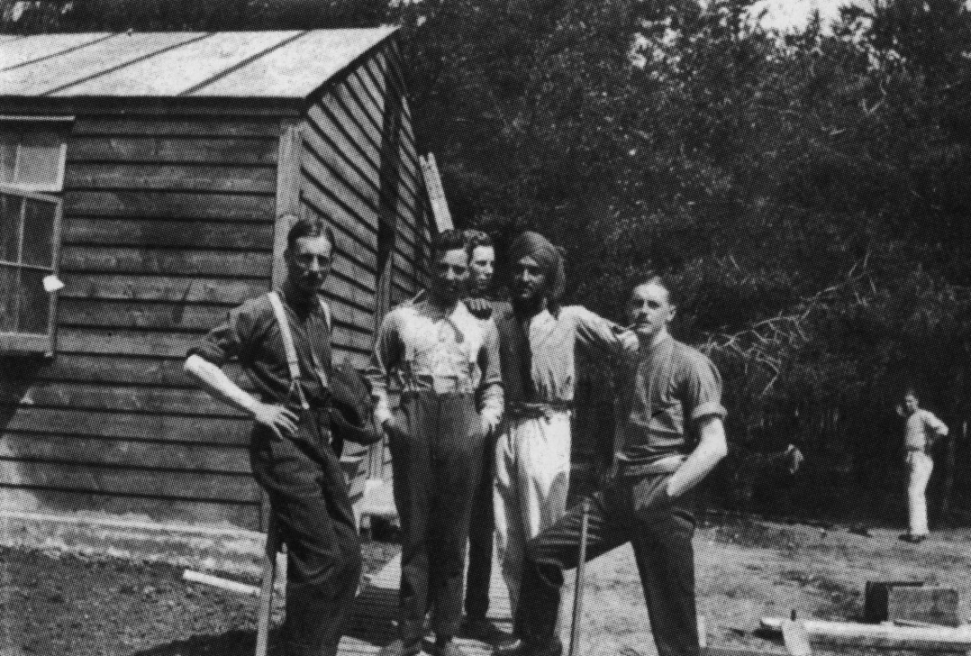
3. Malik relaxing with fellow British pilots during the war. (By Kind Permission of Mr Somnath Sapru)
After the armistice in November 1918, Hardit Singh was given time off. During his sea voyage to India, he made friends with a British Indian Army officer, Captain Keen of the 28th Punjabis. One evening Keen asked the Sikh what his plans were. Hardit Singh told him that he would join the RAF in India. Keen warned him: ‘You know we don’t want Indians in the RAF. You will find one fine day you will go up and your plane will break up in the air.’ Malik left the RAF and joined the Indian Civil Service instead.

