What did the British really think of the Sikh (and other Indian) soldiers they served with?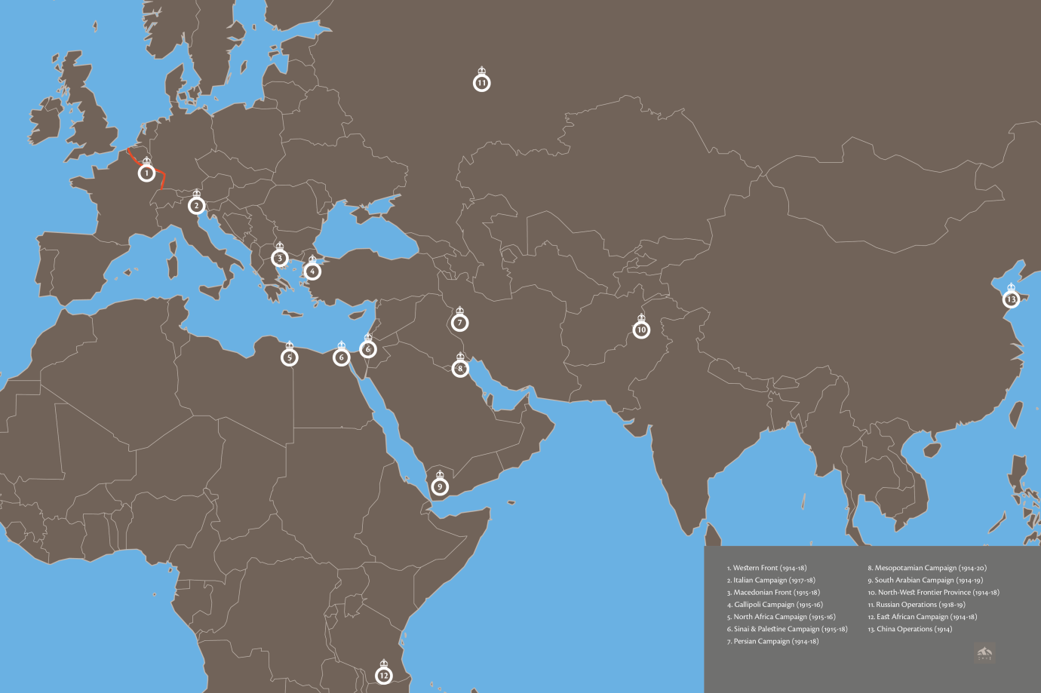
1. Campaign map showing where Sikh (and other Indian) soldiers fought in the First World War. (Designed by Jugasingh.com/Grfik.com)
As part of the British Indian Army, Sikh soldiers were experienced at mixing with Indian soldiers from different backgrounds already, especially Hindus and Muslims.
They were all led by British officers who were carefully trained to understand their language, culture and religion.
During the First World War, religious objects such as little ceremonial daggers and combs for Sikhs and other gifts in their thousands were provided by British charities. A Sikh veteran later said “We were advised to take keen interest in the religious activities… The British officers also participated in our prayer and we used to invite them on special occasions.”
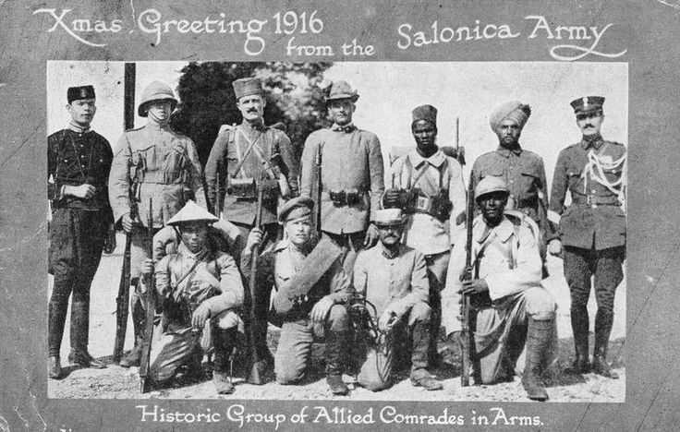
2. This Christmas card from Macedonia in Greece 1916 shows a Sikh (Indian) soldier alongside Greek, French, Italian, Serbian, Montengrin, Russian, British, French North African and French Indochinese comrades. (© IWM (Q 67857))
Indian soldiers also fought alongside different Allied troops in the many campaigns they took part in all over the world.
British leaders praised the courage and devotion to duty of Sikh and other Indian troops.
For example, General Sir Ian Hamilton reported on a battle in 1915 against the Turks at Gallipoli when Sikh soldiers charged an enemy position:
“Not an inch of ground gained was given up and not a single straggler came back. The ends of the enemy’s trenches leading into the ravine were found to be blocked with the bodies of Sikhs and of the enemy who had died fighting at close quarters (close together), and the glacis slope is thickly dotted with the bodies of these fine soldiers all lying on their faces as they fell in their steady advance on the enemy.”
Indian Army soldiers won 9,500 medals in the five main areas where the war was fought, i.e. France and Belgium, East Africa, Mesopotamia (Iraq), Egypt and Palestine, and Gallipoli (they won a further 3,500 medals in India and in the frontier wars). This total includes 11 Victoria Crosses – the supreme award for valour.
By the end of the war a total of 57,000 Indian Army soldiers had been reported dead or missing; 64,000 were wounded.
In the 1919 Victory Parade thousands of members of the British public lined the route from Waterloo to Buckingham Palace to see the officers and men of the British Indian Army who had fought for the Empire. King George V took the salute and thanked the troops for their magnificent services and loyal devotion.
Memorials to all Indian soldiers were erected in Europe, the most famous at Neuve Chapelle in France (opened in 1927) and the Chattri in Brighton (opened in 1921).
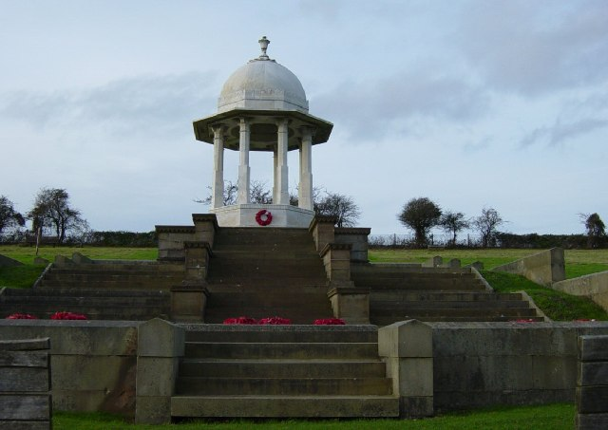
3. The Chattri Memorial today.
A decade later, the British Government in India unveiled the India Gate in Delhi.
After the war some Indian officers were given full army commissions as a reward for their service. This meant they could command white British soldiers for the first time.
Grants of land and money and special pension rights were also given to some Indian officers, on occasion with a guarantee of faster promotion to higher posts.
But…
In reality ordinary British and Indian soldiers did not mix together much during the First World War itself.
Relationships between British and Indian soldiers were mostly limited to British officers who were higher in rank than the Indians they served with.
The British usually thought they were superior to Indians. In a comical ABC guide to the British Indian Army produced just before the war there is evidence of racism towards Indian soldiers.
Here are two of the entries:
- T, for the Tommy (ordinary British soldier), who (much to his joy) refers to the Subadar Major (an Indian officer) as “Boy”.
- Y for the Youth who with pitying sniggers, looks on our Sepoys (ordinary Indian soldiers) as so many “Niggers”.
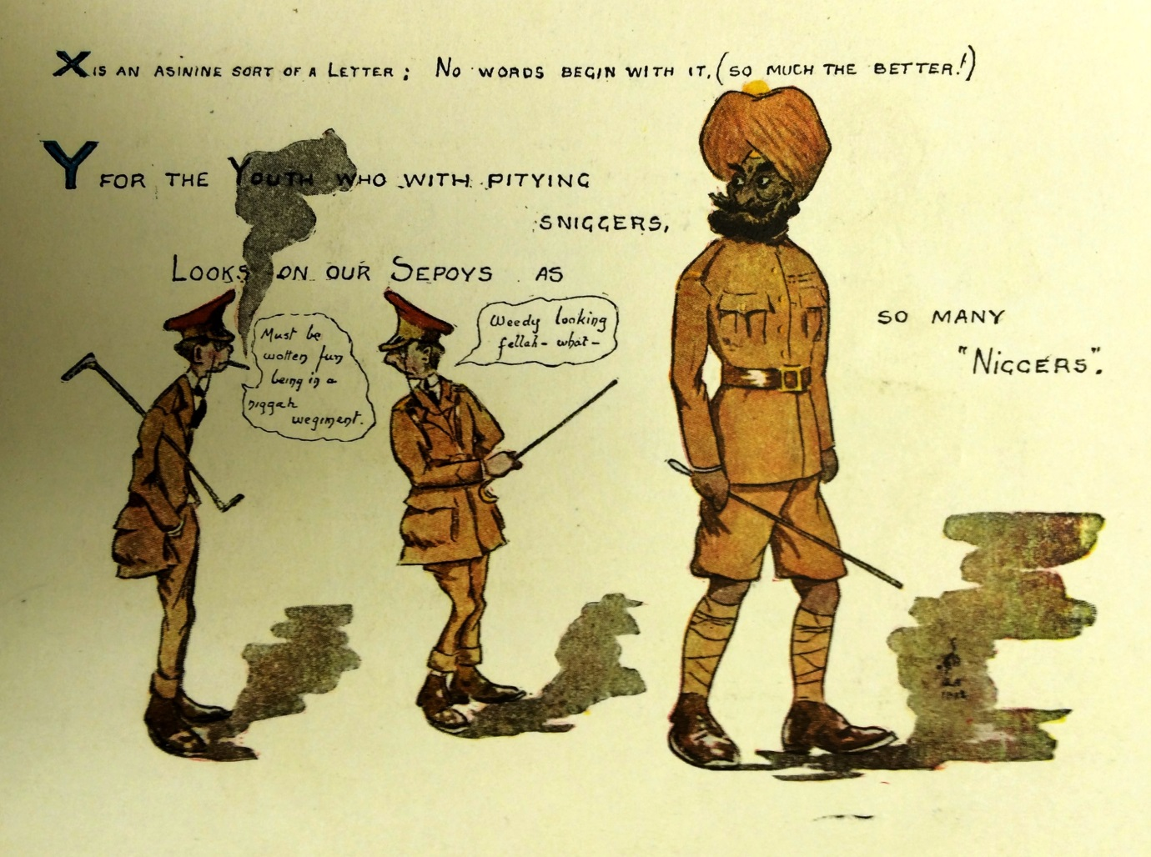
4. The cartoon beginning “Y for the Youth” from the comical ABC guide. (UKPHA Archive)
Indians were to be carefully controlled so that they would continue to obey orders and not get dangerous ideas, e.g. that they were equal to Europeans or might be able to rule for themselves.
During 1914 and 1915 the British government and their generals grew very concerned that the morale of the British Indian Army on the Western Front could not cope with the shock of the fighting, the bad weather and poor conditions. This was why its soldiers were mostly sent to fight in warmer parts of the world for the rest of the war.
The British censored the letters of their Indian soldiers carefully for signs of discontent and low morale.
In a few cases the British could not depend on the loyalty of the whole Indian Army. Some Indian Muslim soldiers mutinied when ordered to fight against their fellow Muslim Turks.

