The German Army produced a booklet for their soldiers which included useful phrases translated from German into Urdu (the language understood by most Indian soldiers including Sikhs).
Notice how some phrases encourage Sikh soldiers to surrender. Other parts of the booklet explained Indian customs so that Germans might understand their enemies better.
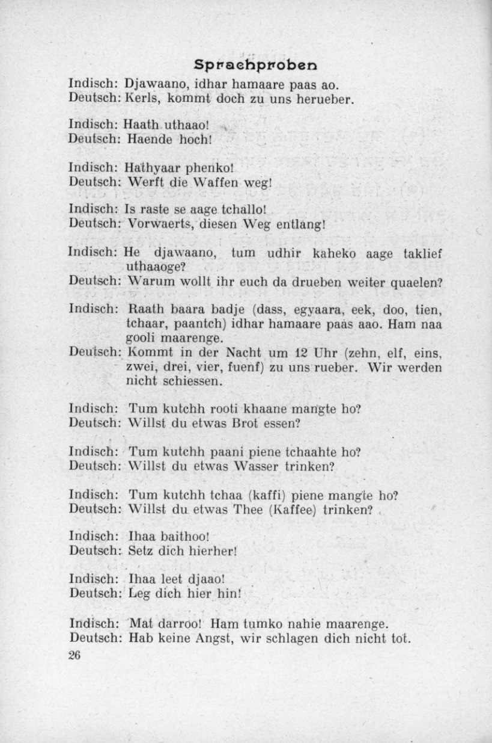
1. Useful Urdu phrases translated in German. (UKPHA Archive)

Urdu Phrases Translated into German
1. Lads, come on over to us.
2. Hands up!
3. Throw your weapons away!
4. Advance, along this path/way.
5. Why do you want to struggle on over there?
6. Come on over to us in the night at 12 [or 10 pm, 11 pm, 1 am, 2 am, 3 am, 4 am, 5 am]. We won’t shoot.
7. Do you want some bread to eat?
8. Do you want some water to drink?
9. Do you want some tea [or coffee] to drink?
10. Sit down here!
11. Lie down here!
12. Don’t be afraid, we won’t beat you to death.

Notes:
Phrases 1, 3-6 address soldiers as a group.
Phrases 7-12 address a single soldier.
Phrase 2 could be either a group of soldiers or just one.

