After the Germans lost the First World War a book was published with pictures and information about the different enemies they had fought.
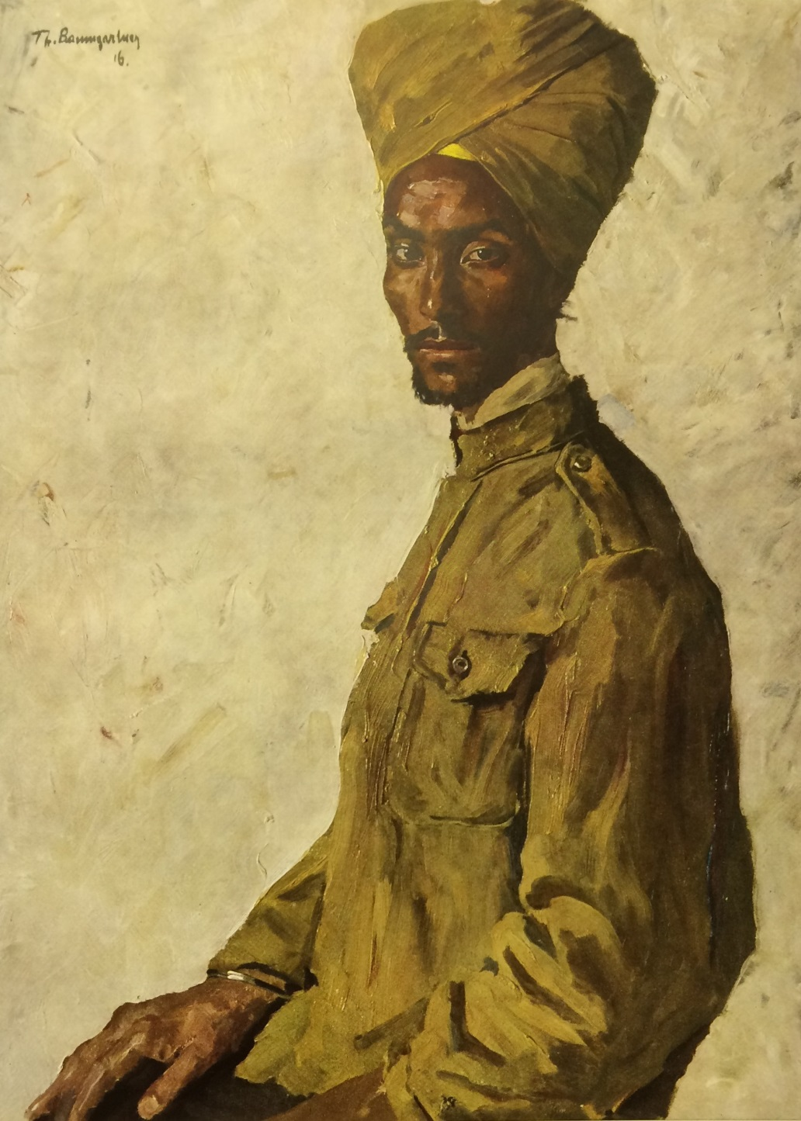
1. A Sikh prisoner of war. (UKPHA Archive)
The publishers thought it might help explain why Germany lost the war. This was what was written about Sikh soldiers:
“…there are regiments that consist solely of Sikhs, others are mixed… The policy of the British-Indian government seems to favour creating mixed regiments, that means putting together a corps (large group of soldiers) of different peoples that are pretty much antagonistic to (hate) each other.
“The Sikh is powerfully built, tall and broad shouldered. His bravery is generally acknowledged, it is even asserted that no Sikh has ever sought to save their skin (save his life) by fleeing (running away). They carry a weapon that is unique to this sect (religion), a blade of thin steel with a razor sharp edge.
“The Sikh turns the blade quickly around his trigger finger (the finger he uses to fire a gun), raises his hand high and hurls the discus (the quoit or circular disc a Sikh soldier wore on their turban) so adroitly (skilfully) that he can cleanly sever (cut off) his enemy’s head from his torso (body)… (in fact Sikh soldiers rarely used their quoits like this during the First World War). Western (European) ways of drilling (marching) has meant the Sikh soldier has almost adapted to the war tactics and has earned a glowing reputation for his exemplary bayonet charges.
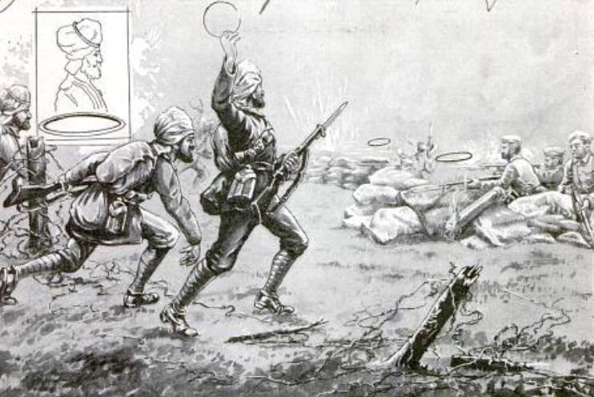
2. Sikh soldiers attacking a German trench with steel quoits. (Courtesy of Ranjit Singh Chohan ‘Freed’)
“A mighty turban is unique to the Sikh and under this, according to religious prescription (rules), he wears his long hair wound up into a knot and held in place by a comb. Beard and moustache are not touched, and if the beard growth is too strong, it has to be twisted up and rolled up on the ears…
“The wide use of gold and silver decorations (for uniforms on special occasions, not in ordinary fighting), along with the different coloured turbans, makes a parade of Indian soldiers a truly impressive spectacle.
“The Sikh is a born soldier; his success in battle is down to military/martial spirit and the area in which he was raised. Gobind Singh, the 10th guru (Sikh religious leader), who welded the Sikhs together into a military unit (turned them into a united force of soldiers), preached (taught) the equal value of a pure way of life, on which he placed the greatest weight (the greatest importance), with brave deeds and submission to the common cause. So for the Sikh there is no higher honour than to die fighting for his beliefs.”
An extract from the book “Germany’s Opponents in the World War” published in 1919.

