The Vickers Machine Gun
The Vickers machine gun is probably one of the most well-known machine guns, used throughout the First World War. Its reliability and ability to mow thousands of men down helped to win battles, and helped to establish its name as one of the strongest, first-rate machine guns of the First World War.
Inventor:
The Vickers machine gun evolved from the original Maxim machine gun, invented and developed by the American Hiram Maxim, who became a British citizen during 1900. After becoming a British citizen, the Maxim machine gun began to be adapted, and was upgraded to keep up with other weapons of the time. The Vickers machine gun was supplied to the British Army by the company; Vickers, Son & Maxim.
Specifications:
The Vickers was a water-cooled machine gun. The main barrel was wrapped in a jacket, which held approximately one gallon of water to continuously cool the barrel. A rubber hose was attached to a special device that helped to condense any steam to make the cooling mechanism as efficient as possible, wasting as little water as possible.
The gun used .303 ammunition (the same as the Lee Enfield rifle of the time), and could fire at a rate of roughly 450 rounds per minute.
The weight of the Vickers varied depending on extras such as muzzle boosters, but the factory weight was about 20 kilograms, plus the tripod, which weighed about 16-18 kilograms. The Vickers had to almost always be used with the tripod extra, to hold it up and support the gun, especially due to recoil.
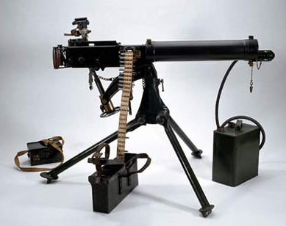
A muzzle booster could be fitted onto the barrel of the Vickers- this attachment would provide additional recoil force to the firing action, which in turn improved the rate of fire, and the propulsion of the bullet.
Throughout the war, Vickers were increasingly being mounted onto planes (the Sopwith Camels and the Spad XIII), and tanks. Due to the fact that they were fitted onto planes, synchronising gear had to be attached, to allow the gun to fire between the rotating propeller blades. On top of this, the water jacket had slits cut into it, which allowed the barrel to be cooled by water, but also the cold air which would be flowing everywhere when the plane was in full flight.
The Vickers also had another extra which was a canvas jacket. This could be fitted around the cooling system, and this canvas jacket reduced rising heat from the barrel, blurring the vision ahead of the men.
The ammunition belt was a 250-round belt- (it held 250 rounds [bullets]).

Advantages of the Vickers:
Firstly, the Vickers was extremely reliable, and was probably one of the most reliable weapons throughout the whole of World War I. This was due to the very high quality of manufacturing, and when in the trenches, the Vickers was simple to use, and so survived very well.
Furthermore, the rate of fire was extremely high, and so could fire more rounds in a hour than the majority of weapons of the time, and due to the cooling mechanism, this allowed the Vickers to continuously fire for hour upon hour, which made huge impact upon the battle and the opposing soldiers.
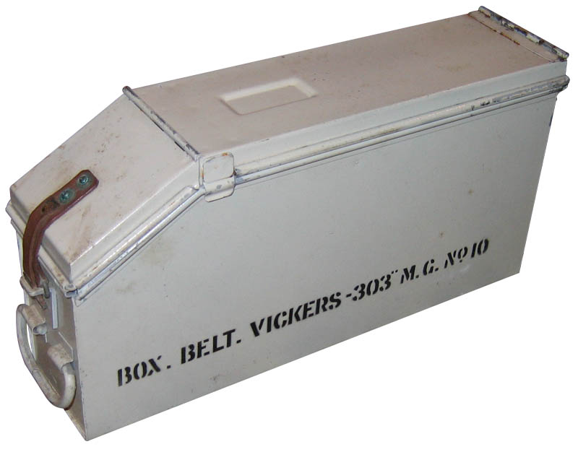
In addition, the parts to the Vickers were so well manufactured and were hard to break or wear out, the Vickers was reliable and the only part if the gun needed to be replaced regularly, was the barrel, as it got so hot when firing continuously.
With the firing rate of 450-500 rounds per hour (.303 ammunition), meant that the Vickers machine gun was sot as many rounds and had as bigger impact as the equivalent of 40 riflemen. This meant a crew of 6 men could produce the same rate of fire and firepower as 40 riflemen per hour.

Disadvantages of the Vickers:
To begin with, the Vickers and its tripod is a very heavy piece of kit. With its tripod weighing roughly 16-18 kilograms, and the gun weighing more at about 20 kilograms, made the transportation and moving of the gun around the battlefield very hard, and a struggle for the men.
Secondly, the Vickers machine gun needed a crew of 6 men; 2 men to carry the equipment (gun and tripod), 2 men to carry the ammunition and 2 spare men on the crew to replace any dead men or to help out the 4 main operating men. These big Vickers crews meant that a lot of men were taken up just for one machine gun, whereas they could have been 4 men in the Vickers crew (no spare men), and the spare 2 men could have become riflemen and this would have been more effective in the long term.
Furthermore, the Vickers machine gun needed a cooling mechanism to cool the barrel and allow it to dire at such as high rate for a long period of time. This cooling mechanism needed one gallon of water every time it was used to cool the barrel. This was a downside as it required a continuous source of water to work, and so the Vickers was only effective where there was a supply of water, which in the middle of the battle field is hard to find.

August 1916: British Army's 100th Company of the Machine Gun Corps:
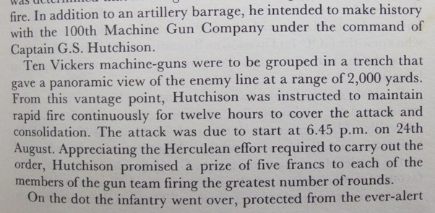
On the 26th August, 1916, the Britsih Army’s 100th Company of the machine Gun Corps managed to fire ten Vickers machine guns for 12 hours solid. Over these twelve hours, they collectively managed to fire 999,750 rounds, just 250 rounds short of 1 million.
These ten Vickers had to sustain fire over a twelve hour period on an area 2,000 yards away to prevent German troops from forming ready for a counter attack whilst the British attack was in progress.
Like shown in the article to the right, Hutchinson made a promise to the men that the machine gun crew who fired the most rounds would receive five francs each as a reward.
The cooling mechanism needed water for these twelve hours for ten Vickers, and they had nowhere near enough water. The men of the corps decided to use all the water from the surrounding area, their drinking water as well as all the contents of every latrine bucket. Any liquid would do for them.
The men also had to replace the Vickers machine gun barrels frequently, and worked their way through 100 new barrels. That’s a new barrel for each Vickers every hour and 20 minutes.
The winning crew of five francs each fired about 120,000 rounds over the twelve hour period.
The final thing that proves the Vickers reliability, quality and what it can stand up to is that all ten Vickers machine guns were still in perfect working order, with no repairs needed after twelve hours of solid fire.

