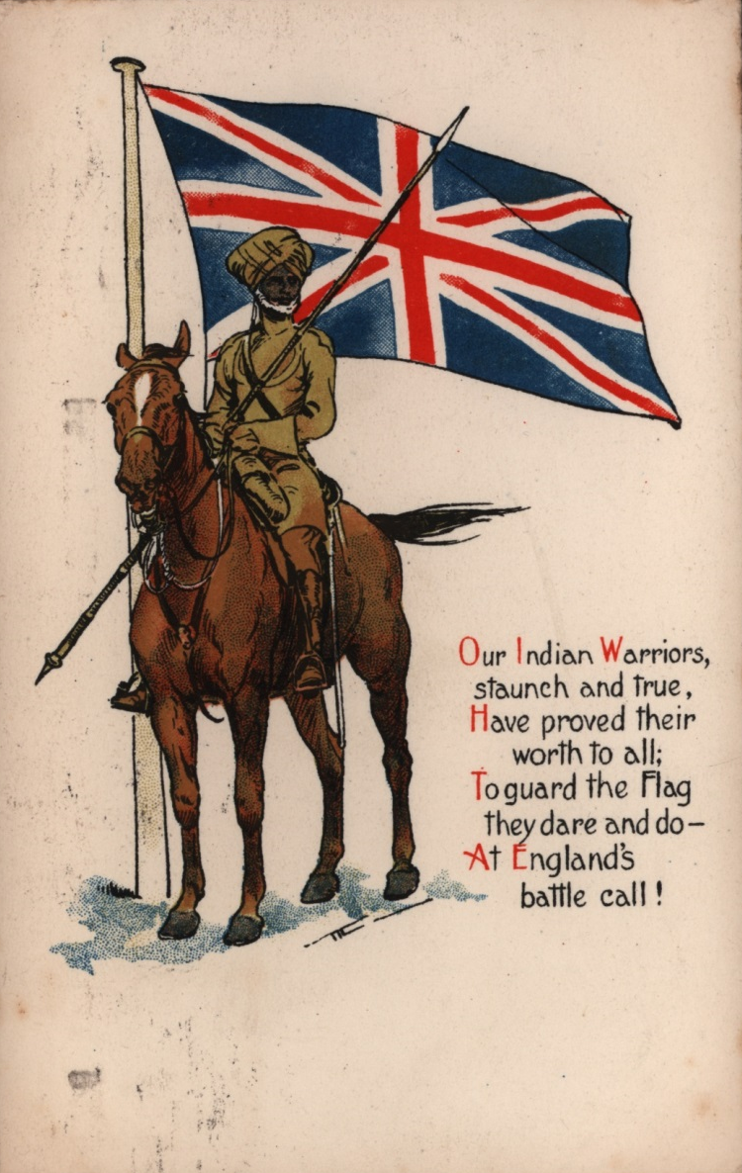
Image
A British postcard with a poem, ‘Our Indian Warriors’, drawn with a Sikh cavalryman (horseman).
The artist may have painted this picture from a photograph.
UKPHA Archive

