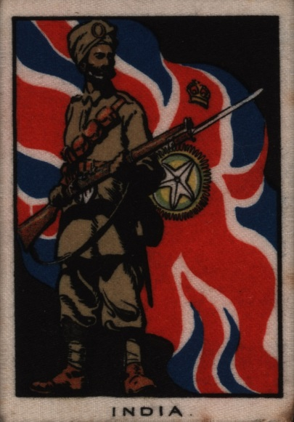

Image
This card is the size of a match box. It shows a Sikh foot soldier standing in front of the flag of the Viceroy of India who ruled the country for Britain.
It was probably sold with a packet of cigarettes. Many British people smoked and built up collections of cards.
The artist may have used a photograph to paint this picture.
Courtesy Satpal Singh Lal

