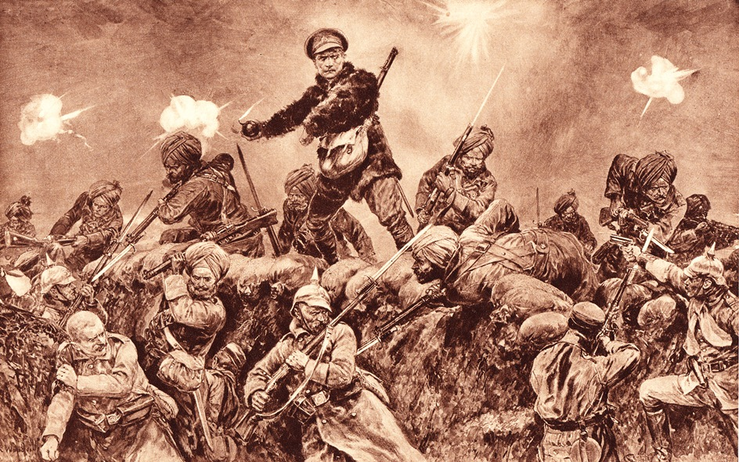
Image
The label reads ‘For the glory of the Raj (the word used to describe the British government in India) Indian troops charging German troops at Neuve Chapelle (an important battle on the Western Front in France), March 1915.’
From ‘Deeds that thrilled the Empire’, a British book published in 1917. The drawing shows Indian Sikh soldiers attacking a German trench lead by a British officer who is preparing to throw a bomb.
The artist probably used his imagination and what he read about the battle to complete this drawing.
Courtesy of Kulwant Singh Bahra Collection

