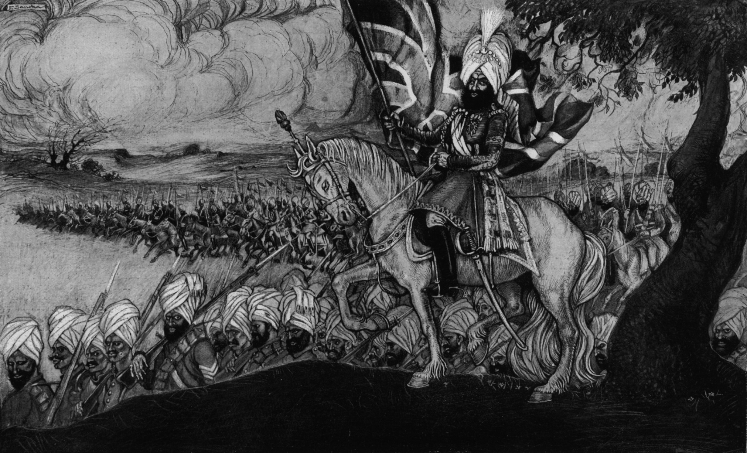
Image
This drawing appeared in a British newspaper. It shows soldiers of the British Indian Army marching to fight against the Germans in Belgium.
The artist probably used a lot of imagination in drawing this picture.
UKPHA Archive

