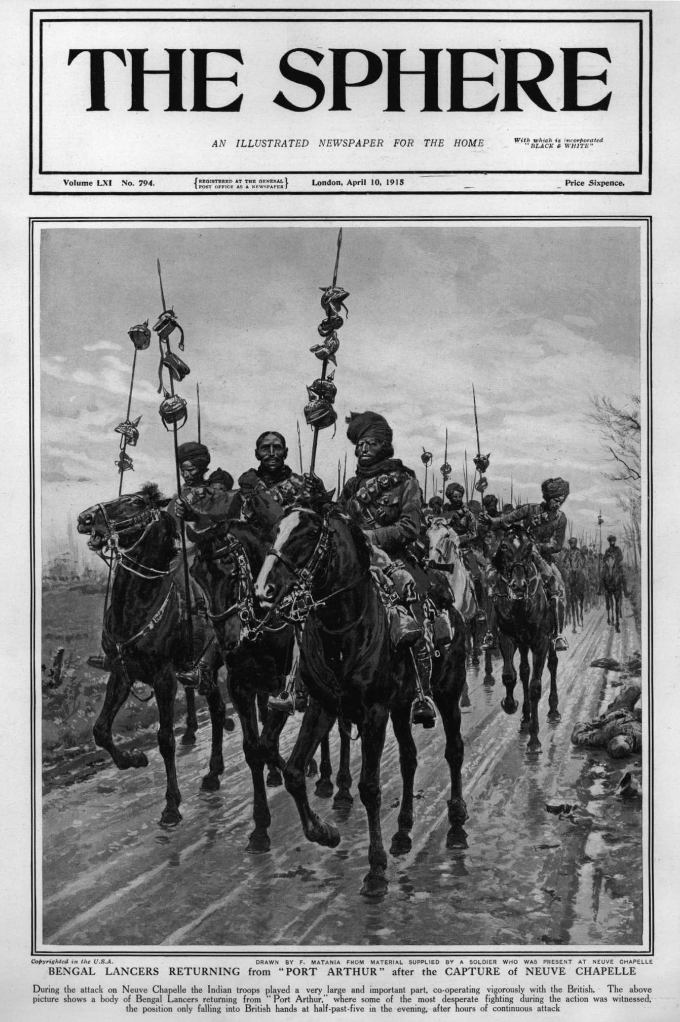
Image
This drawing shows Indian horsemen (called cavalrymen) returning from an attack against the Germans. They proudly display German helmets taken from dead German soldiers (or perhaps German prisoners of war) which are attached to their lances.
‘The Sphere’ was a popular newspaper.
The artist seems to have drawn this picture from information given to him by a soldier who fought in the battle.
UKPHA Archive

