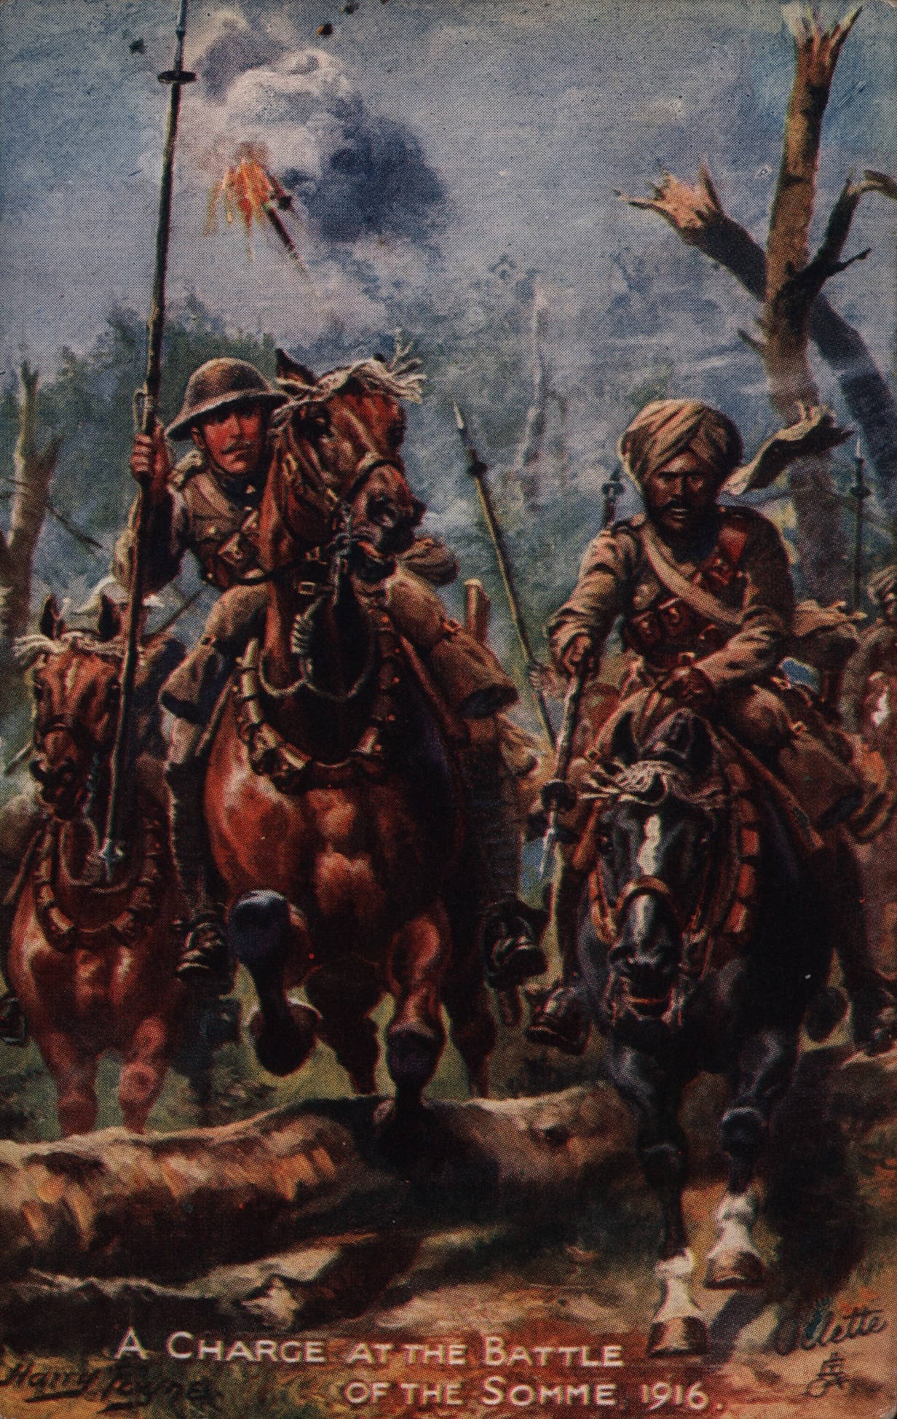 Image
A British postcard shows an Indian Sikh horseman (a cavalryman) charging at the Battle of the Somme on the Western Front in 1916 in France with a British officer.
He was part of the Deccan Horse, the name of a regiment (a particular group of soldiers) in the Indian Army.
The artist probably used his imagination to paint this picture.
Courtesy of Peter Bance Collection

