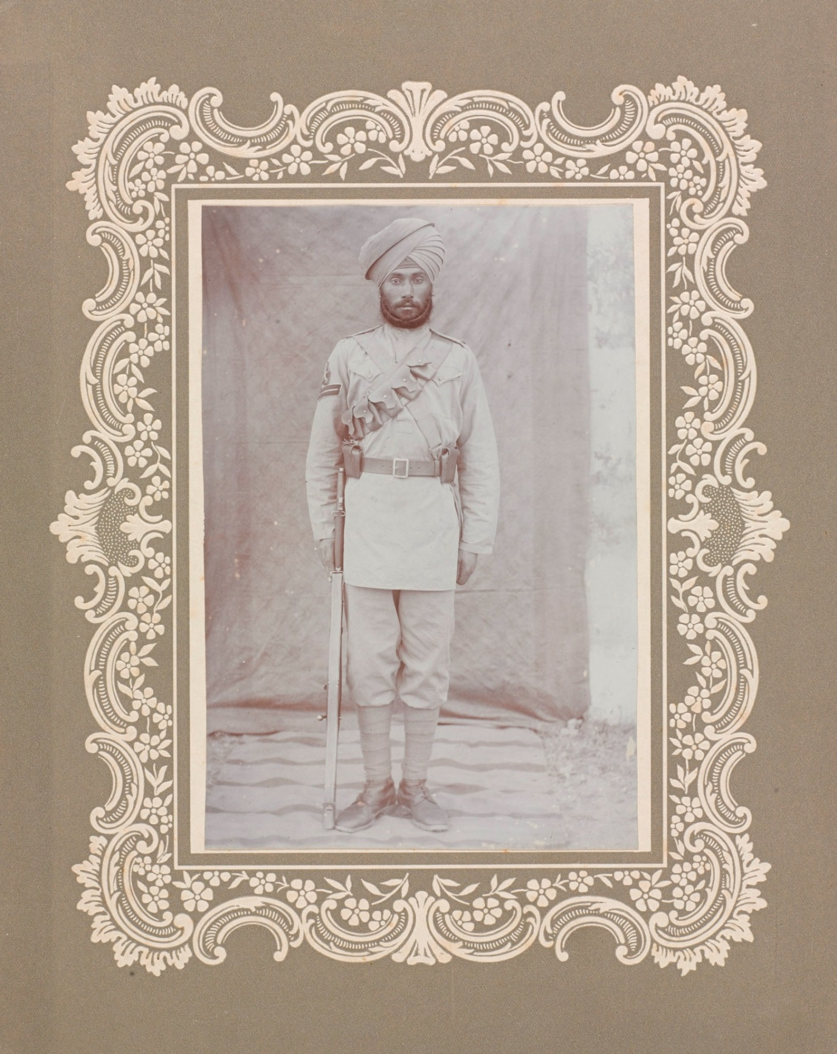
Image
A typical Sikh naik (the same type of soldier known as a corporal in the British Army who was responsible for a small group of other soldiers), c. 1910.
This soldier was part of a group of Indian Sikh soldiers called the 14th Ferozepore Sikhs.
Courtesy of the Council of the National Army Museum, London (acc. no. 1994-05-50-716)

