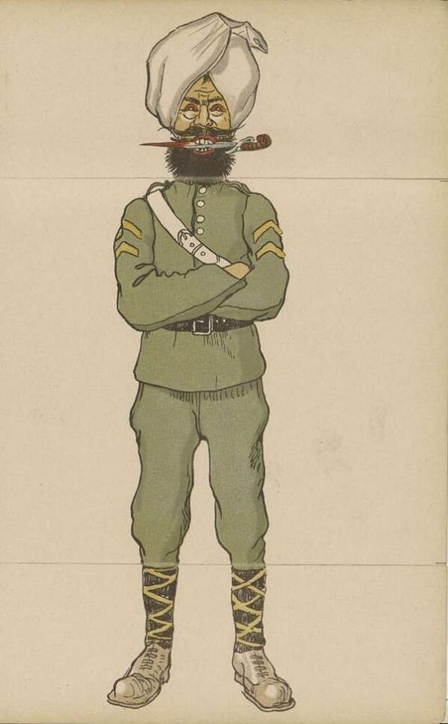
Image
A blood thirsty depiction of a Sikh soldier from a German children's picture book of 1914 entitled “Our Enemies”.
Courtesy of Robin Schäfer, Military Historian, Dinslaken, Germany

