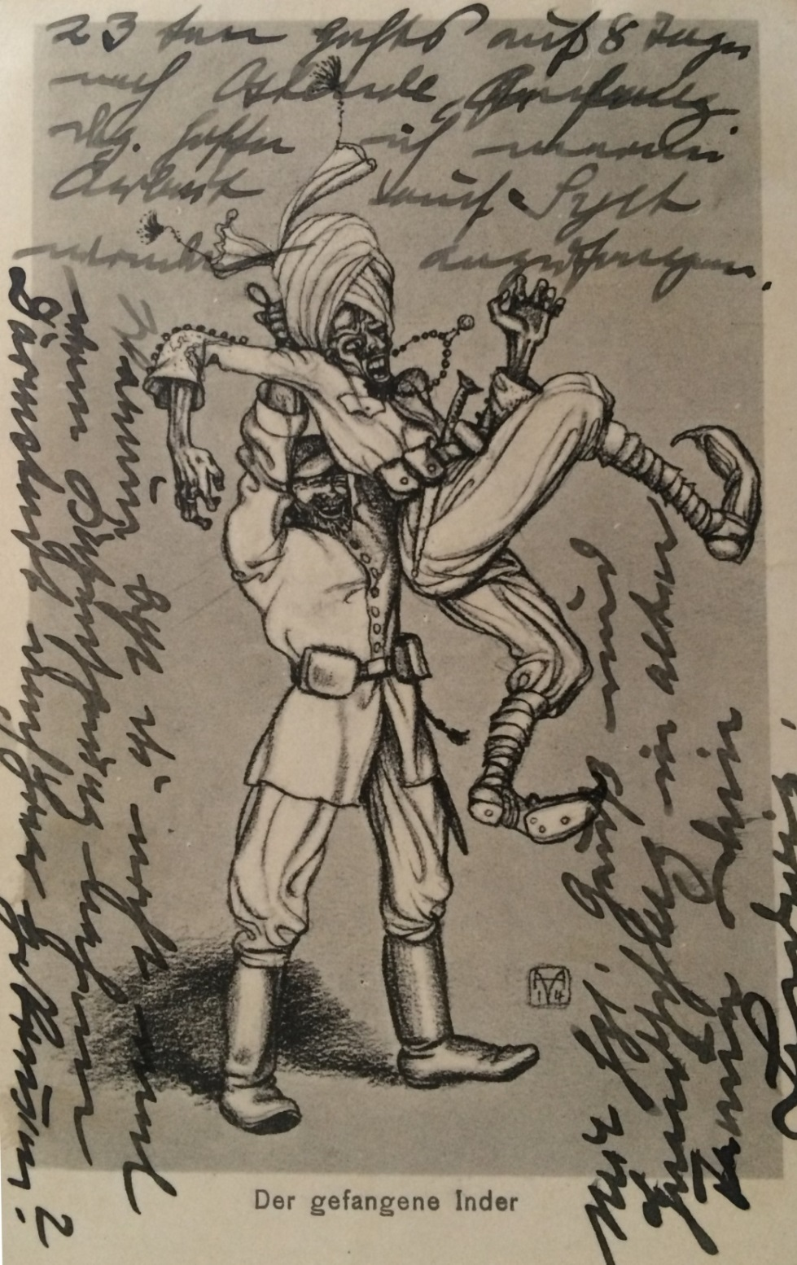
Image
A German postcard from early on in the war with an image of a German soldier holding a captured Indian soldier.
By kind permission of Timothy Moore

