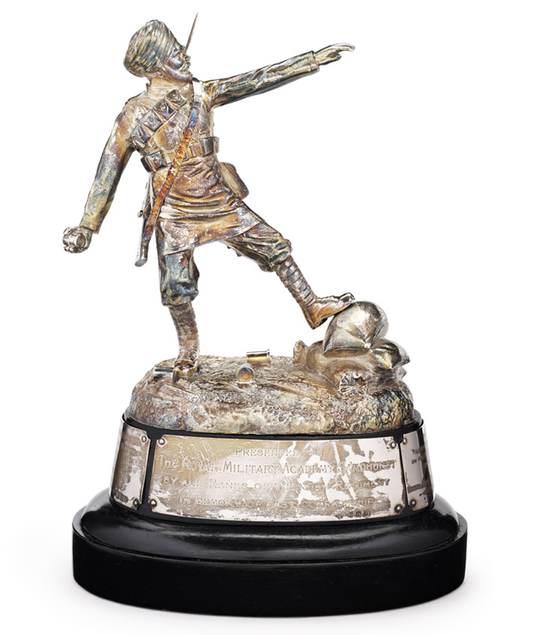

Image
The Sepoy Mohan Singh Trophy, showing the Sikh soldier preparing to throw a grenade during the First World War.
It was created by British officers of a Sikh Indian regiment of the British Indian Army (14th King George’s Own Ferozepore Sikhs), which took part in a battle of the Gallipoli campaign against Turkish forces.
Courtesy of the Council of the National Army Museum, London (acc. no. 1951-07-23-1).

