

***Understanding the Kindertransport***

* *The context*
* *The purpose*
* *The impact*

[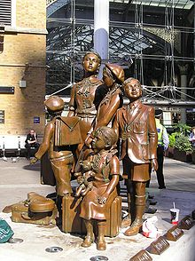](https://en.wikipedia.org/wiki/File:Kindertransport-Meisler.jpg)+

***English***

***Drama: Holocaust Memorial Day***

***School Assembly.***

***(Takes it’s inspiration from the visit to The Journey by the class.)***

***English:***

***Guided Reading: Our Lonely Journey***

***History.***

***WW2 – Experiencing Evacuation***

***Evacuees from Overseas***

***WW1 - What was the impact of WW1 on Germany?***

***Life in Germany in the 1930s for Jews.***

***THE JOURNEY***

**Understanding Leo’s Story – applying classroom learning to discussions and questions.**

**LIVE WITNESS – Linking events/learning to real people**

**RE***:*

***Judaism - Inspirational People from the Past – Moses – Flight from Egypt.***

***Jewish Festivals: - Passover***

***The importance of religion in people’s lives.***

***PSHE***

***Stephen Lawrence Story – understanding Discrimination, Stereotyping and Propaganda.***