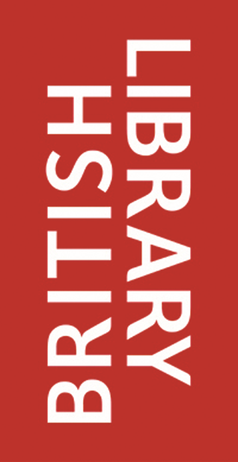
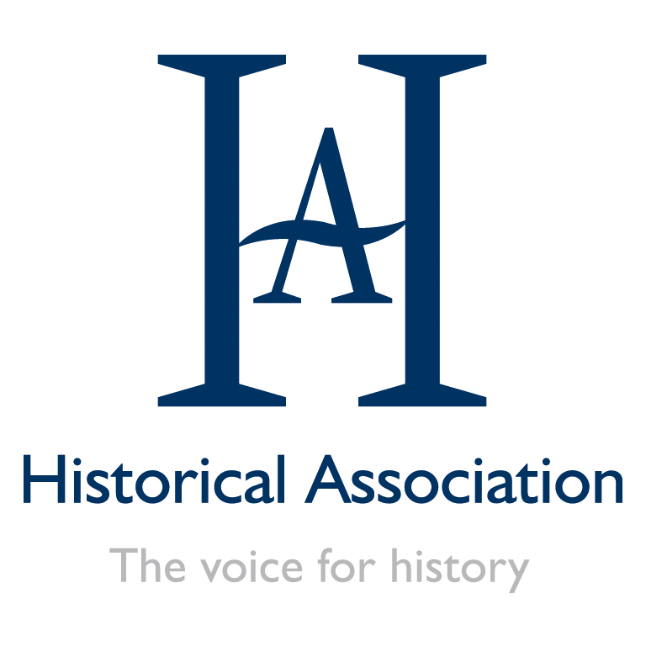

New Perspectives on the 20th Century
Saturday 4 February 2016
British Library, London

New Perspectives on the 20th Century: Programme
10.00-10.30am Registration and refreshments
10.30am– 10.40am Welcome and introductions
10.40am–11.20am British Library introduction to 20th century maps
In this talk, which includes an overview of the current exhibition, The British Library will explore the important role maps played during the 20th century through conflict, peace, and in everyday lives. The talk will consider the importance of maps as agents of change in a century when shifts in education made people more map literate than ever before, with huge implications for where we are today. The session will explore the fresh perspectives these maps can offer on 20th century history.
11.20-11.40am - Coffee break
11.40am–12.40pm Workshop 1
Ben Walsh, Education Consultant
Conflict in the 20th Century: The challenges of teaching the Cold War
A look at new historical thinking on the Cold War and how it might be brought into the classrooms, including new source collections and a range of activity ideas.
12.40-1.30 - lunch and opportunity to explore the British Library exhibition: 20th Century Maps: Drawing the Line
1.30-2.30pm Workshop 2
Alf Wilkinson, Education Consultant
Mapping the First World War
How do maps offer new perspectives that help our understanding of the First World War 1914-1919?
2.30pm–3pm Maps and digital humanities: British Library Labs showcase digital content range for use in the classroom over coffee.
3-3.30pm Plenary keynote – Dr. Jessica Reinisch What Matters Most about the 20th Century?
Dr Jessica Reinisch leads The Reluctant Internationalists research group at Birkbeck, University of London and is the academic lead for the Historical Association’s 2017 Teacher Fellowship Programme: The Cold War in the Classroom.
3.30pm– Close and final opportunity to return to the British Library exhibition

