History homework … at primary school?
See how one international Quality Mark school has used regular history homework to foster enthusiasm and progress in history.
Set overlooking the Mediterranean Sea in Cyprus, Episkopi Primary School has approximately 350 children who benefit from being immersed in the rich and vibrant history of this beautiful island.
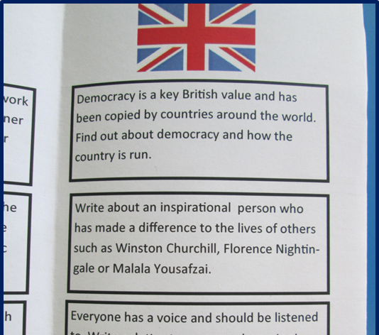
History enjoys a high status in the school, explains history coordinator, Rebecca Ross. Rebecca is very knowledgeable and organised about what she aims to achieve in the subject. She supports new staff in teaching a new topic well, using her wealth of experience and novel ideas to bring history alive. At a recent Quality Mark assessment visit, all around the school there was evidence of engaging events, exciting experiences and challenging children’s work demonstrating the wide range of history-based projects the children undertake throughout the school, all supported by the head-teacher and governors.
Children at the school are extremely enthusiastic about history and the school maintains this momentum despite the transient school population. One of the key ways that the school achieves this is through the setting of regular history homework through a series of take-away menus. While the homework take-away is not a new idea in secondary schools and some middle schools, it is less usually found in primary schools and certainly not related to history, with any homework often being dominated by English and maths.
In her previous school, Rebecca had seen and developed the ‘Take-away Homework Menu’ and was keen to replicate its success in her new school setting.
A new menu every half term!
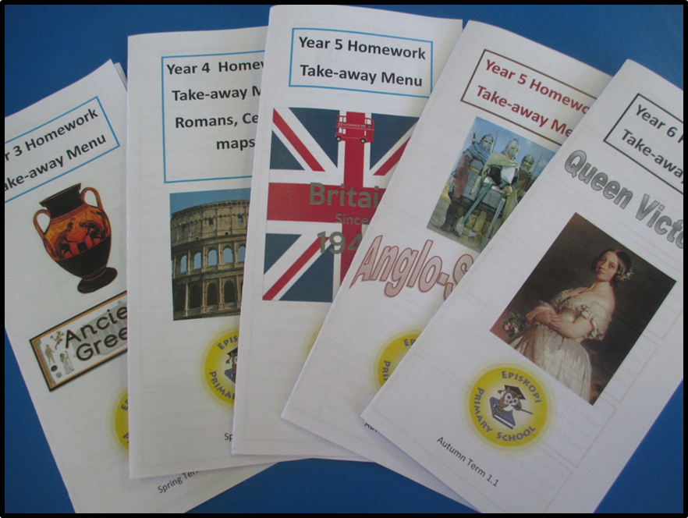
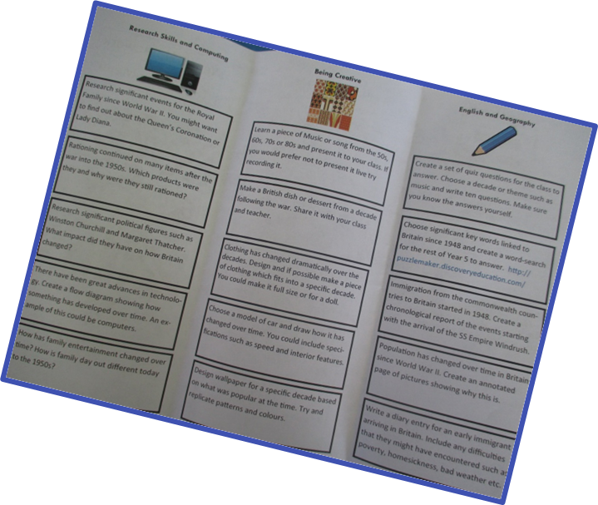
An example demonstrating cross-curricular activities
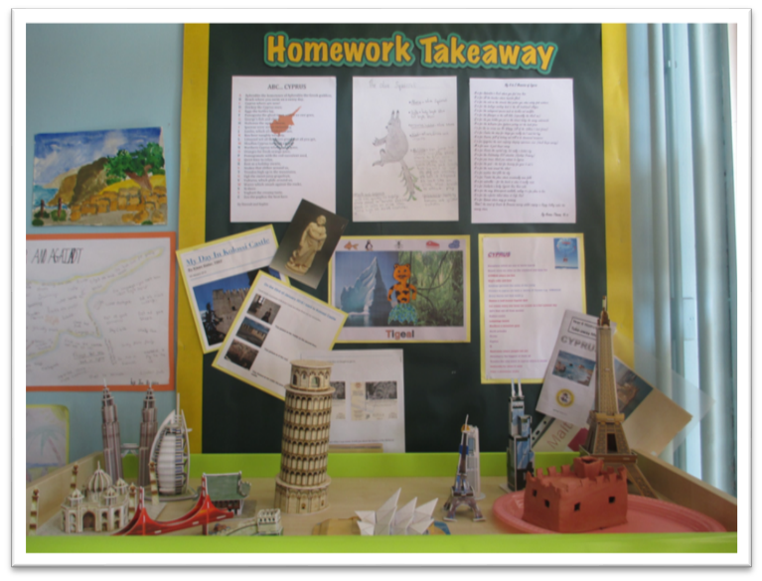
An instant display!

The history homework take away menu allows the children choice and ownership of their learning explains Rebecca. Each term, related to the history topic/s that they are studying, children select from a range of tasks on a homework take-away menu. Each take-away menu aims to:
* Provide activities that are fun and inspire children to want to learn more about the period of history they are studying
* Allow for progression in some of the key historical concepts
* Create opportunities for ownership and choice
* Provide activities which encourage parental involvement and discussion
* Provide some cross curricular approaches that consolidate and reinforce skills and understanding
A wide range of options encourages extended writing, research and development of understanding of the period as well as making cross curricular links.
The homework take-away menus have been well received by both pupils and parents alike. The visiting assessor noted the examples of work produced throughout the school and talked to pupils who were very enthusiastic about what they had created. They also liked the idea that because not every child was doing the same homework task at the same time, they could learn from one another too.
Parents agreed that the range of submissions offered is great. They encourage internet and hard copy research to identify the most interesting topics and areas. Home work at Episkopi is now a truly family event with many parents commenting on the enjoyment of getting involved and sharing the learning with their child. They also commented on the fact that, as an added bonus, their children were learning new and valuable skills along the way.
The homework take-away menu is an idea that some schools have already adopted as standard in other subject areas and indeed some in history, although these are few and far between. The tasks chosen need careful thought and preparation to maintain a balance between creativity and fun as well as achieving the intended objective – enabling pupils to make progress in history, and this has to be at the forefront of any take-away menu design.
With careful thought when planning the purpose of each task, you too can achieve the same results as Episkopi Primary:
- Children who are enthused about history and their learning
- Children who feel ownership of their learning in history
- Positive relationships with parents and carers
- Progression in children’s depth of understanding in history
- Progression in the key concepts relating to history
- Progression in children’s independent research skills
- Cross-curricular skills

Of course as with any successful initiative, it takes time to get it right. Rebecca emphasises:
We want to ensure that all children are fully engaged and developing their history learning outside of school. Activities are carefully selected to meet the children’s interests and learning styles. It was important for us to consult with the children and pupils throughout the process particularly as parental involvement is required for some of the homework pieces. There were initial concerns about resources and time, but families have been very creative and the homework take-away has been well received.
Introducing the homework take-aways has been a great success as the children have shown such creativity and enthusiasm resulting in quality pieces of work. There is something for everyone on the menus; the work produced fully supports the classroom learning and allows for the rest of the family to get involved too. Once up and running, it is a simple and effective way to explore history further through a creative and collaborative approach. The homework take-aways have really enhanced the curriculum and make a great instant display at times too!

Homework is fun!
