History Education and Transatlantic Colonial Slavery
1 June 2017
10:00am-5:00pm
Wilberforce Room, Museum of London in Docklands

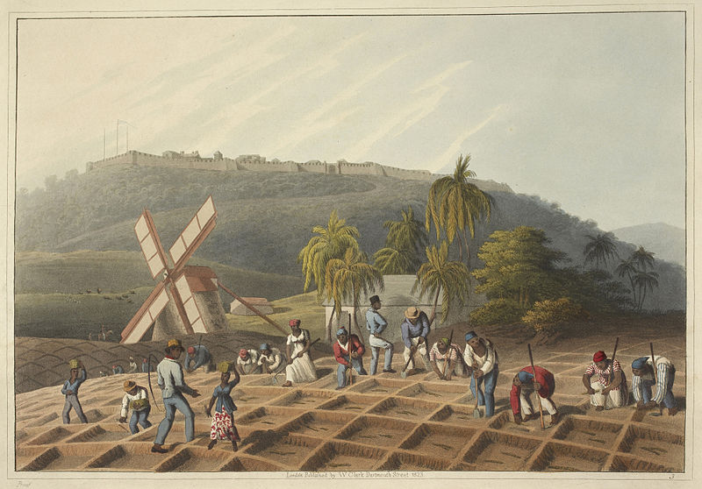
Image taken from Ten Views in the Island of Antigua, in which are represented the process of sugar making, and the employment of the negroes... From drawings made by W. Clark, etc. (With descriptive letterpress), London : Thomas Clay, 1823. Image © British Library.

We would like to invite you to a workshop on the 1 June 2017 focused on new approaches to teaching the history of transatlantic colonial slavery.
Transatlantic slavery and its abolition continues to be taught widely in secondary schools across Britain. This workshop is designed to give teachers and other education professionals access to current academic scholarship and new pedagogical approaches to teaching this history. The event will contribute towards building a network of educators to offer leadership for the transformation of teaching and learning about transatlantic slavery in our schools and other educational environments. This workshop will be an opportunity to share ideas and to think about the development of guidelines for effective practice and scholarship that can be available to schools in the coming year.
Registration is free and lunch and refreshments will be provided. Please book your place here:

https://www.eventbrite.co.uk/e/history-education-and-transatlantic-colonial-slavery-tickets-34567567525

This event is funded by the British Academy and is a partnership between the Antislavery Usable Past project (University of Nottingham), University College London-Institute of Education, Justice to History, and the Centre for the Study of the Legacies of British Slave-ownership, University College London.

9:30-10:00 Registration (Refreshments served)
10:00-10:10 Welcome

10:10-11:10 Session 1: Historicising Race (60 minutes)
Speaker TBC
Session focus: Political and moral dimensions of teaching about transatlantic slavery
Key questions: Why should we teach about slavery and colonialism? Why should we engage with race and how should we frame the engagement? What events and historiographical debates are key to our understanding of the constitution of race over time? How and why should we acknowledge race and racism in the classroom?

11:10-11:25 Break (Refreshments served)

11:25-12:55 Session 2: Transatlantic Slavery: Pedagogical Approaches (90 minutes)
Abdul Mohamud and Robin Whitburn (Justice to History / UCL-IOE)
Session focus: The pedagogical dimensions of teaching about the transatlantic slave trade and New World colonial slavery.
Key questions: What are the pedagogical challenges of this work? How should we approach issues of empathy, race, activism and uniqueness?

12:55-13:55 Lunch (Food served)

13:55-14:55 Session 3: Legacies of British Slave-ownership (60 minutes)
Nick Draper and Rachel Lang (Centre for the Study of the Legacies of British Slave-ownership, UCL)
Session focus: New historiographical developments in the field of transatlantic slavery and abolition.
Key questions: Where does slave-ownership fit into the national narrative of Britain’s involvement with transatlantic slavery? How does this research feed into current debates on slavery and its abolition? How does this shift in focus change the way we think and teach about slavery? What resources are there to support teaching about British participation in transatlantic slavery?

14:55-15:10 Break (Refreshments served)

15:10-16:40 Challenging 2007: Representation and Remembrance (90 minutes)
Local Root / Global Routes: Toyin Agebtu (Ligali), Lucy Capes (Hackney B Six), Katie Donington (University of Nottingham), Kristy Warren (University of Nottingham), Emma Winch (Hackney Museum)
Session focus: Understanding the historical, political and cultural dimensions of the role of representation and remembrance in the classroom.
Key questions: What issues are at stake in the representation of slavery (race, class, gender, nation, empire)? How can we develop strategies of representation that are both appropriate and critical? Whose voice shapes our understanding of the historical narrative? How can we include multiple voices and perspectives? Are there ways of working across institutions and disciplines that can open up new avenues of representation and remembrance?

Each 60 minute session will involve:
- 40 minute presentation by speakers
- 20 minutes audience responses
The 90 minute sessions will also involve:
- 30 minutes small group discussion around tables feeding into the development of ideas for writing a set of guiding principles for the teaching of transatlantic slavery

