1.3- The department uses a range of resources to deliver the planner curriculum.
3.6- The department schemes of learning include a whole range of activities designed to support our students in developing their understanding of historical content and concepts. Some examples of student work and activities are shown below.

Carousel activity about viruses for GCSE medicine.
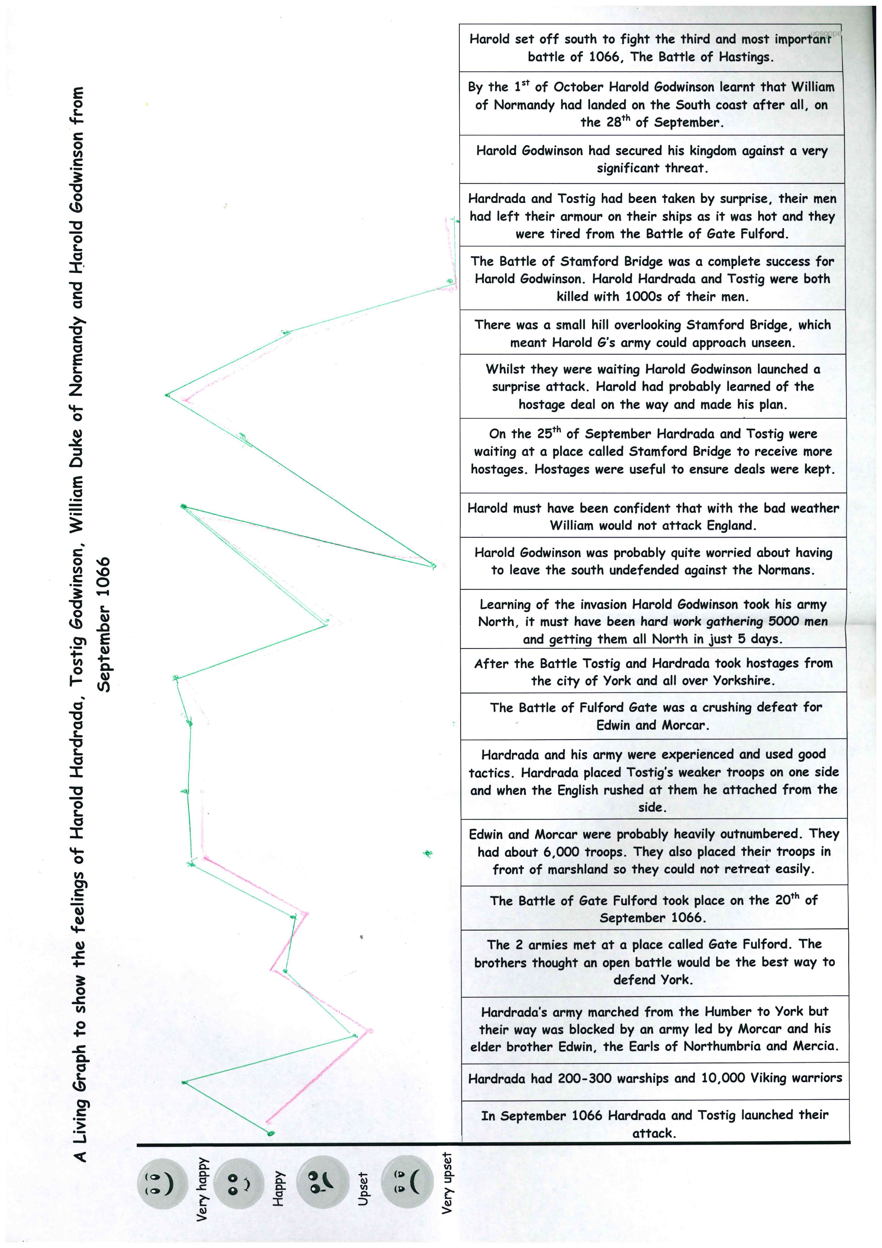
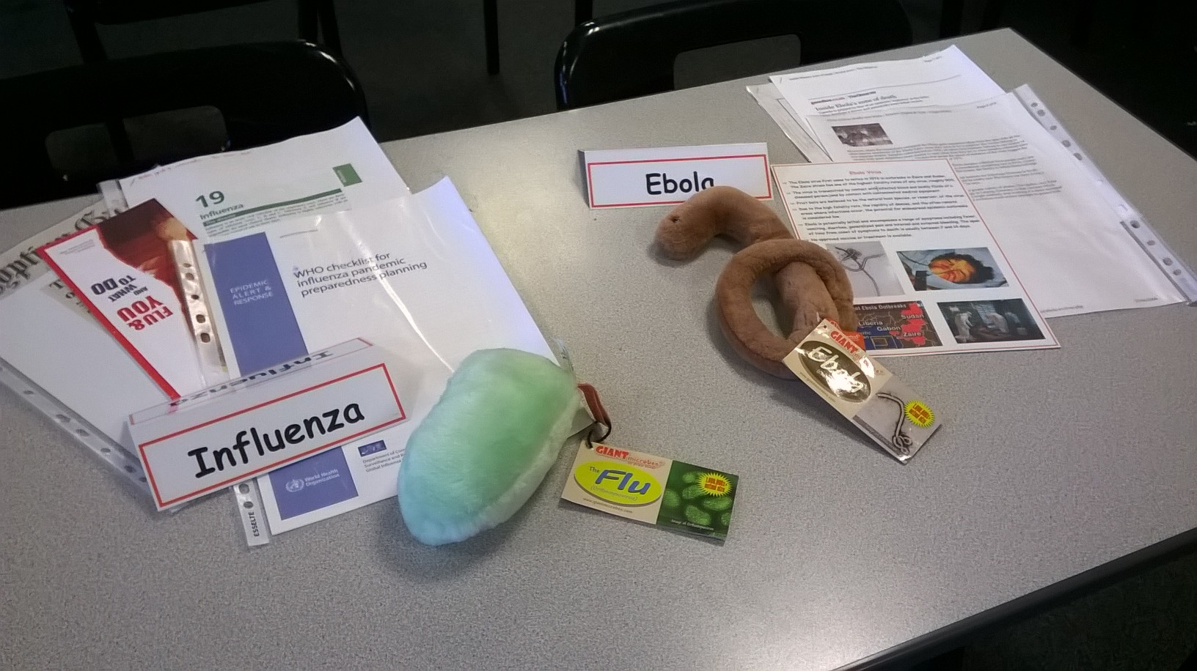

Living graph activity about the Norman Conquest

Locating information about a topic and marking its location in the text with a numbered sticker before deploying it in an exam answer
