Sunken Settlements – Introduction to the Schemes of Work

- The scheme of work takes aspects of the experience of Year 6 pupils at Hampton Vale so that other schools can take their pupils on a comparable learning journey, borrowing freely or adapting resources as they wish. It cannot replicate the visit to the British Museum exhibition since this has closed and it does not assume that pupils can necessarily visit Flag Fen Archaeological Park (although one is highly recommended).The scheme of work (or aspects of it) could be competed on collapsed days and/or after SATS as a challenge for Year 6 pupils who will soon be making the transition to History at Key Stage Three. It could also be directed specifically at more able or gifted and talented pupils.
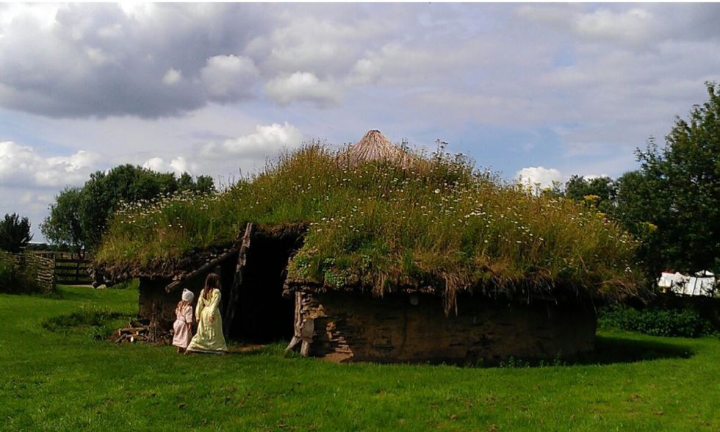
Photo credit: Midnightblueowl
- The scheme of work can be taught as a stand- alone depth study. However it can also draw upon any prior learning from other Key Stage 2 History Units. These include Ancient Egypt (pupils might have already studied this civilization in depth, focusing on details such as religion, the system of government, mummification etc- Sunken Settlements refers to the final phase of Ancient Egyptian history between 1,000 BC and 0 AD when during which it was ruled by Persian, Greek and Roman invaders), Ancient Greece (pupils might have already studied aspects of Ancient Greek history such as religion, the rival city states of Athens and Sparta, Greek myths and legends etc -Sunken Settlements links to Greek colonization of the Mediterranean world between 1,000 BC and 0 AD, particularly after the conquest of Egypt by Alexander the Great in 332 BC and the subsequent establishment of the Greek Ptolomy dynasty)and Britain during the Stone Age, Bronze Age and Iron Age (pupils may have studied the rise of farming during the New Stone Age or Neolithic period, the development of Bronze Age religion at Stonehenge etc- Sunken Settlements specifically refers to Bronze Age life in the Fens of what is now Peterborough between 1,000 and 800 BC)
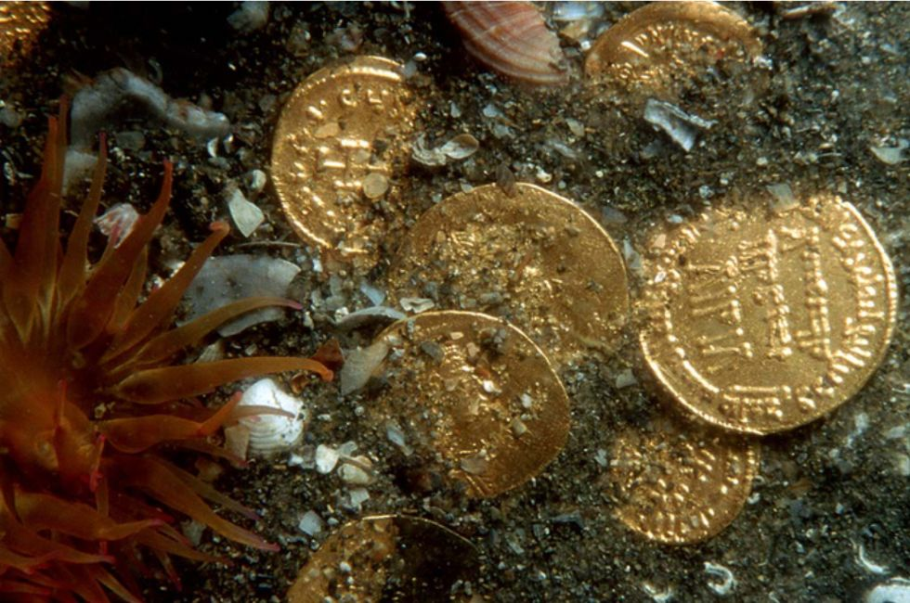
Photo credit: Christoph Gerigk; © Franck Goddio /Hilti Foundation
- It models how an element of local history, based on a rich local site can link to and reinforce other history units. Flag Fen and Must Farm are unique sites but there are other prehistoric or later sites in different parts of Britain that can be used to develop effective local history.

- The scheme of work shows how elements of international, British and local history can be effectively linked, helping pupils to develop their own “maps of the past”. The content linked through particular combinations of study units may be different but the scheme of work models how this can be done, connecting a usually well- resourced study unit such as Ancient Egypt with an internationally important local site.
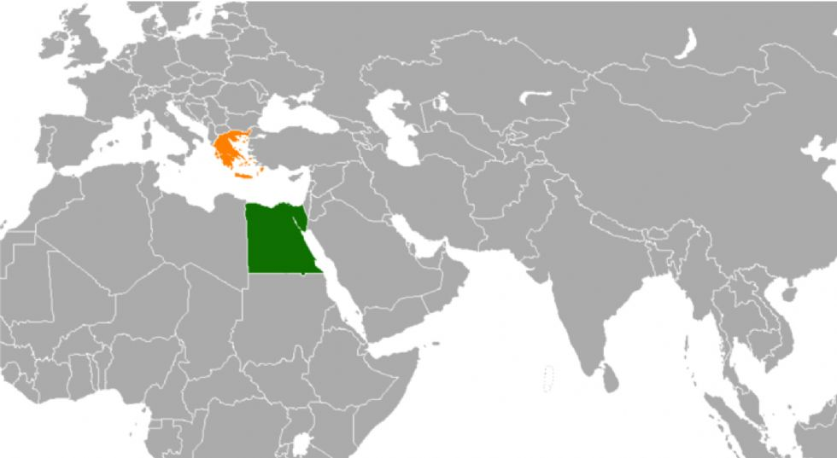Photo credit: Groubani
- Teaching and learning activities have been grouped around a series of historical enquiry questions, which build up through a sequence of learning, consolidating what has gone before and drawing on the prior learning from preceding enquiry questions. The length of time taken to complete each enquiry will partly depend on the number of activities a teacher chooses to use or adapt.
- Five Main Enquiry Questions have been formulated to convert what otherwise might be a particular content heading, such as ‘The Must Farm excavation’, into an often open-ended enquiry question, like ‘How did archaeologists lift artefacts from the mud at Must Farm?’
The five questions are;
How did Franck Goddio rescue hidden treasures from the sea? (Enquiry- handling evidence)
How Egyptian were the lost cities of Thonis-Heraklion and Canopus?(Similarity and difference)
How did archaeologists lift artefacts from the mud at Must Farm? (Enquiry-handling evidence)
How similar and different was life in Thonis-Heraklion and Canopus compared with Must Farm? (Similarity and difference)
What should we put in our museum exhibition? (Historical Interpretations)
- Each question has been shaped by particular historical concepts that underpin the teaching of history as a discipline in schools. These are set out in the National Curriculum for History (2014). Christine Counsell refers to the process of devising such enquiry questions based on concepts as ‘concepts turn content into problems’. By this she means that when a content heading is converted into a question, it sets up an historical problem for pupils to solve, based on a particular subject-specific concept or concepts.
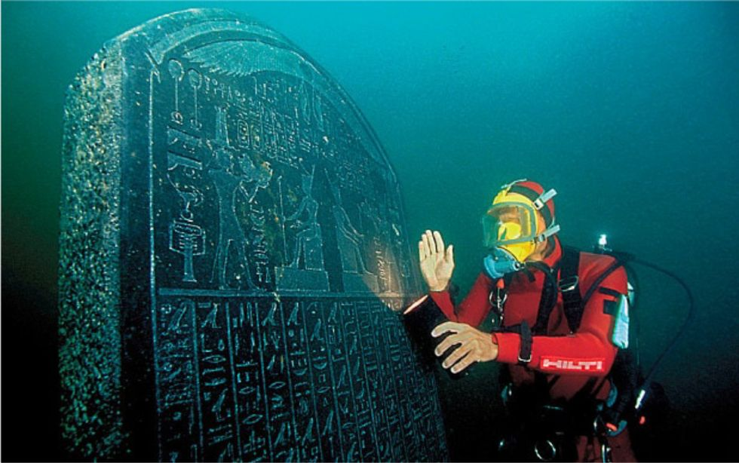Photo credit: Christoph Gerigk; © Franck Goddio /Hilti Foundation
- Schemes of work clearly identify a range of particular concepts being addressed through each enquiry question (it is not possible to address all of them through one question). The general thrust of subject-specific concepts in history is to encourage rigorous higher-order thinking. This is well summarised in the aims set out for teaching history in the National Curriculum for English state schools: ‘Teaching should equip pupils to ask perceptive questions, think critically, weigh evidence, sift arguments, and develop perspective and judgement.’ The following concepts in particular have influenced the framing of the enquiry questions in the scheme of work: handling evidence (enquiry), historical interpretations, characteristic features of a period, making links within and across periods, similarity and difference.
- Sunken Settlements as a project realized the importance in teachers being well informed about the substantive subject knowledge they would be teaching. Two summaries of the historical backgrounds to both excavations have been included in the resources.
- The learning objective under each Main Enquiry Question frames the main focus for that particular enquiry. These objectives are deliberately couched in generic, not content-specific, terms.
- A series of learning outcomes describe the specific outcomes that pupils should have achieved or participated in by the end of that Main Enquiry Question. After each outcome, reference is made in brackets to the historical concept or concepts it is linked to.
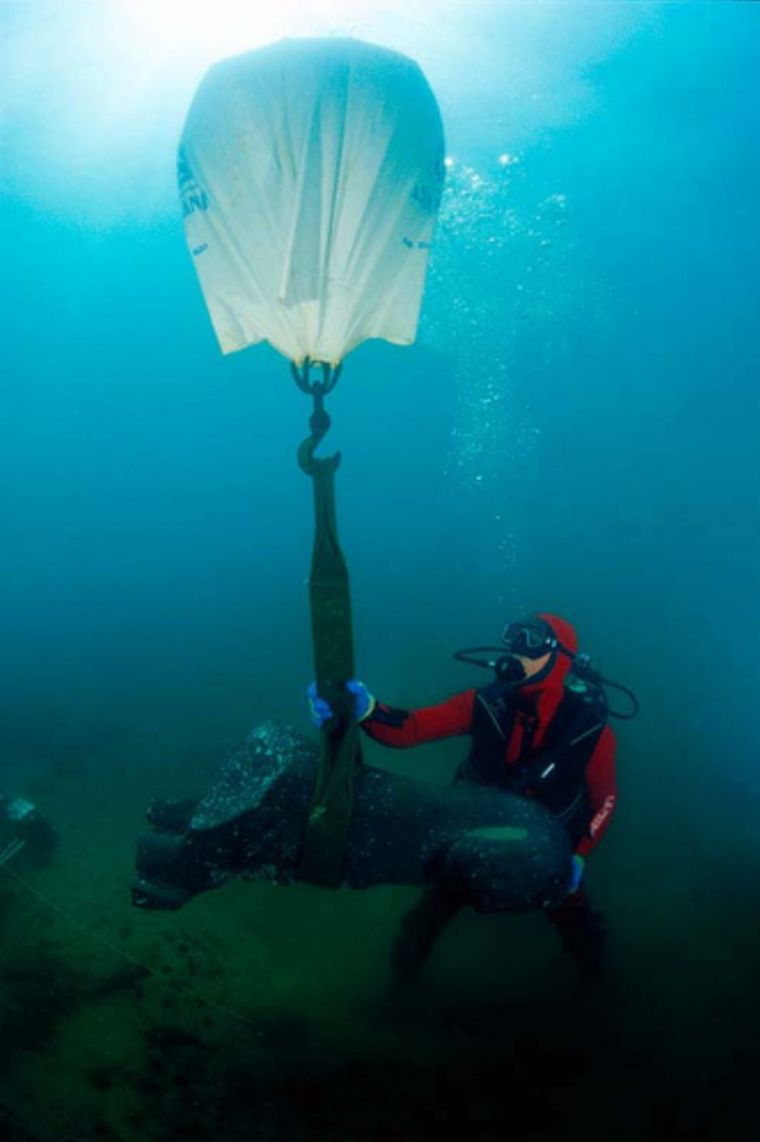
Photo credit: Christoph Gerigk; © Franck Goddio /Hilti Foundation
- The scheme of work for history culminates in a creative outcome, which can be completed by individuals or groups of pupils, in answer to the final Main Enquiry Question, This approach reflects the following definition of the process of historical enquiry from Dr Michael Riley, Director of the Schools History Project: ‘A planning device for knitting together a sequence of lessons, so that all the learning activities – teacher exposition, narrative, source-work, role-play, plenary – all move toward the resolution of an interesting historical problem by means of substantial motivating activity at the end.’

