Must Farm Bronze Age settlement
The remains of a Bronze Age settlement, thought to date from between 1000 and 800 BC have been excavated by Cambridge Archaeological Unit at Must Farm, a brick clay quarry near a chip factory on the outskirts of Peterborough. At the time what is now the fens formed the largest wetland in Northern Europe characterised by reeds, water channels and low lying islands.
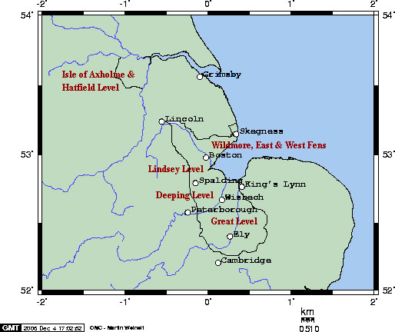
Photo credit: Magog the Ogre (talk)
How was the settlement discovered?
It was first discovered in 1999. A local archaeologist noticed a number of wooden posts sticking out of the edge of the quarry. Archaeologists first evaluated the site in 2006.Extensive investigations were undertaken in 2011 and 2016-2016.
How was the settlement constructed?
The 2006 evaluation revealed that the settlement was made up of a number of roundhouses built on stilts driven into the bed of a shallow, slow moving river channel which fed into the river River Nene. Excavation showed that a palisade (wooden fence) of large ash posts (and some oak ones) surrounded the edge of the settlement.
What was the archaeological site like?
Cambridge Archaeological Unit (based at the University of Cambridge) uncovered remains of timbers (some charred) showing the design of the roundhouses with other artefacts also preserved among them.
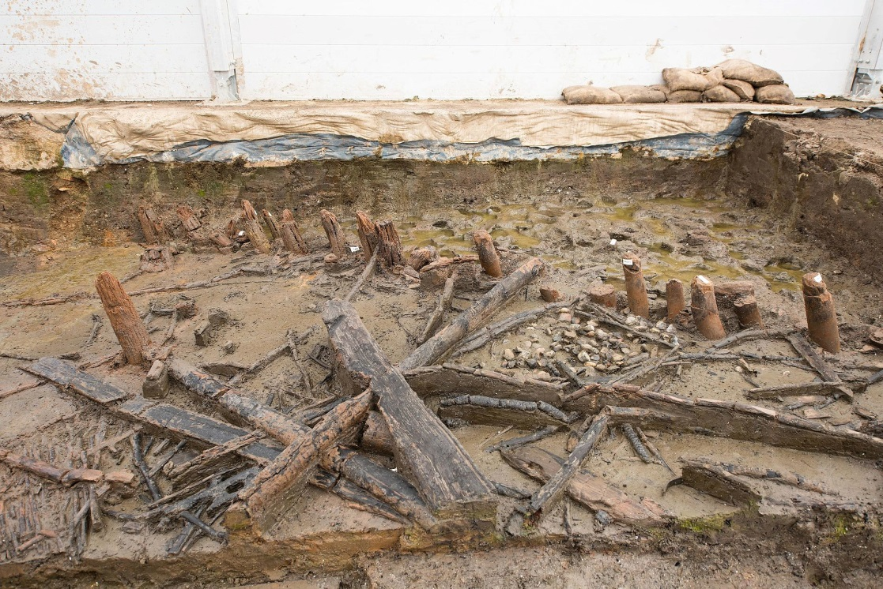
Photo credit; Dr Colleen Morgan

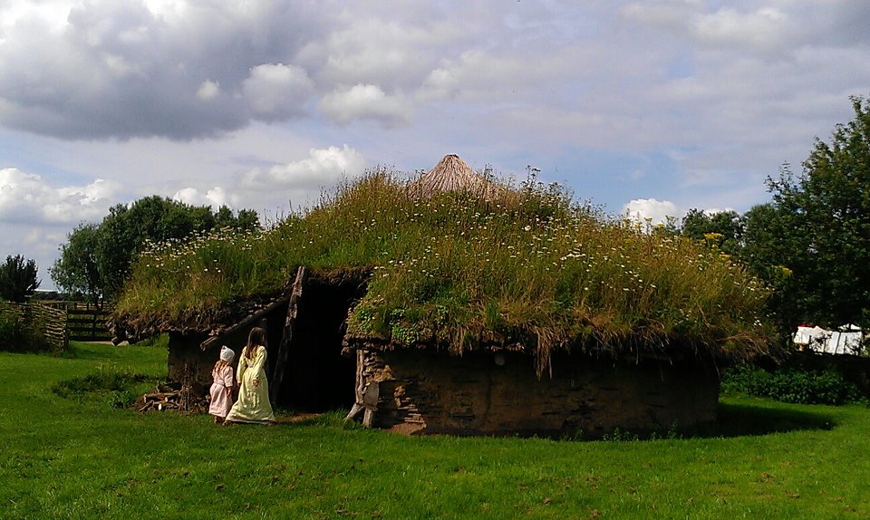
The reconstructed roundhouse at Flag Fen Archaeological Park, Peterborough
Photo credit: Midnightblueowl
How were the round houses constructed?
The houses were built on top of timber stilts with floors of springy wicker panels. The walls were made of stakes interwoven with branches of flexible wood and smeared with a mix of clay, mud and dung which formed a hard surface once dry. The circular wooden roof frame was thatched with local reeds and topped with turf.
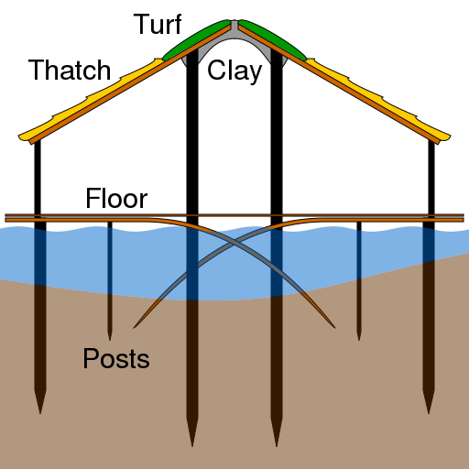
Photo credit: Dr Coleen Morgan
How was the settlement destroyed?
Probably between six and twelve months after it had been built, fire ripped through the settlement, causing the swift collapse of the roundhouses into the river bed. Their remains were covered with moisture resistant silt which helped to preserve artefacts that might otherwise have rotted away. Pottery ranging from large storage pots to small "poppy head" cups were found along with charred textile remnants created from plant fibres. Bowls were found with the remains of meals and spoons being used to consume it. The fire had been so intense that some glass beads which survived it were partially crystallised or shattered.
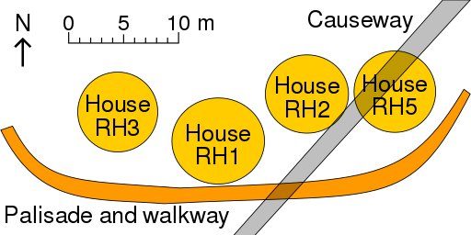
Photo credit; Gmcglee
Why do archaeologists believe that the settlement had only just been completed?
According to Dr Mark Knight of Cambridge Archaeological Unit "We think it was built in winter. Tree ring analysis of the ash posts in the palisade and the oak uprights supporting the houses tells us that they were all felled in the same winter, we just don’t know which one. Within twelve months, the settlement had probably burned down, because the wood was still green, there weren’t any infestations of wood-boring insects, nothing was broken, and very little waste had been generated. There’s even a sense that one of the roundhouses, which we call Structure 4, hadn’t been completed”.
Do we know how the fire started?
It is not possible to establish conclusively how the fire started.However it is unlikely that it was an accident. Dr Knight comments that “The fire was comprehensive. It's not that one building was badly damaged and that at the other end of the settlement effects were limited”. The fact that the fire started in several places would appear to indicate that the roundhouses were deliberately set on fire. Knight asks "Where are the inhabitants? Why didn't they make any attempt to salvage their belongings?"( on this point a recent BBC documentary timed the complete destruction of a reconstructed roundhouse by fire to just 15 minutes which may help to explain the haste with which the Bronze Age people abandoned their homes). Knight goes on to say "And now we have this brevity of occupation too. Is it possible that there were forces out in the fens that didn't want these people here and succeeded in scaring them away? Are we seeing the result of skirmishes or disputes? Or could that be a ritual element? At the moment, we don't have the evidence to say”.
Why was the village built over water?
At this point in the Bronze Age settlements in Britain appear to have been part of a transport network using water. The foreign origin and material of some artefacts indicates that Must Farm was part of a trading system stretching along coasts, rivers and waterways deep in to Europe. It is possible that the Must Farm settlers exchanged the cloth they wove from plant fibres, plus any agricultural surplus they produced for luxury items such as glass and amber beads or other high cost artefacts such as bronze swords .At Frattessina on the River Po in Italy a manufacturing centre imported raw materials and fashioned them in to high quality items for trade. For example ivory was imported from Asia and Africa and necklaces were made from ostrich egg fragments. It is possible that the glass beads found at Must Farm may have come from Italy or further afield, even Turkey or Syria. Siting the village on a waterway may well have been advantageous for trade.
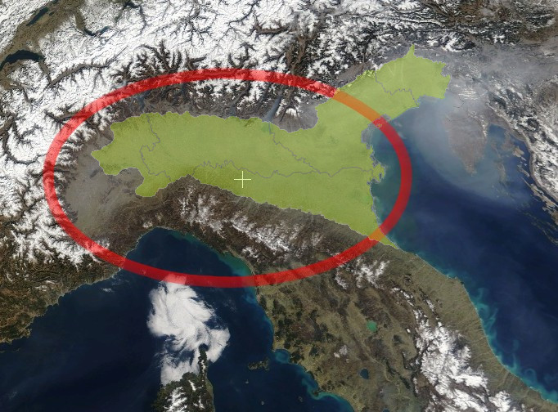
Photo credit; maxcip
Another reason that the village may have been sited over water was for defence. The palisade of mostly ash posts surrounding it was found with some spear heads amongst its remains. This may indicate that it needed defending from human attackers as well as keeping wild animals out. The probable destruction of the village from multiple fires may indicate a co-ordinated assault. It also does not appear that villagers tried to retrieve their lost belongings after the burning huts were abandoned. This may indicate that it was too dangerous to do so.
Where did the villagers of Must Farm come from?
This is not known. As the settlement was newly built, it is possible that the villagers were new to the area. It is also possible that they were migrants from Central Europe or what is now Germany or the Netherlands bringing with them the technical knowledge of how to build round houses on stilts. This may explain the similarities between the design of the Must Farm settlement and remains of lakeside villages of the same period in Central Europe.
How warlike were the Must Farm people?
This is difficult to say. Some archaeologists stress the importance of high value items such as swords as symbols of prestige and wealth rather than their function as weapons. However notches along the blade of swords found at Must Farm are consistent with their probable use in combat. The number of spearheads among the palisade timbers also indicate that it was used for defensive purposes. It is possible that this part of Bronze Age Britain at least suffered from violent conflict.
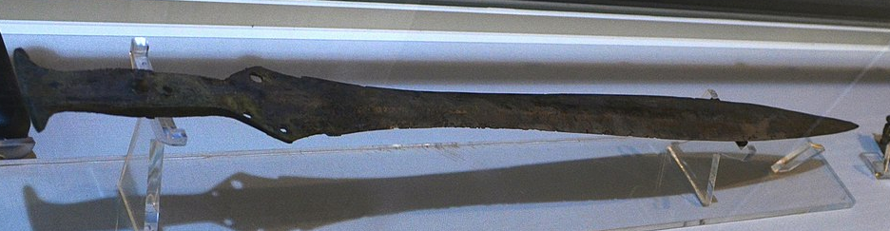
Photo credit; cmglee
Where did the Must Farm settlers get their food from?
Scythes and sickles indicate that villagers were engaged in harvesting crops and the remains of food in bowls indicate that the people consumed ancient strains of wheat and barley. Nettles were also eaten during the Bronze Age. Animal bones have been found at the site indicating that lambs were slaughtered inside the roundhouses and that their carcasses were cured by hanging from the rafters. Sheep were kept on pasture on nearby islands where crops were also grown. Wild Aurochs (an early form of cattle) may also have been hunted. The remains of a butchered red deer were found outside a roundhouse on a gravel surface while remains of wild boar have also been found. On nearby land there is evidence of the consumption of 20 or so cattle, perhaps in communal feasts that may have brought local people together but the meat staple appears to have been lamb. Eel traps and fish bones have also been found indicating that eels and fish formed part of the people`s diet. However perhaps surprisingly given that they must have been abundant in a watery environment, they do not seem to have formed a particularly significant part of the local diet. It has been suggested this is because the people already had such rich sources of food.
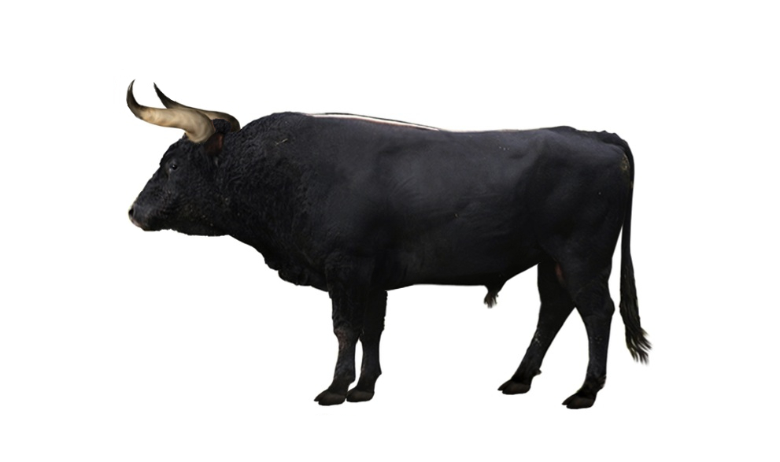

Artists impression of a wild aurochs
Photo credit: Jaap Rouwenhorst/DFoidl
How did the Must Farm settlers use local materials?
Reeds were harvested to thatch roundhouses. Tree trunks were carved in to log boats (eight have been found at Must Farm). The timber must have come from inland. It is thought that the oak and ash used in construction of roundhouses and the palisade came from coppiced trees (that is deliberately managed woodland) with oak being grown for 20-30 years and ash for 15-20. This indicates a well -established agricultural economy and it is thought that this area was probably dotted with similar settlements. Timber was used to make tools, for example a wooden handle with a bronze axe fixed to it were found and a wooden beater for bashing plant fibres as part of the manufacture of textiles.
How did the Must Farm villagers make a living?
They did not earn money because it was not used. The people were probably self- sufficient in food and may have generated a surplus. Remains of burned textiles and tools indicate that they were capable of producing finely woven fabric from plant fibres (such as those found inside the bark of lime trees) and that the quality of their cloth was as good as any produced elsewhere in Europe. It is possible that they were able to exchange food and cloth for high value items they desired through trade networks that saw them acquire valuable bronze tools and axes produced elsewhere. (Interestingly although the people kept sheep no evidence of wool fabric being created has been found).

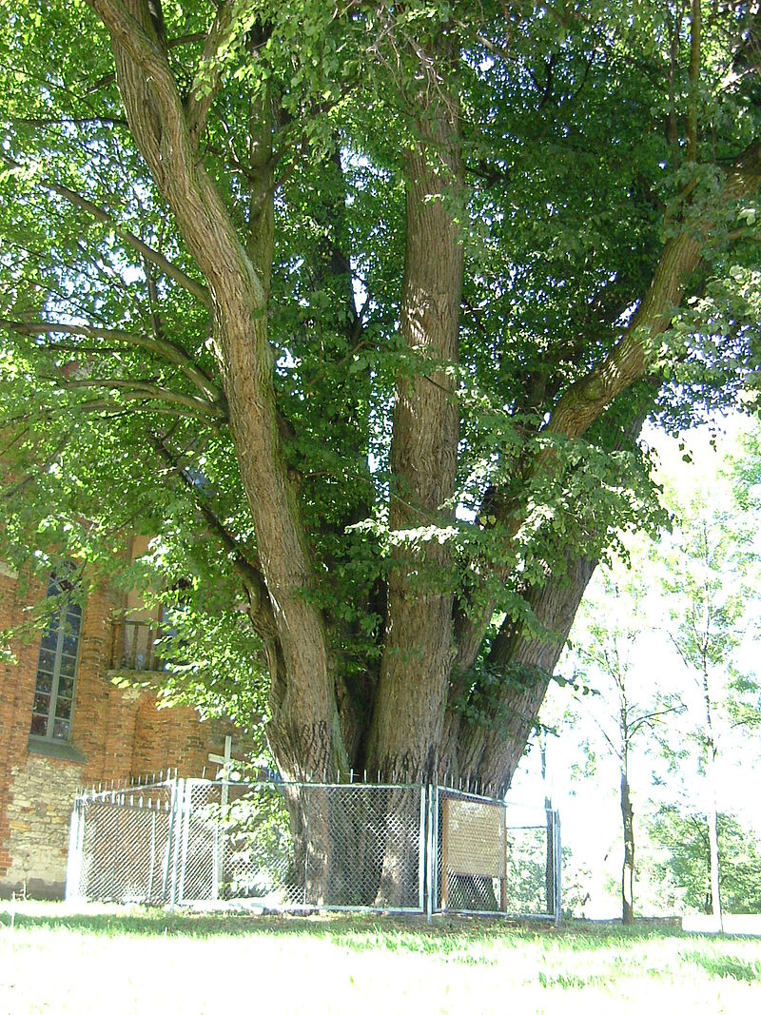
A lime tree
Photo credit: Leszek Korpus
What did the Must Farm villagers believe in?
Their exact beliefs are unknown. No written record exists and no oral tradition survives. The village is close to the remains of a large timber platform at Flag Fen which is thought to have been one of the most significant religious sites in Bronze Age northern Europe. Votive offerings of high status and value such as swords have been found in the timber remains and these could have been to appease gods or spirits or the dead. The Bronze Age dead were sometimes buried with grave goods and could be placed under the roundhouse floor itself if these were on land. Mummification could have been practised and it is possible that bodies might have been kept inside roundhouses to dry out by the fire. A human skull and bone found nearby may date from a different period.
Were the Must Farm villagers rich or poor?
The roundhouses were well built and as comfortable as it was possible to make them with available technology and materials. The structure and content of each was much the same indicating that the households were of equal material status. If there were materially poorer dwellings nearby we do not have evidence of them.
How did the Must Farm villagers rule themselves?
We don`t know.
How did the Must Farm villagers travel around and move goods?
The easiest way of travelling would have been by water in log boats like those found near by (these boats are being preserved at Flag Fen Archaeological Park using techniques developed on the Mary Rose, a Tudor naval vessel). However the earliest wooden wheel ever found in Britain was uncovered at Must Farm. The presence of a horse`s spine nearby may indicate that the wheel formed part of a horse drawn cart. This could have been used for moving goods such as crops.
To learn more about Must Farm
http://www.mustfarm.com/ This excellent website summarises the discoveries made by Cambridge Archaeological Unit with photographs of finds that it has not been possible to include directly in these resources because of copyright.
www.youtube.com/watch?v=ioDzid5ztwM Britain`s Pompeii: A village lost in time. This excellent BBC documentary sets the Must Farm site in its European context. The programme includes excellent graphics reconstructing the village and the landscape of the period.
www.archaeology.co.uk/articles/features/must-farm.htm An article in Current Archaeology dated September 2016 with the title Must Farm: An extraordinary tale of the everyday. It includes quotes from Dr Mark Knight of Cambridge Archaeological Unit.

