THONIS-HERACLEION AND CANOPUS

The great Mediterranean ports and emporia (major trading centres) of Thonis-Heracleion and Canopus thrived in the last centuries of ancient Egyptian history, when they received goods, people and influences from around the Greek world and beyond.

Natural events caused them to be gradually, and then perhaps cataclysmically, sunk beneath the sea. However modern archaeologists have located the sites and are now systematically recovering the artefacts and reconstructing their history.

Where are Thonis-Heracleion and Canopus?

The sites are on the Mediterranean coast of Egypt, about 20 km east of the centre of Alexandria, Thonis-Heracleion on the west side of the Aboukir peninsula in Aboukir Bay and Canopus on the west side of the peninsula
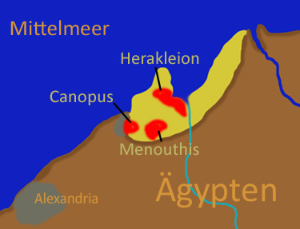
Photo credit: Chris Osanbruk

Egypt naturally divides into two geographical zones, with the long, narrow habitable Nile valley in the south, tightly bracketed by hostile desert, and the vast delta of meandering river branches in the north. As the river Nile fanned out into the delta, it used to have seven main branches and Thonis-Heracleion and Canopus were at the northern end of the westernmost of these, the Canopic branch. Nowadays, flood control has reduced the branches to two, each with its major city on the Mediterranean: Rosetta in the west, famous for the Rosetta Stone that was found there, and Damietta in the east.

Thonis-Heracleion and Canopus are now under the sea, as is the contemporary nearby port of Menouthis. Thonis-Heracleion’s inland ‘twin’, Naucratis, 77 km to the south, is on land and has been excavated since the 19th century. These names are Greek because the sites were founded or thrived during the period of Greek rulers in Egypt, although Thonis is the Egyptian name while Heracleion is the Greek name for the same place. To the south-east of Naukratis was the important regional centre of Sais, which had existed since the earliest times (under its Egyptian name of Sau) and was the capital of the country in the 24th, 26th and 28th dynasties.

When did Thonis-Heracleion and Canopus exist ?

When Thonis-Heracleion and Canopus first appear in history, Ancient Egypt had existed as a kingdom for nearly 3000 years, and the Nile valley had been settled for at least 1000-1500 years before that. The country was, unsuspectingly, in the last few centuries of its independent existence, before it became a province of the Roman Empire (although the final traces of its ancient religion lasted until the 4th century AD, when an altar to Isis was restored in London).
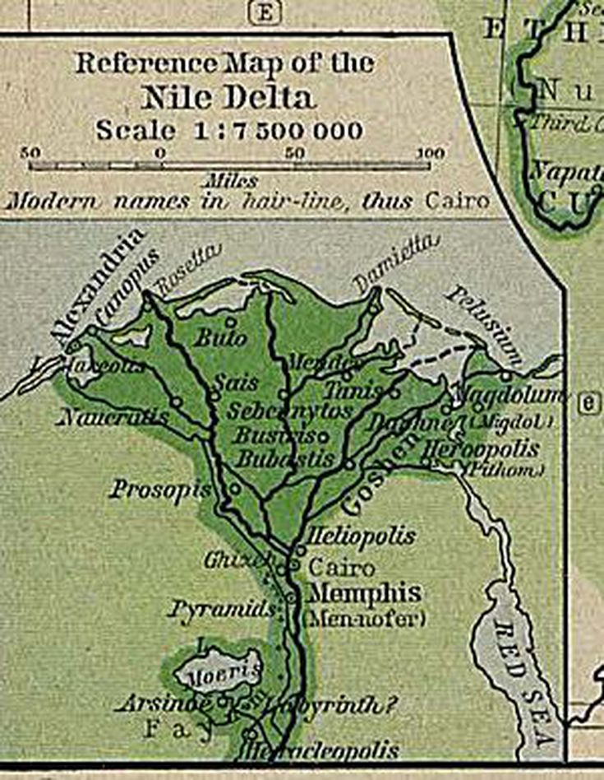

Thonis-Heracleion was founded at the same time as Naucratis, in the early 26th dynasty, by pharaohs who fostered trade, military and religious links with Greece. These paired cities became the principal trading ports between Egypt and the Mediterranean world, Thonis-Heracleion receiving goods on the coast, collecting customs dues and transporting the goods to Naukratis further inland for distribution. Both thrived through the uncertainties of Egyptian history: the Persian Empire conquered the country and deposed the 26th dynasty, but were themselves driven out by the conquering Greeks under Alexander the Great, who was followed by the long dynasty of the Ptolemies, descendants of his Greek general Ptolemy. The last we hear of Thonis-Heracleion is in the reign of Ptolemy VIII, when it is mentioned in a stela (carved or inscribed stone slab) dated to 118 BC, and the city was probably lost to the sea soon afterwards.

How do we know about the cities?

The region is described in Greek myth as the place where Herakles (Hercules) landed and from whom the city of Thonis-Heracleion takes its Greek name. The historian Herodotus (484–425 BC) relates the tale that there was a temple to Herakles when Paris took refuge in Egypt after the Trojan War (Paris was the son of the Trojan king Priam and lover of the beauty Helen of Troy). While clearly fictional, this perhaps shows that the northern coast of Egypt was associated in the Greek mind with a temple to Herakles. Strabo (writing in the first decades AD, the time of the early Roman Empire) and contemporary geographers name and describe the settlements of this coastal area, with measurements of distances between them and landscape features.
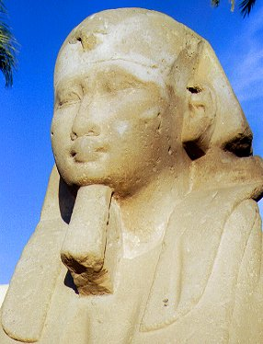
Sphinx of Nectanebo the First
Photo credit: Bouette

Since Egyptian hieroglyphs have been deciphered experts have been able to read texts and monuments referring to these cities. Firstly, the 380 BC Decree of Sais, issued in the reign of pharaoh Nectanebo I, lists customs dues to be paid at Thonis and Naukratis. One copy had been found in Naukratis during 19th century excavations, but a second copy was to be found at Thonis-Heracleion during the current excavations. The Decree of Canopus (238 BC, the reign of Ptolemy III Euergetes I) describes a city called Heracleion with temples to Amun-Gereb and Herakles, and a boat procession as part of a festival of the god Osiris between Thonis-Heracleion and Canopus.

In 1866 the Egyptian astronomer el-Falaki made a map, and early 20th century antiquarians followed, then Daressy in 1929 identified the site of Canopus and suggested that the other sites were now also submerged.

In 1933, an R.A.F. pilot saw ruins in the water near Aboukir, and a local scholar (Prince Omar Tousson) he consulted took advice from fishermen and found a site with fine stone columns; he recovered a magnificent statue of Alexander the Great which is now in the British Museum.
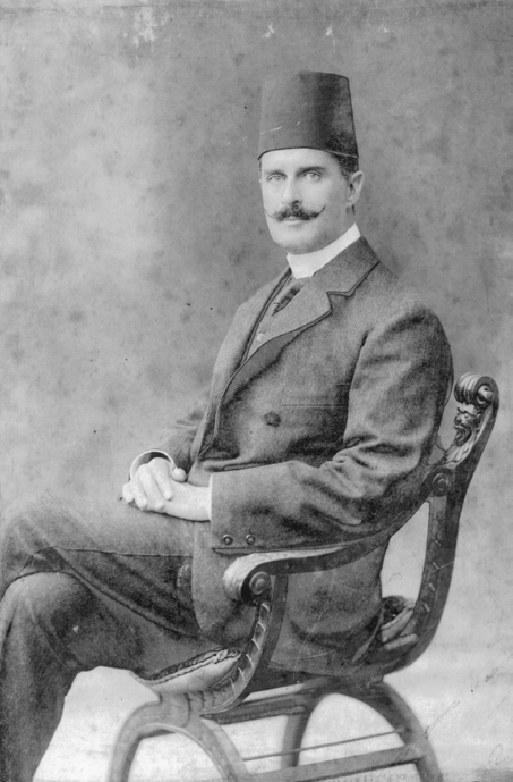
Prince Omar Tousson of Egypt
Photo credit: In Magazine Alexandria Center

Thorough investigation of the sunken cities, however, had to wait until the underwater archaeology of the Institut Européen d’Archéologie Sous-Marine (IEASM) under Franck Goddio, and their collaborators, the Oxford Centre for Maritime Archaeology. They began a project in the 1990s looking for sunken ships of the Napoleonic Wars, but when that work finished they turned to the more ancient sites and have been there ever since.

How were the sites found and excavated?

Following its spotting in in 1933 and the discovery of sunken ruins and statues, it was clear that at least some of the named cities of this area were potentially still present beneath the waters around the Aboukir peninsula.

Following modern archaeological conventions, Franck Goddio and his team began with non-invasive investigations, carrying out what archaeologists call ‘desktop survey’ to search documents for information on and locations of the sites they hoped to find. The ancient authors were only partly helpful, because the landmarks and distances they describe are not clear, and the coast has changed markedly since their times. Goddio, therefore, used sonar to plot the contours of the sea bed over a huge area of over 110 sq km (68 square miles). The team found the sunken rocky coastline, the course of the old Canopic branch of the Nile, and its subsidiary course, canals and lakes, with the scattered low islands and patches of marsh. This explained the name Thonis, which comes from the ancient Egyptian hone, meaning this kind of lagoon-like port; Heracleion was ‘the hone of Sais’, as indicated on a stela the team have recovered. The canal that texts describe as being the link between Thonis-Heracleion and Canopus, and which was used for the annual rites of Osiris, could also be seen on sonar.
Franck Goddio
Photo credit; Christoph Gerigk/Franck Goddio

Because little would be visible in or on the seabed, nuclear-magnetic resonance (NMR) was used to search for smaller-scale topography and buried items. Then Goddio’s team turned to diving. This was difficult due to the cloudy, silt-ridden waters of the bay, but strict archaeological principles were followed, except that instead of using trowels and brushes they used air lifts or water dredges which remove silt by suction like a vacuum cleaner.
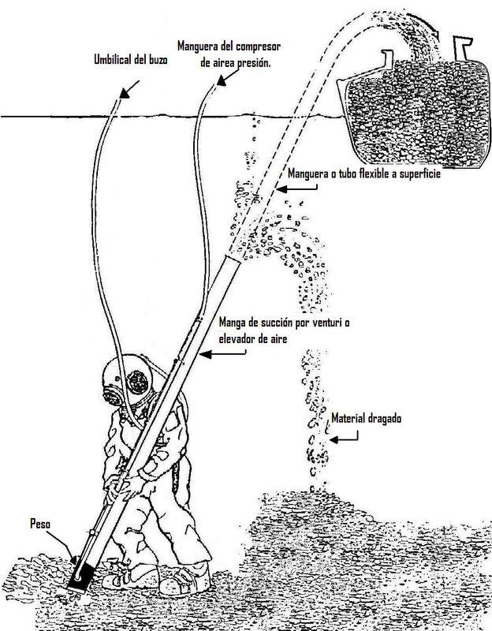
Each item must be mapped in place, numbered, carefully lifted in the most appropriate way — there might be a heavy carved stone to be hauled to the surface, or a fragile piece of jewellery — and then taken on to the team’s boat that serves as their home, operation headquarters and conservation lab. Archaeologists can use hoists to lift heavy objects to the surface or can hook them to a buoyant airlift which helps to raise them to the surface.

Preservation is excellent for most hard materials, hence the team found statues and temple pillars, ceremonial tanks, carved reliefs, offering deposits of metal and pottery, coins and weights, jewellery and so on. These shed much light on ceremonial and formal practices in the city. We know less about the domestic life of the people, however, because no houses or minor buildings have been or are likely to be found — houses for the living were of unbaked mud-brick and will have dissolved long ago, and the organics that are plentiful in other parts of Egypt due to desiccation (the process where artefacts are preserved because they completely dried out by the extreme heat) are lost here. By contrast the houses for the gods (i.e. temples) and the dead were made of stone or had stone for their gateways and important areas.

As a port, some traces of ships were to be expected, but expectations have been wildly exceeded. More than 69 ships of every size and kind and 750+ anchors, of stone or lengths of timber with lead inserted to weight them down, have been found so far. Some ships were deliberately scuttled (sunk) in a group to block a canal, while others had just sunk.

Were these cities typical for their time?

Yes and no. These coastal trading centres would have looked very different to the towns of the valley with their unstructured layouts surrounded by their fields — with the cliffs and desert forming the limits of cultivation — annually awaiting the Nile flood which added fertile silt to the soil. And they would not have resembled the towns of most of the delta, neatly balanced on their elongated geziras (sandy mounds) between the water courses and the low-lying lush fields.

Thonis-Heracleion would have resembled a smaller, less structured version of Venice (an interactive map can be found at http://www.franckgoddio.org/service/news-newsletter/detail/article/interactive-map-of-sunken-city-heracleion.html). It had low islands between lakes and natural and canalized rivers, the central islands heavily built-up with huge temples — the main ones of which appear to have been completely Egyptian, not Greek, style — and administration buildings, surrounded by areas of jetties, wharves and warehouses, plus housing as in every ancient Egyptian city, which included single storey homes and some higher ‘apartment buildings’, shops and workshops.
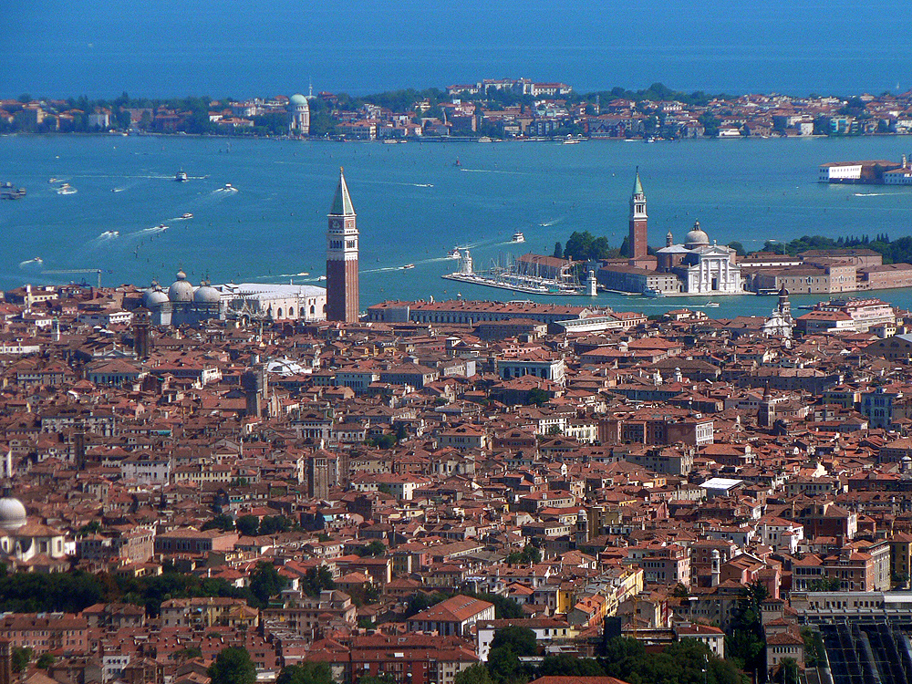
Modern Venice
Photo credit: Oliver-Bonjoch

The smaller and outer islands might have been more closely connected to the sea, with, probably, fishermen’s and fowler’s homes, humbler dwellings and less formal trading going on. Thonis-Heracleion was a dedicated port, having no cultivable land and obtaining its main food supplies from the hinterland, although somewhere there are likely to have been places for live animals to be kept, mainly for the temple sacrifices but also for fresh meat.

The three main canals, the narrower water courses and the surrounding lakes would have been thronged with ships, of Egyptian and non-Egyptian styles. The Palestrina mosaic, shows a fantasy version of a Nile landscape during flood time, and the lower part shown below gives a (very) general impression of what Thonis-Heracleion might have looked like.
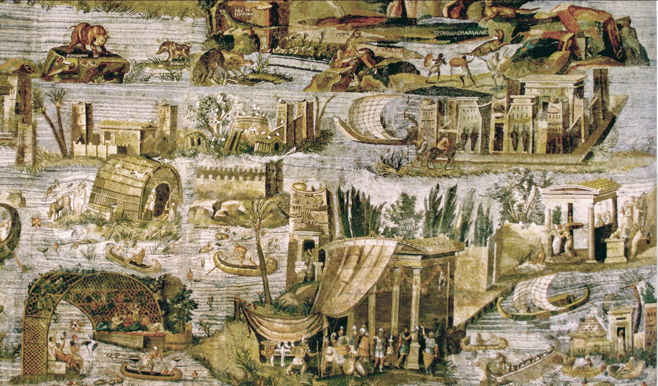
The Palestrina Mosaic with a large temple at upper right, a smaller temple collapsing into the water to its left, a simple reed structure collapsing middle left, and many boats of various kinds. (Wikimedia Commons: https://upload.wikimedia.org/wikipedia/commons/2/27/Mosaïque_nilotique,_Praeneste,_Italie.jpg)

These would have been exciting places to live, busy and cosmopolitan. But they were also vulnerable to storms from the sea, threats from seafarers and dependence on other areas for basics such as food staples. In terms of health, Egypt harboured disease organisms carried by various insects and parasites (malaria and bilharzia being widespread), but sites like Canopus and Thonis-Heracleion, close to the sea and receiving the sea breezes and the fast-moving flood from the length of the Nile, were probably less troubled by these; on the other hand, their populations were open to infections brought by visitors.

Who were the people?

As well as the local Egyptians there would have been sailors and traders from many places in the Mediterranean, especially the Ionian Greek cities of what is now the Turkish coast and the Greek islands. Pharoah Psamtek began using Ionian Greek and Carian mercenaries to strengthen his forces and Nekau (about 610 BC) included experienced sailors who formed the first real Egyptian navy — Egyptians had, through their history, been used to river and cautious coastal sailing and were not confident on the sea. Herodotus tells that in his visit to Naukratis (about 450 BC) he saw traders from twelve Greek islands and city-states, and that no-one was allowed to enter Egypt for trade except through Naukratis. Nectanebo I made trade deals with both Athens and Sparta.

From 332 BC, Egypt was ruled by the successors of Alexander the Great, and was part of the Greek world, so Greeks were in many positions of authority. Some historical documents describe conflict with the local people, although the country had had almost a millennium of domination by foreign powers and the Greek rule must have seemed less alien and inflammatory than some, especially after the recent oppressive and debilitating control of the Persians.

INCREASINGLY, EGYPT FALLS UNDER FOREIGN RULE:
- 1760 Hyksos (a group of local tribes and city states of the Levant)
- 1080 Libyans
- 752 Nubians/Kushites
- 674 Assyrians (puppet rule)
- 525 Persians (rule by satraps- Persian governors)
- 342 Persians again
- 332 Macedonian Greeks (Alexander, then his successors the Ptolemies)
- 30 Rome (Octavian, who became Caesar Augustus)

Mercenaries had been used in Egypt for centuries, by conquerors, to put down local revolts, resistance to royal authority and civil conflict. Egypt even created a silver coinage to pay the Greek mercenaries and gave them the site of Naukratis to be their settlement and trading post. These factors, together with the positive feature of ancient Egypt that there was no ‘immigration control’ or ‘citizenship test’, would have given an international flavour to the cities.

What did people look like, sound like, and even smell like?

Ionian Greeks, Carians (inhabitants of Caria in Anatolia, part of modern Turkey), Cypriots and people of the Levant (a phrase referring to countries south of modern Turkey and north of Egypt in the Eastern Mediterranean) such as Phoenicians and Jews would have worn their distinctive clothing and followed their own customs, perhaps blended with Egyptian customs and beliefs if they were settled in the country. We would expect the basic plain off-white linen, headcloths or wigs in the Egyptian style to contrast with brighter, complex-weave textiles in the clothing of the visitors — shaggy wool clothing had been sent as gifts to pharaoh back in the 18th dynasty, exotic and prestigious but hardly useful in such a hot climate — plus their different and varied hairstyles, jewellery, armour and weapons. Even the scented oils and fats that were used as perfumes were different from place to place.
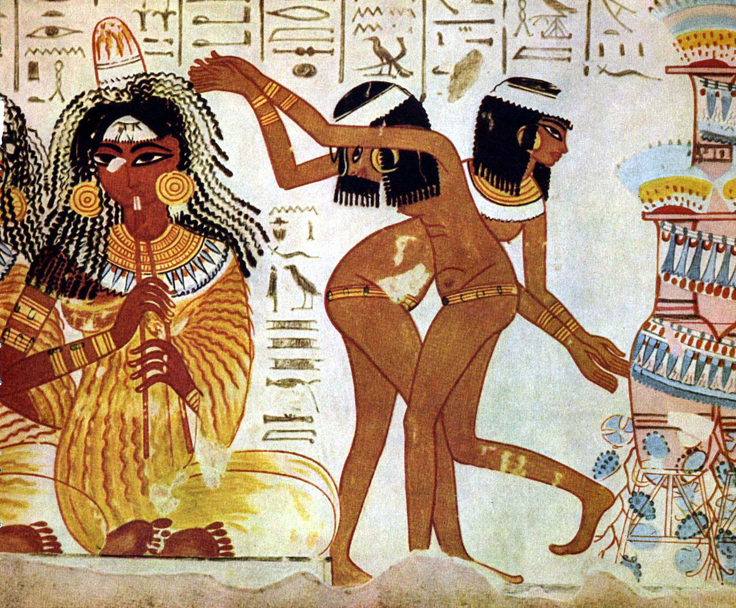
Egyptian wall painting showing dancing women
Photo credit: The Yorck Project

There would have been a vibrant mix of unrelated languages. A stylised form of the Assyrian language had been the language of high diplomacy for a millennium, then Persian was used for administration throughout the Persian empire, but Greek became the language of Egypt’s economic world and then of its rulers, the Ptolemies, so it would have been heard constantly in the ports. Individuals would have probably developed their own lingua franca (common language) that worked for their own trade deals.

The arrival of large numbers of male traders, soldiers and sailors could lead to intermarriage and families with blended cultural traditions, languages, names, even food. Marriage was a personal, not a family or community matter in Egypt, and the acceptance of foreigners meant that such marriages were not frowned upon, although in the ports there would have been an imbalance of men to women. Perhaps Naukratis, deep in the delta, would have provided more potential wives.

Egypt had had immigration and intermarriage from beyond its southern borders for millennia, so people of Nubia (now Sudan) were familiar residents and visitors in much of the country; Nubian mercenaries had been especially highly regarded in Egypt from the earliest dynasties. Fewer Nubians might have been found in the far north, but it would not have been a complete surprise to see some Nubians in these ports.

We should not imagine, however, that these cities were paradises of international harmony. For example, there was a national revolt in the reign of Apries, the stated cause being resentment of his use of foreign troops rather than Egyptian ones. In the Persian period a dispute between the priests of the temple of Khnum at Elephantine and the Jews who had a nearby temple led to the destruction of the latter, and we have the letter the Jewish community sent to the Persian governor, asking for help in rebuilding.

What kind of religion was practised in Thonis-Heracleion and Canopus?

There were thousands of gods worshipped in ancient Egypt: hundreds of principal gods were known by different names and had different attributes in different areas. This reflected the origins of the Egyptian state, formed from a consolidation of many small ‘kingdoms’ or city states, each with their own patron deities. Composite gods were common, blending the attributes of two or more gods. The great temple at Thonis-Heracleion was that of Khonsu-Thoth, the former being the moon god but having the attributes of healing and avenging, the latter that of justice. Near the temple were found small stone sarcophagi (stone coffins) which were probably for mummies of the ibises (a common but holy bird) sacred to Thoth. At Naukratis the great god Amun-Ra was known in the local form Amun-Ra-Baded, and had a major temple in traditional Egyptian style, but there were also Greek-style temples and shrines.

Just as foreigners were welcome to move into Egypt and live as citizens, so they were free to worship their own gods, and these had arrived over the millennia from Nubia, Libya, the Levant, Western Asia and latterly from Greece. On the other hand, any person could worship any Egyptian god of their choosing, and favourites — known from statuary, amulets and imagery — tended to be the deities of the Egyptian households and fertility like Bes and Horus-the-child, plus protective symbols such as the Eye of Horus.
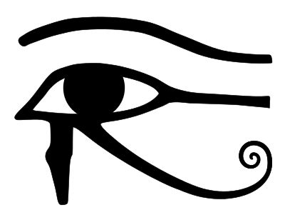
In time these foreign and native deities became identified one with another to form international composite gods, such as the recognition of the purely Egyptian goddess Isis as the Greek goddess Aphrodite. There are examples of funerary stele of Carians, in mainly Egyptian style with funerary gods and winged sun-disks, but showing the dead in Carian clothing and sometimes with Carian inscriptions. Serapis, the composite god linking the Apis bull (the incarnation of Ptah, one of the creator gods of the Egyptian pantheon) with Zeus (chief god of the Greeks) and Hades, had been invented in the early Ptolemaic period as the ultimate supreme god; he was less popular in Egypt than had been hoped, although his worship ultimately spread round the Roman world.

The celebrations of the rites of Osiris, god of the underworld and of resurrection, were clearly continued, thousands of years after they had been founded, in the international communities of Canopus and Thonis-Heracleion. The ‘Osiris mysteries’ celebrated his death, burial and resurrection — and hence gave hope of eternal life to humankind. There are many finds of the ritual equipment that was used in in the ‘mysteries’ buckets and ladles, votive boats, offering vessels, and a ‘garden tank’ that would have contained figures of the god made of soil containing seeds: as the seeds sprouted in the damp soil, so Osiris also lived again after being under the earth.

Huge statues of the god of the Nile, Hapy, of Osiris and his wife Isis, of Shu, god of air with the ‘decades’ (astronomical symbols showing protection of the country against disasters), and of pharaohs including Nectanebo II, maintained the state ideology of strength, security and the approval of the gods.

What was being traded?

Coming in would be silver for currency and its by-product lead; copper from Cyprus, wine and oil from Greece, Cyprus and Phoenicia; wool (Egypt did not have woolly sheep); cedar wood from Lebanon, providing the large, straight trees that Egypt lacked and had always needed for flagpoles and to be cut into long, sweet-smelling planks for high quality furniture and coffins; iron, not seen in Egypt until the reign of Tutankhamun, despite it being the most desirable metal elsewhere; Greek perfume flasks, although other Greek pottery did not seem to catch the attention of the Egyptian market. People too: mercenaries and experienced sailors were also always wanted.

Going out was grain, which was produced in such quantity that Egypt later became the ‘bread basket’ of Rome; gold — Egypt was known to be ‘rich in gold’, it was ‘as plentiful as the sands of the desert’ and some came from Egypt itself but more was traded from Nubia in the south; natron (a form of salt used to dry out bodies prior to mummification) and alum (for mordanting dyes), finished goods such as amulets and scarabs, the magical power of which were highly regarded by all Egypt’s neighbours, jewellery, papyrus and perfumes and medicinal oils — some of which are named on their flasks, for example the highly expensive cinnamon oil.
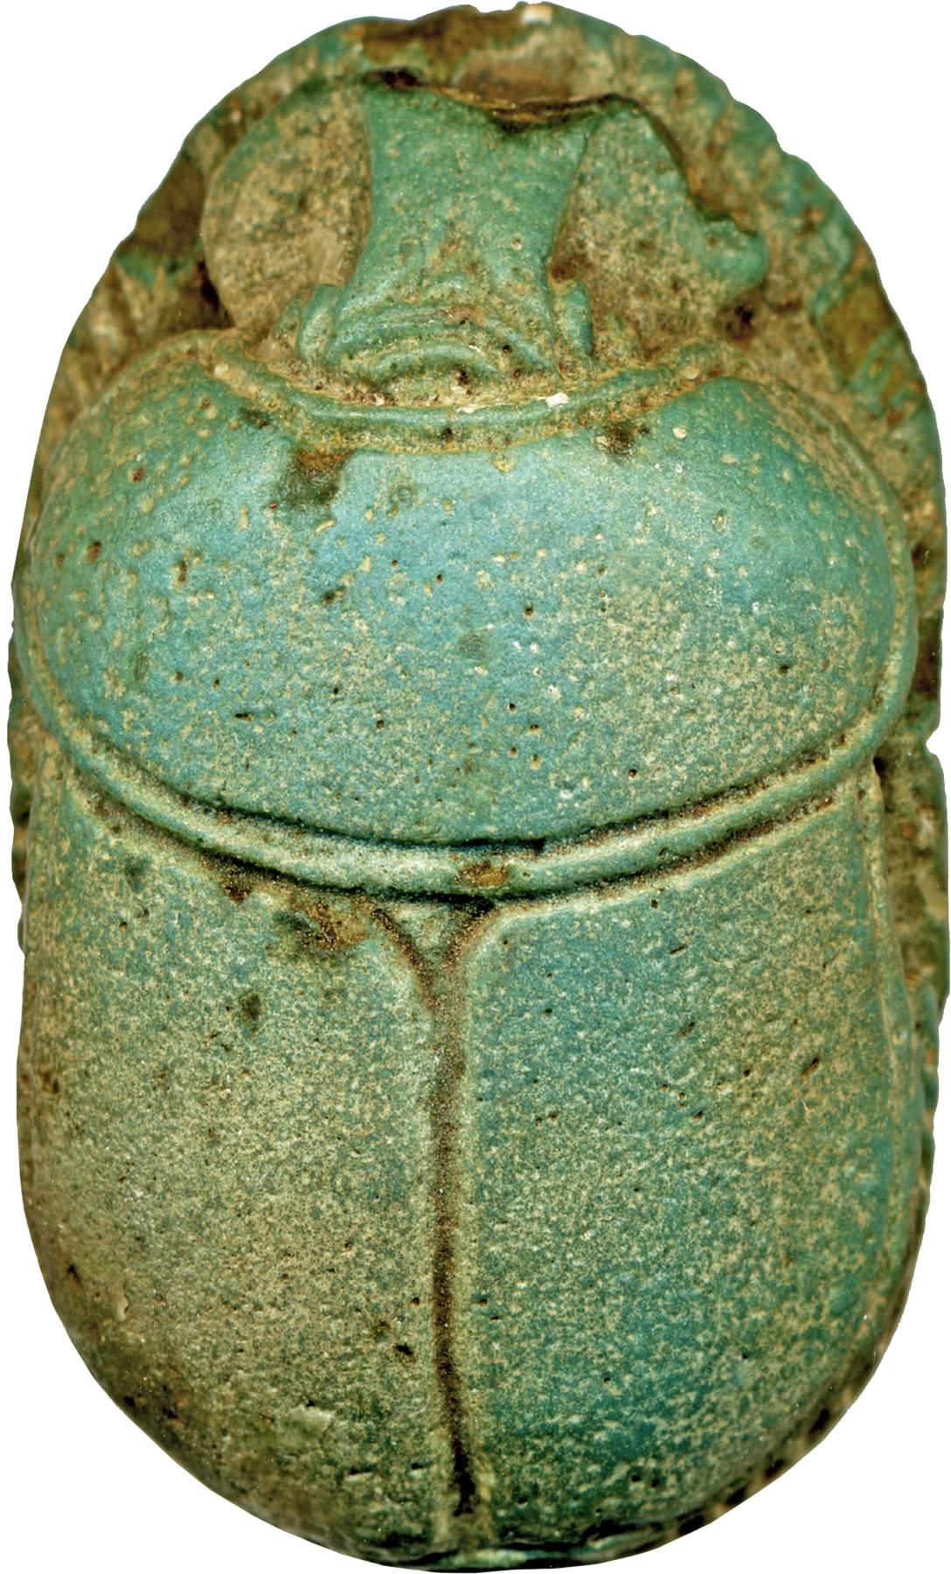
A scarab amulet
Photo credit: Walters Art Museum
Why did the cities disappear?

There is known to be a slow tectonic tilting from north to south in the southern Mediterranean, which would gradually sink the north coast of Africa beneath the sea. It has also been speculated that there has been sea level rise. A reconstruction illustration of Thonis-Heracleion accessible by clicking from this link
https://www.theguardian.com/cities/2016/aug/15/lost-cities-6-thonis-heracleion-egypt-sunken-sea
shows some islands with buildings partly under water as a result of one or other of these factors.

Magnetrometry showed that there had been a failure of sediments in some areas of the islands, a combination of cracking and possible liquefaction. This is suggested as having been exacerbated by the weight of major buildings such as the great temples.
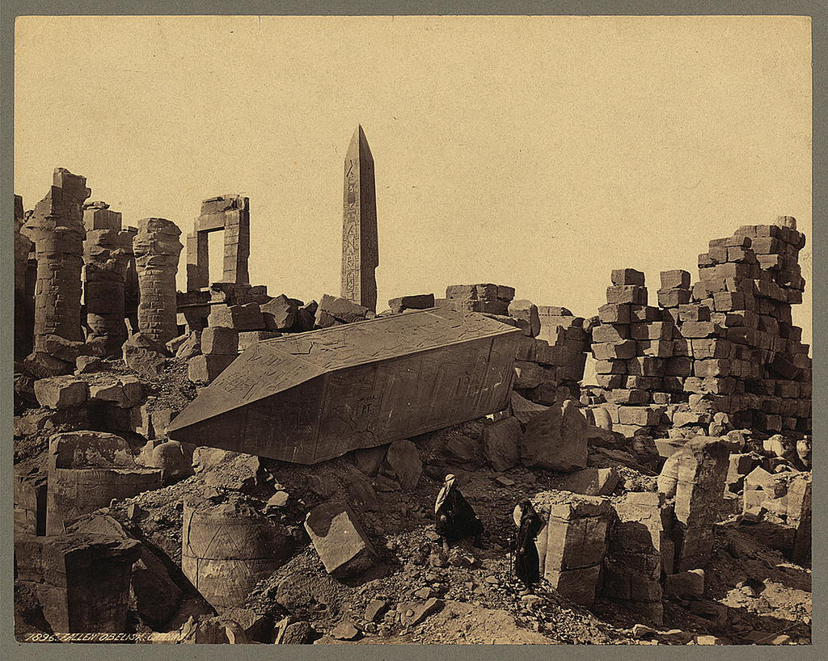
There might also have been a tsunami following earthquake, which would have engulfed the low islands and removed some of the land. All of these factors would create difficulty in sustaining infrastructure and made many buildings unstable even if they had not collapsed. Finally, in the eighth century AD it appears that the whole area of coast around the Aboukir peninsula was sunk and the cities were lost until their 21st century resurrection.

To learn more about the sunken settlements

Sunken cities. Egypt’s lost world by Franck Goddio and Aurélia Masson-Berghoff
http://www.franckgoddio.org/projects/sunken-civilizations/heracleion.html
http://www.franckgoddio.org/projects/sunken-civilizations/canopus.html

