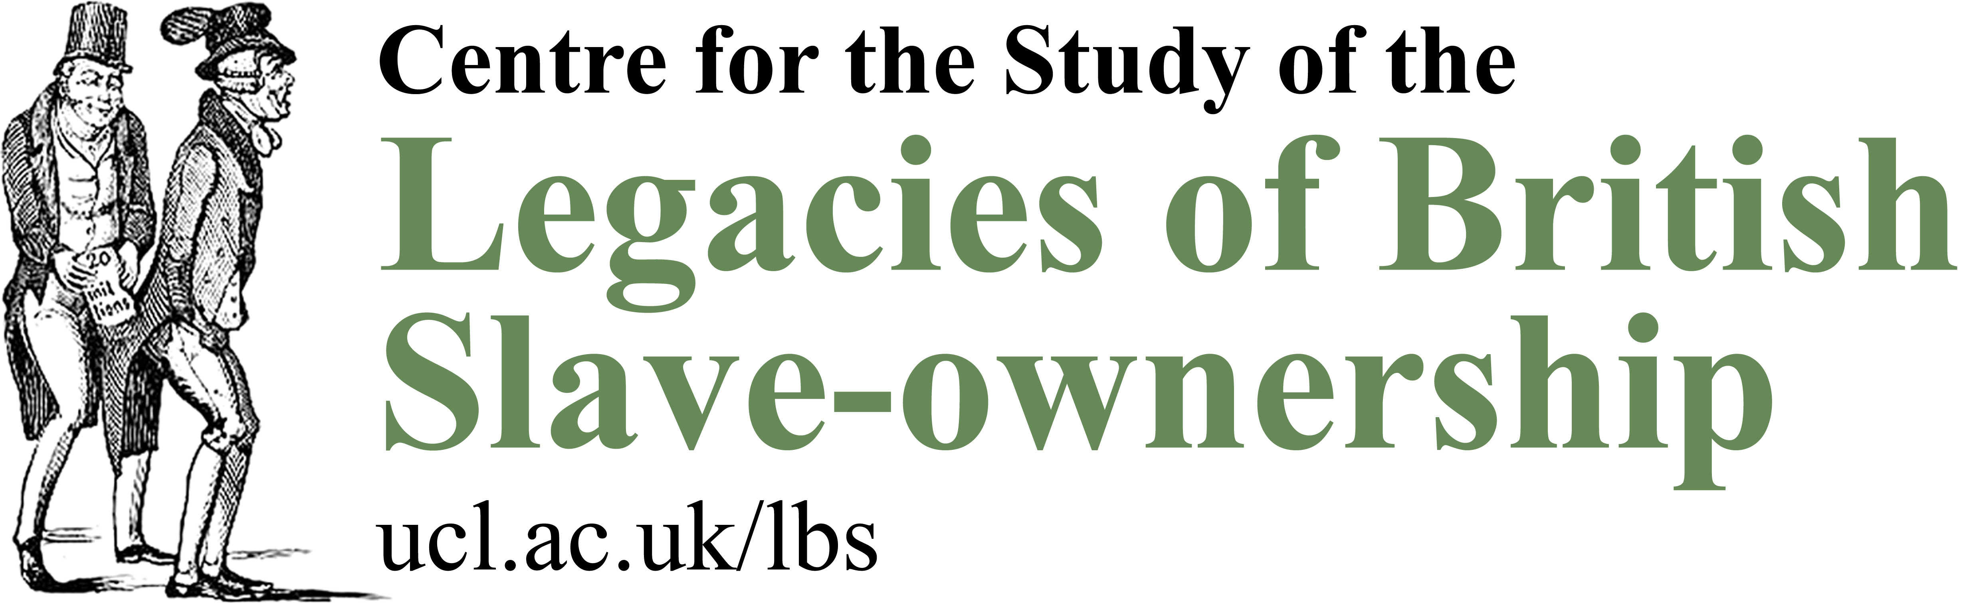

Historical Association Teacher Fellowship Programme application form

Teacher Fellowship Programme 2019: Britain and Transatlantic Slavery
Please complete this entry form and send it along with the supporting documentation (see below) to the HA Education and Events Officer, Maheema Chanrai, at maheema.chanrai@history.org.uk by the end of the day on Friday 1 February 2019.

About you
Name:
Job title:
School:
Email address:
Mobile:
Postcode:
No. of years teaching (including NQT year):

Referee details
Name:
Position:
Email address:
Phone:

Supporting information
- Please tell us in no more than 800 words:
Why you want to join the programme
What you and your school hope to gain from your involvement
How this will fit with your curriculum requirements and what age range you would be considering when teaching this period

- Then, in no more than 600 words:
Outline a series of lessons or teaching activities you are particularly proud, of reflecting upon how and why this has been a triumph.

- Finally, please attach an example of a teaching resource that you have written or worked on. This should preferably be linked to the topic in consideration.

As indicated in the application guidance, please make reference to the Working principles for teaching Britain and transatlantic slavery in which you already have experience during the course of your submission.

