HA Resource Hub Submission Form
Resource Title: Do you think Boudicca was a hero or a villain? |  |  | Age Range: KS2
Author name and email contact:  Tim Lomas  tlomas@outlook.com | Resource Details: (e.g. how many documents does it consist of? In which order?)  8 sources and a series of questions/activities
Necessary prior learning to complete this:  Some work on the Roman invasion of Britain |  | What does it lead to next?  Fitting into a wider context on the Roman invasion of Britain
Explanation: How should this resource be used?
This is intended to challenge more able key stage 2 pupils who can handle a detailed investigation using a range of different sources to come to a decision about an overarching enquiry.

DO YOU THINK BOUDICCA WAS A HEROINE OR A VILLAIN?

Background information:
By 61AD the Roman Governor of Britain, Suetonius Paulinus was planning what to do next. In the previous 17 years he had conquered or become friendly with most tribes. However, the Welsh tribes were still causing problems so he decided to deal with them. Whilst far away in Wales he heard news that there had been a revolt led by a woman named Boudicca from the Iceni tribe.

The revolt spread. The Catuvellauni tribe joined the rebellion and later the Trinovantes. The Trinovantes joined Boudicca because they were angry at the way Romans treated them. In the town of Colchester they drove them from their homes and called them slaves. They also did not like the Roman temple built in honour of the Roman Emperor. Roman priests made the native tribes pay heavy taxes. The Romans were no match for Boudicca’s army who destroyed the town after two days. They killed every man, woman and child.

The rebellion soon spread. Many Roman villas were destroyed as well as towns. Chelmsford and St Albans was captured and again many were killed. London was also besieged and some 70,000 were supposed to have been killed. Suetonius decided he needed to fight.

SOURCES:

  - Account by the historian called Tacitus
“Prasutagus, the late King of the Iceni tribe had got together a huge treasure during his long reign. When he died he left it in equal shares to his two daughters and the Roman Emperor. But Roman tax collectors looted his lands, whipped his wife Boudicca and assaulted her two daughters. The Romans’ slaves robbed her house. Leading members of the Iceni tribe lost their homes and lands. The relatives of the dead King Prasutagus were made slaves. The Iceni rebelled”

2. Map of tribes at the time of Boudicca

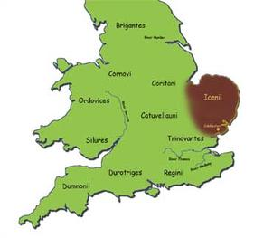

3. Map showing the positions of the Romans at the time of Boudicca’s revolt
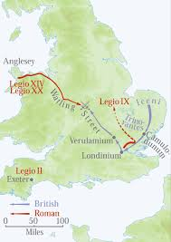

4.Tacitus describes the battle.
“Suetonius’s army added up to little more than 10,000 men but he decided to fight the crucial battle. He chose a spot circled by woods. It had a narrow entrance and dense trees behind. So he had no fear of an ambush. The enemy he knew had to come at him from the front across an open plan. He drew up his soldiers in this order. The legions were close together in the centre. The lightly-armed troops were kept at the back to fight when needed. The cavalry were on the wings.

A huge number of Britons came to the battle field. They did not draw up in clear lines of fighters. Separate bands and whole tribes rushed up and down shouting. So sure were they of winning that they put their wives in carts on the edge of the plain. There they could see the battle and admire the Britons amazing bravery. Boudicca drove through her army with her two daughters in a war chariot.

Then the battle began. The Roman legions formed lines. The narrow passage into the clearing slowed down the enemy attack. But the Britons advanced fiercely and threw their spears with deadly results. Then the Romans rushed forward in a wedge. Straight away the cavalry charged the enemy. With their lances they killed all the enemy who dared to make a stand. The Britons fled but got tangled up in the wagons at the back. A dreadful slaughter followed. Neither men nor women were spared. Some writers say that at least 80,000 Britons were killed. The Romans lost about 400 men. Even the oxen, transfixed with spears, added to the heaps of the dead. Boudicca took poison and killed herself”.

5.Pictures from a school textbook used 30-40 years ago

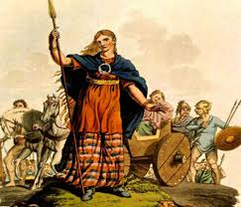

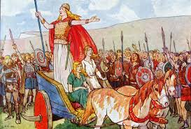

6. Description of Boudicca by Dio Cassius

“She was very tall. Her eyes seemed to stab you. Her voice was harsh and loud. Her thick reddish hair hung down in a great mass to her hips. Around her neck was a large golden tork (necklace). She always wore a flowing tartan tunic over which she fastened a thick cloak with a brooch, she looked terrifying”

- Information about sources.
Tacitus was a Roman historian who wrote 50 years after the event. He got most of his information from his father in law who fought in the Roman army against Boudicca and who later became a governor of Roman Britain.

Dio Cassius was a Greek historian who write 150 years after the revolt.

There are some carving and sculptures and archaeological evidence that shows for example a great fire in Colchester.

8. A picture of Roman legion

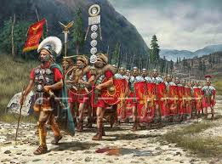

Questions:
- Looking at the sources, what do think is meant by “tribe”, “Emperor”, “slave”, “rebellion”?
- Does Source 1 give us clues as to why the Iceni rebelled against the Romans?
- Does Source 3 show why the Romans found it difficult to defeat Boudicca? Roman soldiers might be able to march 30 kilometres a day
- What advice would you have given Suetonius on how he might have defeated Boudicca?
- Using Source 4, take a scene from the battle and draw how it might have looked using the evidence from the source;
- Is there anything in the account in Source 4 that makes you suspicious of any part of the story;
- Source 7 has some information about the author, Tacitus. Does this alter your view?
- Source 5 comes from a school textbook. How is it similar and how is it different to information in Source 4 and Source 6? Why do you think it might be different?
- What message do you think the author was trying to give in Source 5?
- If you had won this battle, how would you have dealt with the defeated enemy?
- Source 8 is not about Boudicca’s rebellion. Is it of any use in telling us anything about why she was defeated?
- Is Boudicca hero or a villain? There is a statue of her on the Embankment in London. Would you have put one up to her? Do you think the statue makes Boudicca look like a hero or villain? Why?

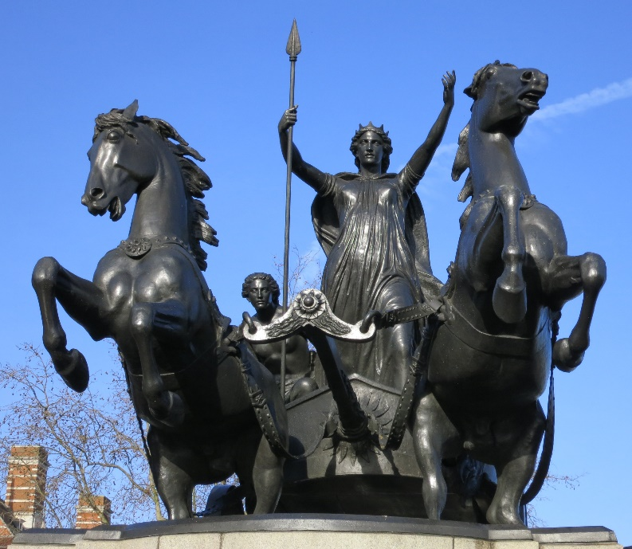

- Can you think of any reasons why Boudicca might have been portrayed in this way?

