HA Resource Hub Submission Form
Resource Title: Crime and Punishment through the Ages – Victorian times |  |  | Age Range:  Upper KS2
Author name and email contact:  Tim Lomas  tlomas@outlook.com | Resource Details: (e.g. how many documents does it consist of? In which order?)  10 source extracts, 2 pictorial images and a series of tasks/questions
Necessary prior learning to complete this:  Part of a post 1066 activity either as part of the Victorian period or as part of a development/thematic study on crime and punishment |  | What does it lead to next?  Either further work on the Victorian period or a broader study of crime and punishment over a wider period of time to place this in context
Explanation: How should this resource be used?
An opportunity for pupils to look at actual extracts from Victorian sources to assess what crimes were committed and the accompanying punishments. They are encouraged to express viewpoints, consider what mattered to the Victorians and how things compare to today. Pupils may also be able to look at websites to see what other crimes were being committed such as in their local area. These crimes were “less serious” ones so pupils may be able to see what other types of crime were committed and how things compared with other periods of history.

CRIME AND PUNISHMENT THROUGH THE AGES:
Victorian Crime and Punishment
Read the passages below. They are all taken from newspapers and they report crimes in Victorian times. After reading them, try to answer the questions below.

1. “A boy aged 15 was sentenced by Mr Barstow at the Clerkenwell Police Court on Tuesday to 2 days imprisonment for stealing 7 apples worth tuppence from an orchard at Highfields” (September 3 1881).

2. “A partner of an old-established firm of solicitors near Lancaster met a tramp the other day and gave him a penny. A policeman who saw the act took the tramp into custody for begging. Later that evening two young ladies called upon the solicitor and he gave them a shilling for the Ladies’ Jubilee Fund. He then asked them to take a seat and wait a while. A policeman was called and the solicitor gave the ladies into custody for begging. The policeman hesitated. The police superintendent was called who also hesitated. The solicitor would not give in until the tramp was released” (April 16 1887)

3. “Hannah Baxter aged 15 was sent to a reformatory for three years at Glasgow on Tuesday for pickpocketing. The court was told that she picked a police official’s pockets while being taken to the cells after her arrest” (December 4 1897)

4. “At the City Police Court on Monday two youths named Charles Youle and Frederick Odling were charged with having milked a cow on the West Common on Sunday morning. PX Clixby stated that he was returning from his beat when he saw the prisoners milk a cow and drink the milk. They then went away. He followed and took Odling into custody but Youle got clear away until he was arrested on Monday morning. The magistrates informed them they had committed a crime for which they were liable to be transported” (July 14 1857)

5. Private George Garrett, 93rd Highlanders, at Chatham received 50 lashes for threatening to throw his shoe at an officer (July 21 1857)

6. George Goodricke was sentenced to 7 days imprisonment at Scarborough on November 12 after being unable to pay a fine of 7s 6d. Goodricke was caught stealing a turnip from a field. He told the court he did it because he was hungry. He was arrested by the owner of the field who caught him with half a turnip under his arm and eating the other half

7. At Manchester on Tuesday George Carroll was charged with neglecting his children. Inspector Ashley of the NSPCC said the house consisted of one room up and one room down. It was found to be in a terrible state of filth. The room upstairs was used as a bedroom by the prisoner, his wife, their three children, a step daughter and a lodger and a s a cote for 30 pigeons. (February 10 1894).

8. At Oldham Police Court, a youth was charged with blocking the footpath by talking with another person. The magistrates said that the footpath was for walking on not talking on and fined the youth (September 18 1880).

- What are your first impressions about the crimes and punishments here?
- Can you put them into different groups?
- What does this say about what people felt was important at the time?
- How would these crimes and punishments be seen today? Are there some that may be regarded differently today?
- Besides crime what can these tell us about life at the time?

Once you have answered these questions look at the two pictures below.

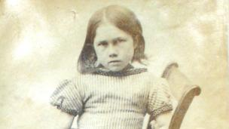

This is a photograph of a girl age 7 who was sentenced to 7 days hard labour at Oxford for stealing a pram.

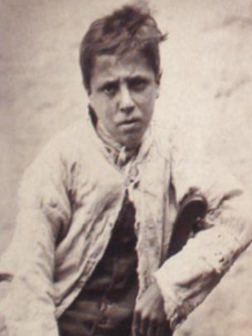

This is a photograph of a 13 year old boy sentenced to 14 days in prison for stealing a leather strap.

Do these two photographs surprise you after reading the 10 crimes and punishments above?

