HA Resource Hub Submission Form
Resource Title: Take one image- World War 2 |  |  | Age Range: 8-11
Author name and email contact:  Paul Bracey  Paul.Bracey@northampton.ac.uk | Resource Details: (e.g. how many documents does it consist of? In which order?)  A4 Activity sheet (Resource 1)  You need a primary school history textbook (easily purchased online) or website related to World War 2.  https://www.bbc.co.uk/teach/school-radio/history-ks2-world-war-2-clips-index/zjc8cqt  Bingham, J. (2015) World War 2 (Explore!) London: Wayland
Necessary prior learning to complete this:  Nothing required  However, it is appropriate to say something about re-enactments. They are very popular both in schools and with organisations such as English Heritage and are great fun. However, we need to ask ourselves how far a re-enactment tells us about the time especially as it typically focuses on one event. |  | What does it lead to next?  You could look at aspects of the peoples' lives during this period (e.g. evacuees, the, rationing, the role of women) in depth.
Explanation: How should this resource be used?
Step 1: Share the question - your child is going to look at a picture and decide how well it tells them about World War 2
Step 2: Ask your child to put aside anything they know about the topic and look at the picture and pick out the 3 adjectives which sum up what it tells us.( The picture shows pilots at a critical stage of the war.)
Step 3: Your child should justify their choice of words on the sheet
Step 4: Find out what you child knows about this time and how well they think the picture sums up what life was like for everyone.
Step 5: Spend the next few hours or days reading/find out about the lives of different people's lives in and events in during the war. Here are some suggestions:
- the main events of the war in Britain and the world.
- the lives of both people in the armed services
- the Blitz and bombing during the war in both Britain and Germany (e.g. compare Coventry and Dresden)
- the role of civilian men and women during the war - factory and land work
- children during the war , evacuees and kindertansport
- the role of people from different ethnic groups and the empire
You do not have to cover everything about the time but enough to show something about the lives of different people.
Step 5: Go back to your sheet and ask your child to look back at the picture again and decide how far they think it sums up the lives of people at the time. Ask them if they have changed their mind and why.
Special note: You can use this approach with any topic - however it needs to be followed up by looking at peoples' lives at a different time in the past. A template (Resource 2) is included should you wish to do this.

Take one image - How much does this photograph tells us about World War 2?
.
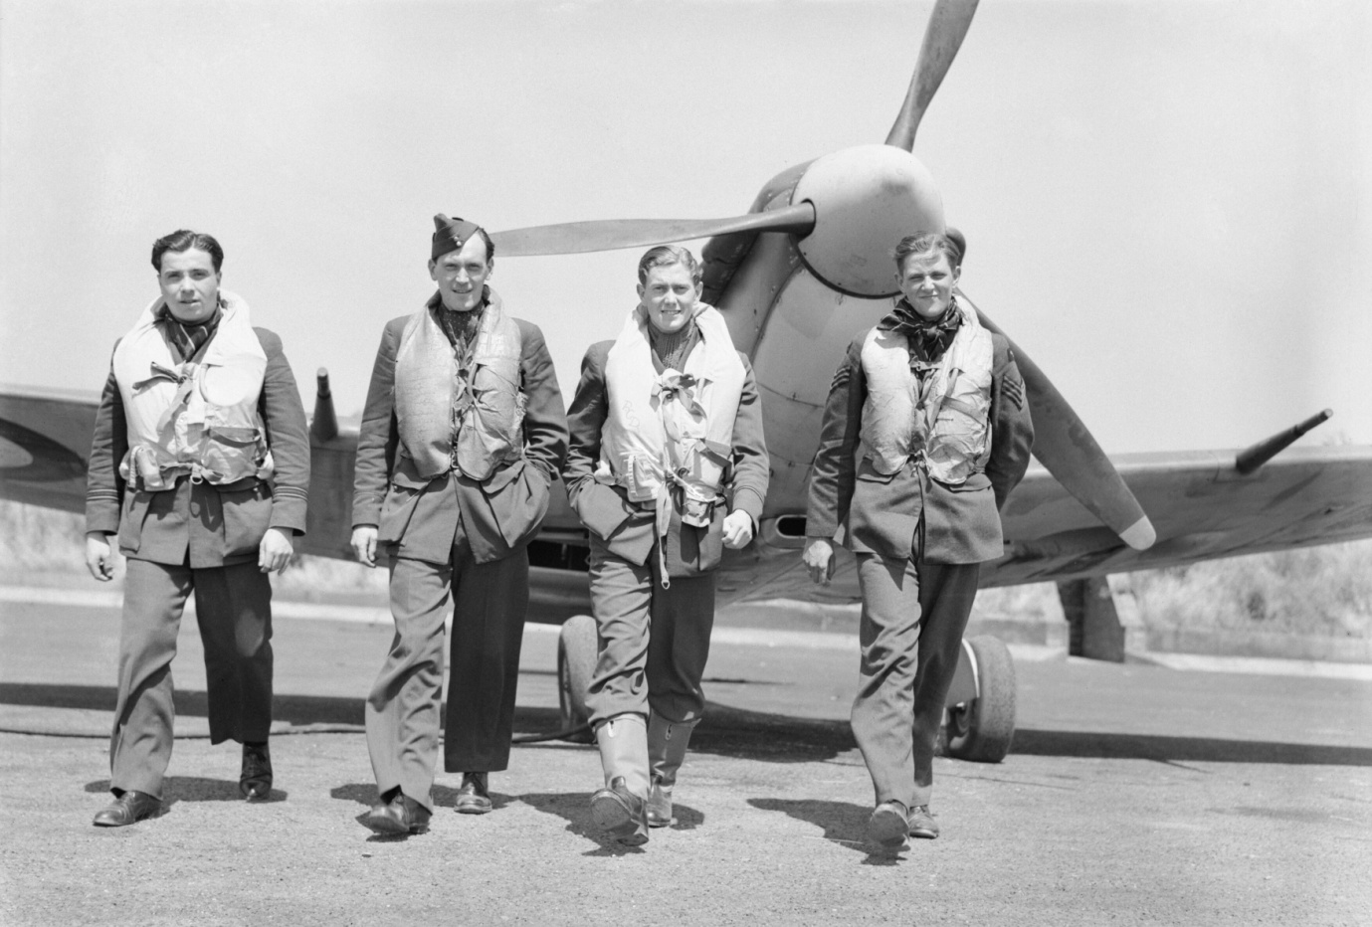 Pilots of No. 611 Squadron walk away from a Supermarine Spitfire Mk V at Hornchurch after a daylight sweep over France, 7 July 1941.
Imperial War Museums. IWM Non Commercial Licence.
https://commons.wikimedia.org/wiki/File:Pilots_of_No._611_Squadron_walk_away_from_a_Supermarine_Spitfire_Mk_V_at_Hornchurch_after_a_daylight_sweep_over_France,_7_July_1941._CH3056.jpg

Rich poor colourful fun dangerous

happy sad busy nice horrible
Any word or words which you would prefer..................................

1. I have chosen................... because......................................................................................
2. I have chosen....................because........................................................................................
3. I have chosen....................because............................................................................................

Activity 2: Now find out about life during World War 2 using a textbook or website

Activity 3: How well does the photograph sum up the time? Choose one of the following
- very well
- partially
- not at all
Complete the following but avoid copying information from texts
I have chosen ...................................................because...............................................................
......................................................................................................................................................
........................................................................................................................................................

Have I changed my mind since activity 1? Give a reason for your decsion
...............................................................................................................................................................
................................................................................................................................................................
..................................................................................................................................................................

