HA Resource Hub Submission Form
Resource Title: Empire soft hard power legacy cards |  |  | Age Range: KS3
Author name and email contact:  Helen Snelson  enquiries@history.org.uk | Resource Details: (e.g. how many documents does it consist of? In which order?)  6 pages
Necessary prior learning to complete this:  British Empire |  | What does it lead to next?  Study of 20thC Britain to present day
Explanation: How should this resource be used?
This set of cards can be used to explore the remaining legacies of Britain’s Empire for Britain’s soft and hard power in the world today. It therefore fits after a study of Empire. It has been used by explaining soft and hard power as terms, then getting students to draw a continuum line and to decide where on the line each goes. In an ideal world, students then compare lines and discuss differences of opinion.

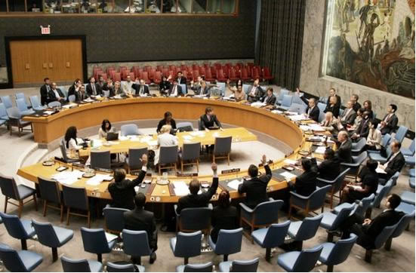
Britain’s role in the world
Britain has declined in economic power since 1945. However, because it used to be the world’s most powerful country, in it has one of the five permanent places on the United Nations Security Council, which was set up in 1946. It is the council’s job to maintain world peace and security.
Britain is also a key member of NATO, the military alliance of North American and European countries. Although Britain’s armed forces are smaller than they used to be, they are still relatively large compared to those of other countries, for example Germany. This again is a legacy of Empire. During the time of the Empire the British navy was large enough to control all the seas of the world.

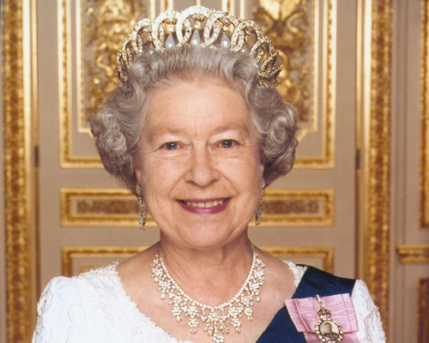
The Queen as a head of state
The Queen is the head of state of the United Kingdom and Northern Ireland. That means she has an important role in the constitution. No law passed through Parliament can become law until she has signed it. She is also head of state of 15 other countries in the Commonwealth. These are countries which were colonies and now have their own independent governments and parliaments, but still have the Queen as the head of state. Examples of these 15 countries include Canada, New Zealand, Australia and Jamaica. Other former colonies are in the Commonwealth, but the queen is not head of state. For example, India is a republic, it has a president. There is a strong movement to become a republic in Australia.

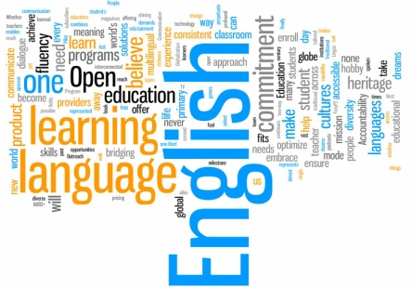
English as an international language
English is a language which at first evolved in the British Isles. It is now the leading world language. This is partly due to the spread of the British Empire. English was the language of government for one third of the world’s people in 1920. Mandarin and Spanish are spoken by more people as a first language than English. However, English is the world’s most often used language, spoken by over 1 billion people. 89% of students in the European Union learn English as their first foreign language in their schools. It is an official language in 54 countries and of international organisations such as the EU and the UN. When the United States gained its independence from the British Empire in 1776, they chose to adopt English as the official language. Therefore, when the USA took over as a superpower from Britain at the start of the 20th century, English continued to spread. India is regarded as an emerging superpower and English is one of its official languages. Today you will often hear people who do not have English as a first language using English to communicate.

Shared heritage around the world
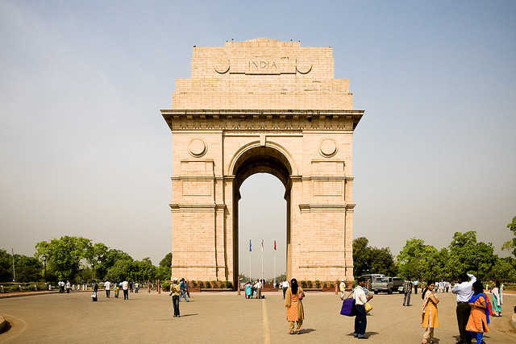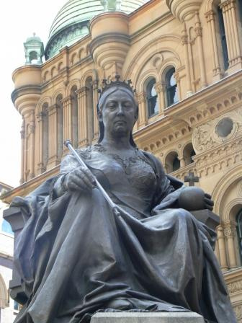
Lutyens’ India Gate, New Delhi, India Statue of Queen Victoria, Sydney, Australia
British culture has provided a shared heritage around the world. You will find productions of Shakespeare’s plays in many of the world’s countries. The most visible shared heritage is buildings. In India, for example, there are some of the greatest examples of the work of the great British architect Edwin Lutyens. You will also find statues of Queen Victoria in unexpected places!

Immigration and Emigration
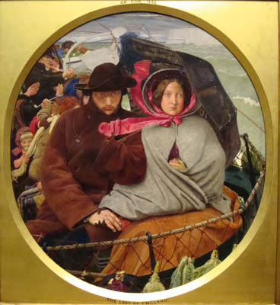
People are often surprised to learn that until 1983 there were more people leaving the UK each year than arriving to live here. Some sources estimate that 11 million people left Britain between 1700 and 1950 in order to make a new life overseas. Many of these went to the colonies, particularly Canada, New Zealand, Australia, and, before and after independence, the United States. Since the 1950s people from the former colonies have come to live in Britain. Many of them regarded Britain as home. They had learnt all about Britain in school, fought for Britain in the two world wars and worked to make the British economy the strongest in the world.

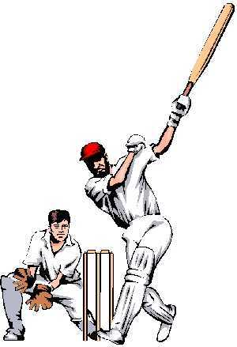
Sport
Sport is used as a way to bring nations together in healthy competition. There are close sporting ties across the Commonwealth. The British Empire Games started in 1930 and are held every four years. In 1978 they took their current name, the Commonwealth Games. There are also Commonwealth Youth Games. Many sports which originated in Britain are played across the Commonwealth countries. The most famous of these are cricket and rugby. One of the most famous competitions in cricket is the Ashes, played between Australia and England every four years.

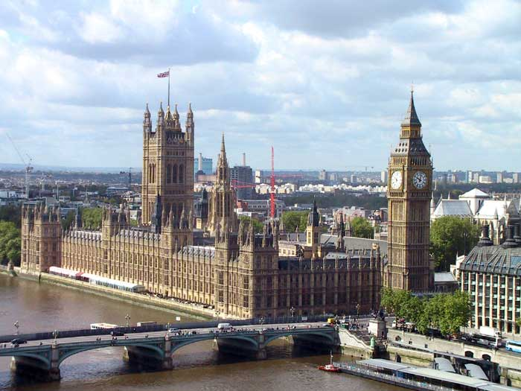
How government works
In the UK we have a system of government often called the Westminster system. The UK Parliament sits in the Palace of Westminster. There are lots of different ways of running a country and the Westminster system is just one of them. It includes a head of state with a ceremonial role. That means she or he does not get involved in day-to-day politics. It has a first, or prime, minister who heads the day-today government. It has a cabinet of people who also run the government. It has a parliament which is multi-party and elected in at least one part of it. Due to the British Empire, this system of government is now used in many parts of the world. Countries with a system based on the Westminster model include, Bangladesh, India, Israel, Canada, Pakistan, Singapore and Ireland.

Value of a British education
Historians have long studied how Britain's great public schools (Eton, Harrow, Winchester etc) helped the growth and maintenance of her empire. Boys were prepared for life serving the Empire with military discipline, a focus on sport and by patriotic headmasters and popular literature. Wealthy boys from the colonies also went to these schools, for example Nehru. Today these schools still have a status on the world stage that makes them sought after by the world’s rich. For example, Sherborne School has a branch in Qatar. Many countries in Africa still model their exam system on the old English O level exam. The leading UK universities are still among the best in the world, attracting many overseas students.

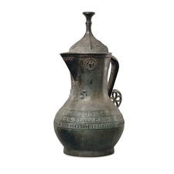
The Asante Ewer
Medieval English, about AD 1390-1400
Found in the Asante kingdom (modern Ghana), West Africa
This ewer was discovered in 1896 in the Asante kingdom on the west coast of Africa. It represents a rare survival of a lidded bronze vessel from the last years of the fourteenth century. The astonishing fact of its survival is matched by its intriguing find spot.
On the front of the jug are the royal arms of England that were current from AD 1340 to 1405. The manufacture of the jug was in the last years of the reign of Richard II, who used the symbol of the white hart between 1390 and 1399.
What brought the ewer to the west coast of Africa? Two other English bronze jugs from the late fourteenth century were found at Kumasi at the same time as this example. This may suggest that they left England as a set and that they all originated from the household of Richard II. However, the mystery behind their arrival at the Asante kingdom is still unsolved. A photograph from 1887 shows the jug placed under a sacred tree in a royal palace, suggesting that these items were held in high regard by the Asante people.
(Source: www.britishmuseum.org)

- Think! What does this mysterious object suggest to us about Britain’s connections with the rest of the world?

