HA Resource Hub Submission Form
Resource Title: Significant individuals/ similarities and differences. |  |  | Age Range:Y2-Y4
Author name and email contact: Ailsa Fidler | Resource Details: (e.g. how many documents does it consist of? In which order?)  One document with two potential sheets to complete.
Necessary prior learning to complete this:  The children may have covered a significant individual/event or place when they were in Year One or Two, this can be drawn upon for this activity- what made the even or person important? |  | What does it lead to next?  The children can be asked to research a chosen significant individual, with support and present their findings, this could be done through a short film, podcast or even a family drama!  Children can also go on to look at the Titanic and what it tells us about life in the Edwardian period.  Children may also want to explore back a further hundred years- what was life like in the given areas in 1820, 1720 so that they track changes over time.
Explanation: How should this resource be used?
Significant Individuals
David Lloyd George was PM during the Spanish Flu epidemic in 1918, he was still PM in 1920 so is a useful person to compare with Boris Johnson.
Ways to decide if someone is significant/important include Ian Dawson’s criteria which are if s/he:
changed events at the time they lived.
improved lots of people's lives - or made them worse.
changed people's ideas.
had a long lasting impact on their country or the world.
had been a really good or a very bad example to other people of how to live or behave.
For sheet one therefore- children can be asked to explore whether Boris Johnson and David Lloyd George are significant and why, they can also be asked who, at this point is the most significant?
Information about David Lloyd George can be found here:
https://www.gov.uk/government/history/past-prime-ministers/david-lloyd-george

Information about Boris Johnson can be found here:
https://www.britannica.com/biography/Boris-Johnson

You could choose 4 or 5 key things from each of their lives, write them out in a child friendly sentence and do a treasure hunt around the house for them. Ask the child(ren) to choose what they think are the most important ones and to give a reason for their answers.
If you do a comparison, remember that there is no right answer about who is more significant- as long as the opinion the child gives is backed up with some evidence.

This could lead on to work on other significant people:
https://www.nationalarchives.gov.uk/education/resources/significant-people/

Then finally, the children could choose one of the ones from the above resource and find out as much as they can about them and how life in Britain has changed since they were alive.
Similarities/differences.
It is also possible to consider how life has changed since Edwardian times.
This BBC Bitesize are is related to the Titanic (which you may wish to go on to explore) but gives an overview of what life was like for children in Edwardian times- although you may wish to discuss what it was like for poor children and equally very rich children.

https://www.bbc.co.uk/bitesize/topics/z8mpfg8/articles/z639dxs

This may also be helpful:
https://nationalarchives.gov.uk/documents/education/edwardian-schools.pdf

Significant Individuals?

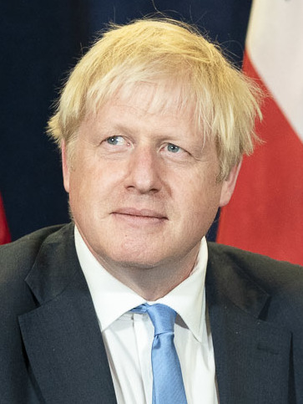
Why is he important? Can you think of 3 reasons?
What does he do?
Who is this?
This Photo by Unknown Author is licensed under CC BY-SA
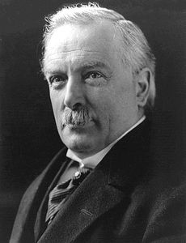
Why was he important? Can you find 3 reasons?
What did he do?
Who is this?
This Photo by Unknown Author is licensed under CC BY-SA

Similarities/Differences

Complete the table below.
What was life like for a child in 1920? How is it the same/different to life for you now?
1920 | 2020
House | House
School | School
Shopping | Shopping
Toys | Toys
Leisure time | Leisure time
Explanation: How should this resource be used?
Significant Individuals
David Lloyd George was PM during the Spanish Flu epidemic in 1918, he was still PM in 1920 so is a useful person to compare with Boris Johnson.
Ways to decide if someone is significant/important include Ian Dawson’s criteria which are if s/he:
changed events at the time they lived.
improved lots of people's lives - or made them worse.
changed people's ideas.
had a long lasting impact on their country or the world.
had been a really good or a very bad example to other people of how to live or behave.
For sheet one therefore- children can be asked to explore whether Boris Johnson and David Lloyd George are significant and why, they can also be asked who, at this point is the most significant?

Information about David Lloyd George can be found here:
https://www.gov.uk/government/history/past-prime-ministers/david-lloyd-george

Information about Boris Johnson can be found here:
https://www.britannica.com/biography/Boris-Johnson

You could choose 4 or 5 key things from each of their lives, write them out in a child friendly sentence and do a treasure hunt around the house for them. Ask the child(ren) to choose what they think are the most important ones and to give a reason for their answers.

If you do a comparison, remember that there is no right answer about who is more significant- as long as the opinion the child gives is backed up with some evidence.

This could lead on to work on other significant people:
https://www.nationalarchives.gov.uk/education/resources/significant-people/

Then finally, the children could choose one of the ones from the above resource and find out as much as they can about them and how life in Britain has changed since they were alive.

Similarities/differences.
It is also possible to consider how life has changed since Edwardian times by looking at what is the same and what is different.
This BBC Bitesize are is related to the Titanic (which you may wish to go on to explore) but gives an overview of what life was like for children in Edwardian times- although you may wish to discuss what it was like for poor children and equally very rich children.

https://www.bbc.co.uk/bitesize/topics/z8mpfg8/articles/z639dxs

This may also be helpful:
https://nationalarchives.gov.uk/documents/education/edwardian-schools.pdf

