Resource sheet 2.2A
Korean War photo pack
Source A
Private Frank Holden of the 1st Battalion, The King’s (Liverpool) Regiment, cleaning his Browning machine gun in Korea.

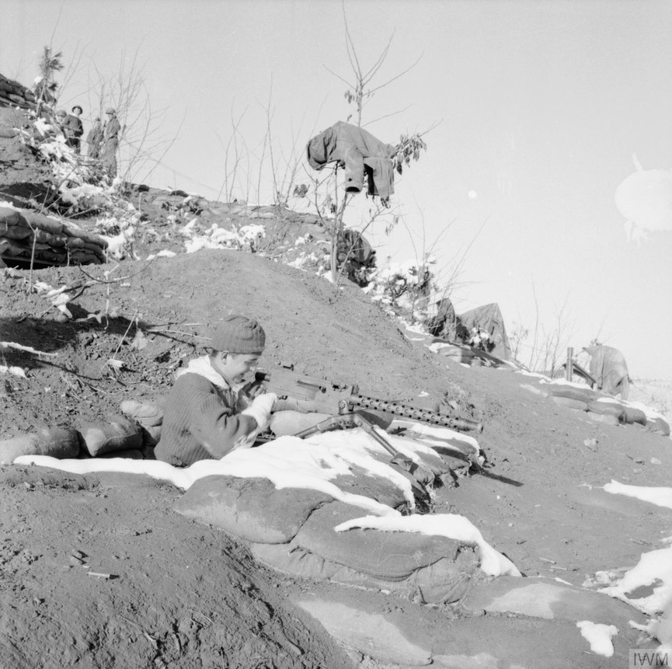

www.iwm.org.uk/collections/item/object/205190661
© IWM BF 10896

Source B
Men of the 1st Battalion, The Royal Ulster Rifles in ‘Happy Valley’, north of Seoul, just before the Chinese attack of 2 January 1951.

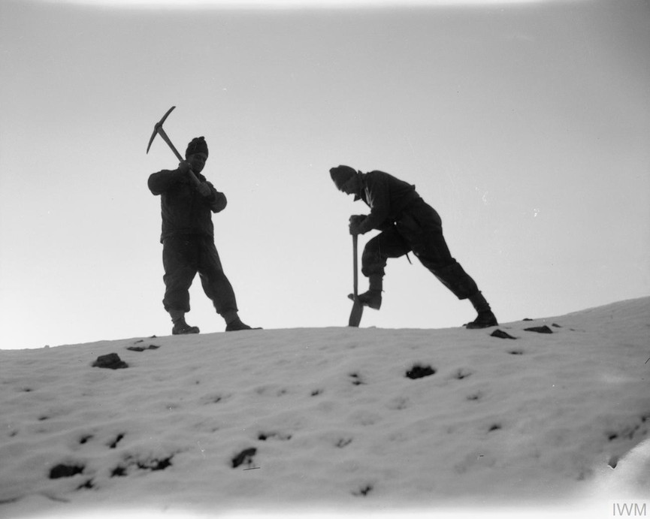

www.iwm.org.uk/collections/item/object/205190848
© IWM BF 223
Source C
A British soldier talks with Korean children.

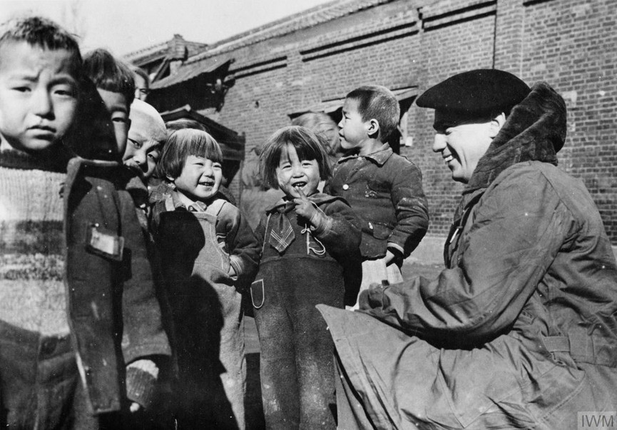

www.iwm.org.uk/collections/item/object/205190740
© IWM MH 32850

Source D
The King’s Own Scottish Borderers during an intensive bombardment of Chinese-held hills. Left to right: Lance Corporal Bill Hunter; Private Jim Beveridge; and Private Tony Donaldson.
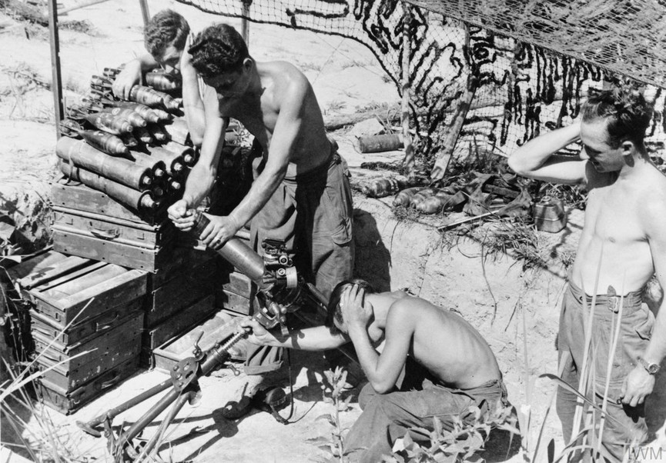

www.iwm.org.uk/collections/item/object/205191685
© IWM BF 10896

Source E
The King’s Own Scottish Borderers: Lance Corporal John Private John Dunbar, Private John Devine (with rifle) and Lance Corporal Ted Arbuthnott watch for enemy movement across the valley.
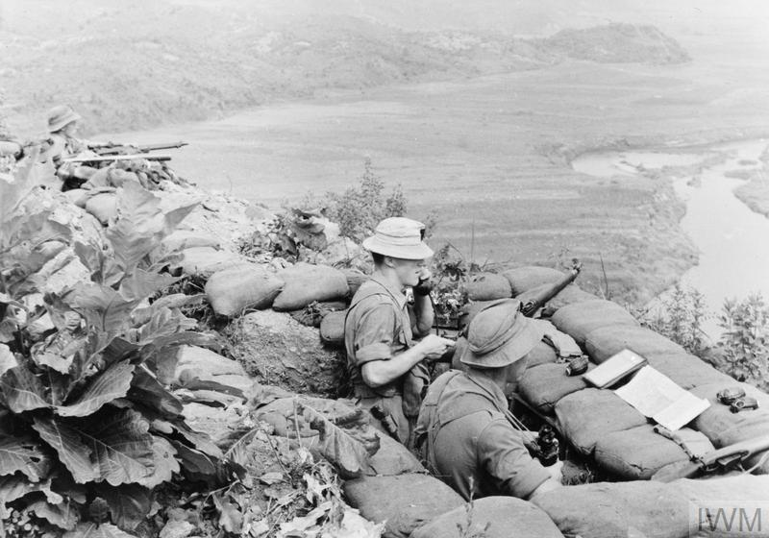
www.iwm.org.uk/collections/item/object/205191682
© IWM KOR 607

Source F
A means of communication used by the Chinese fighters.

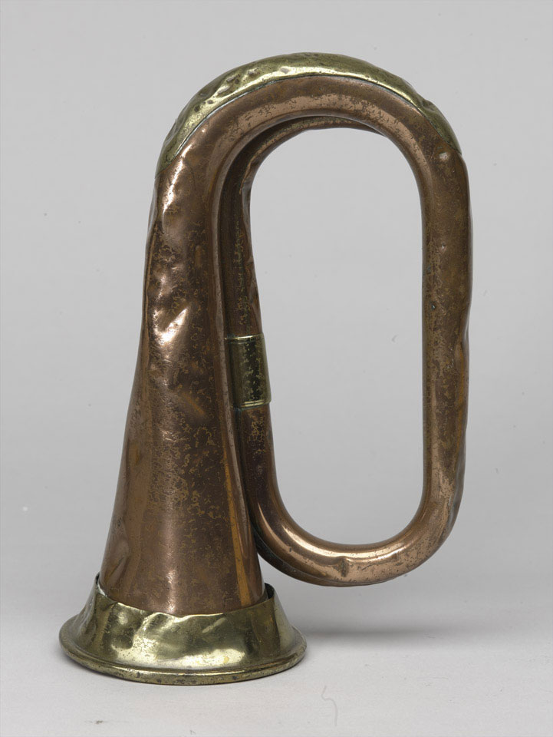

https://collection.nam.ac.uk/detail.php?acc=1997-07-44-1
Image courtesy of the National Army Museum, London

Source G
Korean families made homeless and fleeing the fighting.

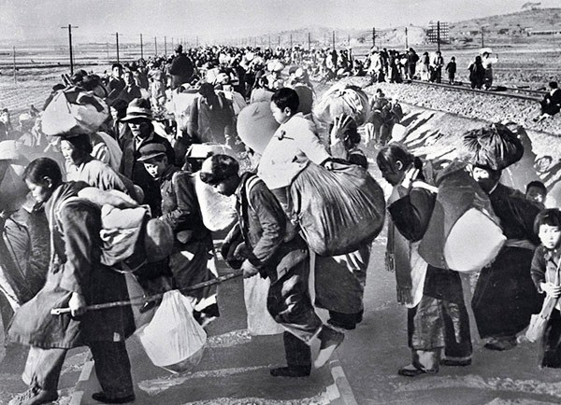

https://commons.wikimedia.org/wiki/File:South_Korean_refugees_mid-1950.jpg
US Defense Department
Source H
American bombers in action.

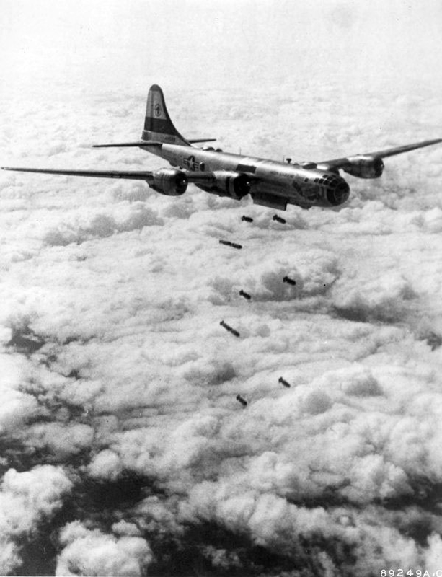

www.goodfreephotos.com/historical-battles/korean-war/b-29-superfortress-bomber-unloading-bombs-during-korean-war.jpg.php
US Air Force
Source I
American bombs falling on Wonsan in North Korea.
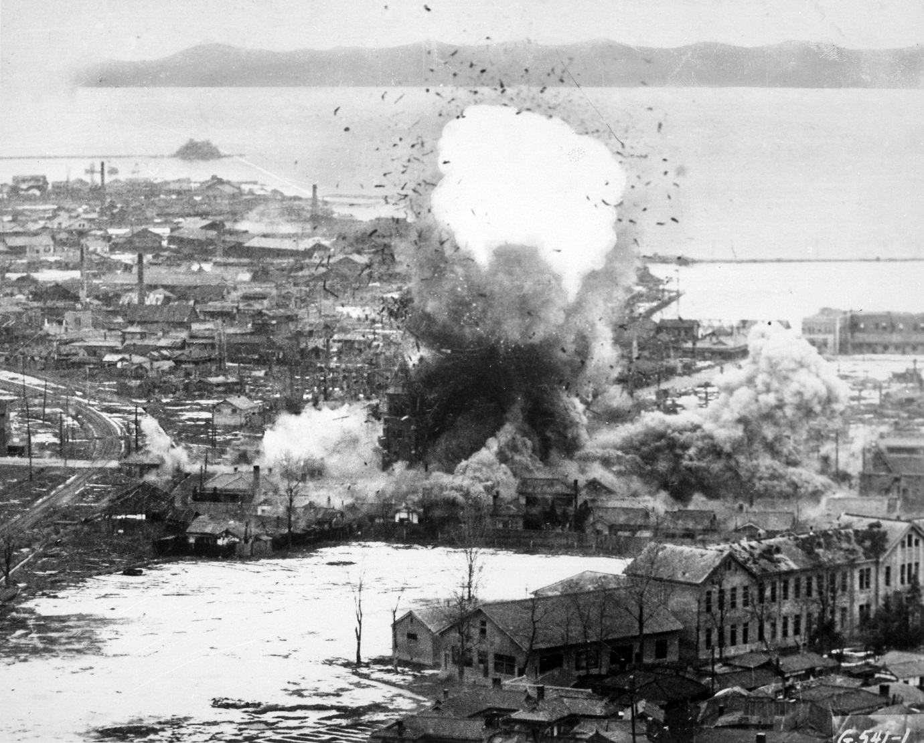

www.goodfreephotos.com/albums/historical-battles/korean-war/b-26-invaders-bomb-logistics-depots-in-wonsan-north-korea-korean-war.jpg
US Air Force
Source J
Men of the 1st Battalion, The Royal Ulster Rifles dug deep defensive positions in Korea.
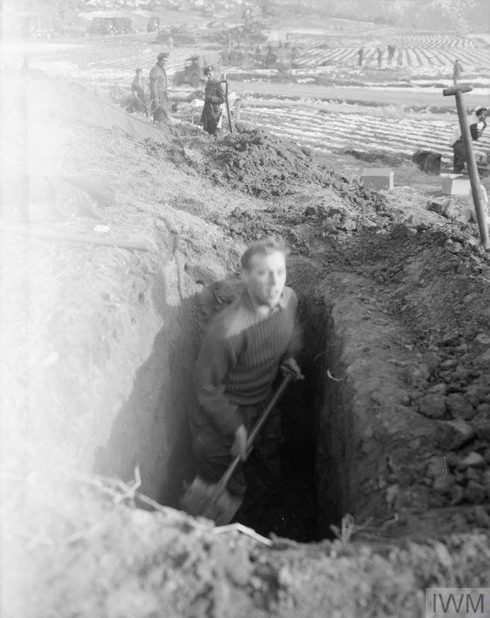

www.iwm.org.uk/collections/item/object/205190850
© IWM BF 224

