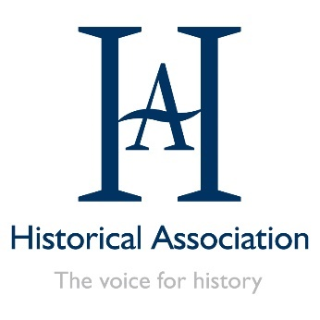
HA webinar series: A great curriculum is like a great museum
  - Booking request form
Please complete and return this form to events@history.org.uk.

Delegate contact
First Name: | Surname:
Position: | Organisation:
Telephone: | Email:
Please note that one booking is required per person/device listening live. If you wish to make a booking for multiple members of your department, you can copy this section for each colleague to be invoiced together.

Delegate information
Historical Association Membership Number:

How did you hear about this webinar series?

An active membership number is required for the HA member discount to apply.

Finance and invoicing
Billing address:

Purchase Order number (where required): | Email for invoicing:

Pricing structure
Each individual webinar is available to book online via Eventbrite and a discount is available for those who wish to book for multiple webinars in the series using this form. All prices listed are subject to VAT, as well as Eventbrite fees if booked online.
Please note that we are only able to process manual bookings and invoices for block bookings of all 4 webinars, otherwise an online booking must be made using Eventbrite for each webinar.
Number of webinars booked | HA Member | Non-member
1 webinar | £30 | £50
3 webinars | £80 | £140

Programme selection
For all webinars we recommend listening live in order to interact with the presenter(s), but if you can't participate live then a recording link will be made available to all registered delegates.
Webinar | Date | HA member | Non-member
Choosing the right curriculum | Wednesday 9 December, 16.00–17.00
Using the best pedagogy to make your curriculum work | Wednesday 20 January, 16.00–17.00
Using effective assessment to see if your curriculum has worked | Wednesday 10 February, 16.00–17.00
Total cost (excluding VAT)

If you would like to book for an individual webinar in this series, please book online using Eventbrite:
- Choosing the right curriculum:
https://www.eventbrite.co.uk/e/124143684101
- Using the best pedagogy to make your curriculum work:
https://www.eventbrite.co.uk/e/124238902903
- Using effective assessment to see if your curriculum has worked:
https://www.eventbrite.co.uk/e/124240437493

Terms and Conditions
Please note that completing this form does not constitute a confirmed booking. You will be asked to confirm your booking upon receipt of an invoice. Please read through the HA CPD terms before booking at https://www.history.org.uk/go/cpd-terms-conditions.
Please tick this box to confirm you have read these conditions:

Data protection
We collect your personal data in order to fulfil your event booking with us and provide you with the services you have signed up for. Please read our Privacy Notice at http://www.history.org.uk/go/privacypolicy for further information or contact us on data@history.org.uk.

