Corporate webinar recording offer
  - A guide for corporate members on how to redeem and book your free recording
- You will be sent an email from the HA membership team with a unique access code for you to use to book your ticket. This will begin with CORP- and will include your organisation’s membership number.

- Visit the booking page on Eventbrite for the webinar you wish to use the offer against. Please note that you will not be able to watch a webinar live using this offer, only view the recording.

- On the Eventbrite page, click on the Tickets button:

- A pop-up window listing different ticket options will appear. Click on Enter promo code

- Type in your unique access code and click Apply

- A new ticket option will appear called HA corporate member – free webinar recording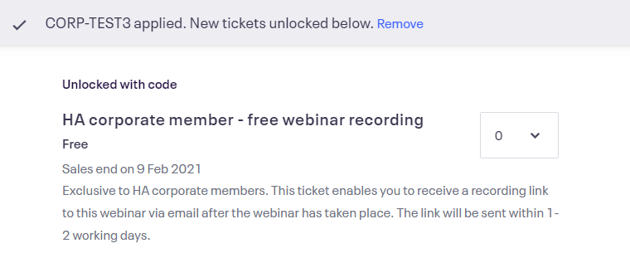
- Select 1 ticket for this ticket option using the dropdown menu and click Checkout
- Follow the instructions on the booking page and click Register when finished to complete your registration. Make sure to register your email address as the one that you would like sent the recording.

- You will receive a confirmation email from Eventbrite confirming your booking.

- 1-2 days after the webinar has taken place, you will receive an email to the address you registered with a link to view the recording. The recording will be hosted on Zoom and is accessible using your internet browser. Please note that the recording will usually be available to view for a time-limited period.
Please refer to the terms and conditions for further information:
https://www.history.org.uk/go/corporate-recording-terms

