Year 7: Who were the ‘rulers of the sky’?
Title: Who were the ‘rulers of the sky’?
LO: Explain how Oba Ewuare combined magic and military might
Task 1:
- Where might you find these artefacts?
- What do you think they might be used for?
- What can you infer about the people who made them?

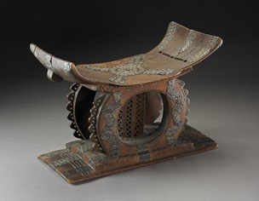
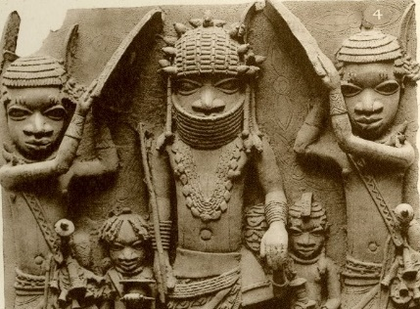

This half term we are studying medieval Africa. We will consider the kingdoms of Benin and Asante (modern-day Nigeria and Ghana).
Task 2: Recap using a mind-map everything that you have learned about medieval England.
Challenge: What were the misconceptions that people had about medieval England and how did we use evidence to challenge them?
Misconceptions about medieval Africa
One of the legacies of the transatlantic slave trade (we will learn more about this in Year 8) is misconceptions about Africa. Lots of people nowadays believe that Africa was not developed or that societies were not complex or wealthy. This is a misconception – it is not true. It has sometimes been difficult for historians to study African history because many African societies were destroyed when they were invaded by the British or other European countries.
Our enquiry question for this half term is: What can we learn from the kingdoms of Benin and Asante about African histories?
Task 3: Why do you think that the question talks about African histories and not African history?
Task 4: Copy this table onto a whole piece of A4 paper. You need to keep this safe as you will be adding evidence to it throughout the term. This is your enquiry tracker, and you will use it to track your learning.
Myth | Evidence from the Benin Kingdom to challenge the myth | Evidence from the Asante Kingdom to challenge the myth
1. Africa has historically been cut off from the world | 1 | 5
2. Africa had no place in shaping the modern world | 2 | 6
3. African history can only be written through European documents | 3 | 7
4. African history doesn’t change or develop (Hegel) | 4 | 8

Insert map from: www.pinterest.co.uk/pin/96897829461903257/
Task 5: Use the map to the left to find the Benin and Asante kingdoms.
Using a map of modern Africa, Google or an atlas, work out which African countries today would have made up the kingdoms of Asante and Benin.

For the next two weeks, we will be focusing on the Kingdom of Benin, which was in modern-day Nigeria.
Task 6: Summary task: Read through the text below about the beginning of the Benin Kingdom and use the words to fill in the gaps.
According to __________, the great god Osanobua created the world. Olokun, his eldest son, became the god of the waters. Obiemven, his daughter, was put in charge of farming and childbirth. Ogiuwu, his youngest son, became the king of death. Around the year 900, groups of Edo people (people who lived around the _________ delta) began to cut down _____ and make clearings in the rainforest. At first they lived in small ______ groups, but gradually these groups developed into a _________.
The kingdom was ruled by a series of kings, known as Ogisos, which means ‘______ of the sky’. In the 1100s there were _________ for power and the _______ lost control of their kingdom. The leaders of different villages began to fight one another. To help restore peace, the _____ people asked a prince from Ife, in the nearby Yoruba Kingdom, to help. The Prince Oranmiyan chose his son to be the first Oba (king) of Benin. Eweka was the first in a long line of Obas, who reached the peak of their power in the 1500s under Oba Ewuare. People believed that the Obas (______) of Benin were the direct descendants of ________, the creator god. The Obas were all ___________ as gods.
Words to fill the gaps: Nigerian, family, rulers, struggles, worshipped, Edo, kings, Osanobua, Ogisos, kingdom, trees, legends
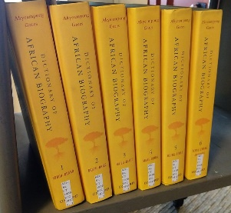
Who was the first Oba of the Benin Kingdom?
Task 7: Use the information about Oba Ewuare below to create a page for the Dictionary of African Biography.
Your biography should include at least three key dates in a short timeline, an explanation of their achievements and a quote from a historian.
Oba Ewuare was the ruler of the Benin Kingdom from 1440 until 1473. Ewuare became king in a violent coup against his brother Uwaifiokun, which destroyed much of Benin City. After the war, Ewuare rebuilt much of the city of Benin, reformed political structures in the kingdom, greatly expanded the territory of the kingdom and fostered the arts and festivals. He left a significant legacy and is often considered the first King of the Benin Empire.
Keywords
Coup: a violent taking of power
Consolidate: to strengthen (make more solid)
Urbanisation: increasing the number of towns and cities
Administrative: to do with running an organisation
Ewuare was the first of the five great ‘warrior Obas’. During his 40-year reign, Benin became a strong and powerful kingdom. Ewuare began trading with Portuguese merchants, which made the kingdom wealthy and enabled the Oba to pay for a large army. In turn the army conquered new territories and expanded the kingdom.
Ewuare’s changes helped to consolidate the kingdom. He set up royal festivals designed to protect the kingdom, such as the Ugie Erhe Oba Festival dedicated to the Oba’s sacred ancestors, and Igue, which strengthened the Oba’s magic powers.
Ewuare also developed the Kingdom of Benin by improving the road system. These developments were helped by growing military power as Benin expanded its size.
In the decades before the Portuguese arrival in the 1480s, Benin expanded territorially as well as consolidating as a state. The historian AFC Ryder noted, ‘Oba Ewuare’s power was strengthened by his reputation as both a magician and warrior.’ There was a belief that the kingdom was magically gifted, which gave soldiers in battle strength and made them more likely to win. The people of Benin showed no signs of converting to Christianity and had confidence in their new religions.
In conclusion, Ewuare accelerated the urbanisation of Edo in the mid-fifteenth century and developed new titles and administrative structures. Another important feature of Ewuare’s rule was that he introduced several new religious beliefs, founded new shrines and established new festivals. The strength of Benin at the time of the Portuguese arrival and its ability to reject the demand for slaves were certainly partially down to the work of Oba Ewuare.

Image credits (not to be shared with students)
Task 1: Both images © The Trustees of the British Museum
Task 7: CC BY-SA 4.0/Phoebe/Wikimedia

