Year 7: What was life like in Great Benin?
Title: What was life like in Great Benin?
LO: Describe the grandeur of Great Benin/Edo, capital of the kingdom
This week you will be learning about Great Benin (also known as Edo and Benin City). Great Benin was the capital of the Benin Kingdom; it was where the Oba lived and it was very wealthy. Look at the engraving and labels of Great Benin below and answer the questions.
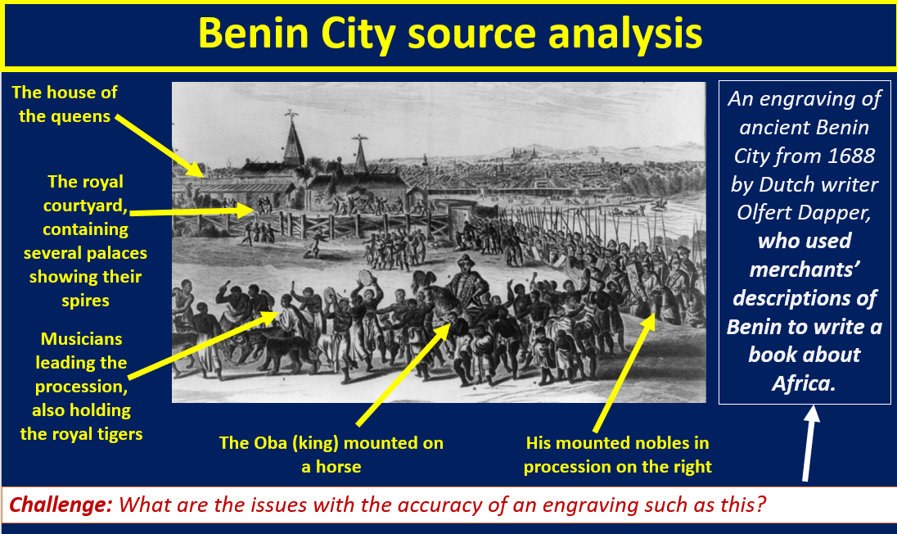
Task 1: Using the labels, what can you infer about Great Benin from this engraving?
P: I can infer…
E: The detail that shows me this is…

Challenge: What are the issues with the accuracy of an engraving such as this? Tip: Look at where the engraving came from and who made it.
What can sources tell us about Great Benin and the power of the Oba?
Task 2: Read the five sources about Great Benin and write a PEAL paragraph explaining what the sources tell us about life in Benin City and about the power of the Oba.
Source 1: Description of Great Benin by Lourenco Pinto, a Portuguese ship captain, in 1691
‘Great Benin, where the king resides, is larger than Lisbon; all the streets run straight and as far as the eye can see. The houses are large, especially that of the king, which is richly decorated and has fine columns. The city is wealthy and industrious. It is so well governed that theft is unknown and the people live in such security that they have no doors to their houses.’
Source 2: Archaeological evidence of the walls of Great Benin from scientist Fred Pearce
According to estimates by the New Scientist’s Fred Pearce, Benin City’s walls were at one point ‘four times longer than the Great Wall of China, and consumed a hundred times more material than the Great Pyramids’. Pearce writes that these walls ‘extended for some 16,000 km in all, in a mosaic of more than 500 interconnected settlement boundaries. They covered 6,500 sq km and were all dug by the Edo people… They took an estimated 150 million hours of digging to construct, and are perhaps the largest single archaeological phenomenon on the planet.’
Source 3: Description by the British Captain John Adams regarding presents to the Oba
‘It is the practice here for masters of vessels to pay the king a visit soon after their arrival and such a ceremony is seldom allowed to be dispensed with, as on these occasions the black monarch receives a handsome present, consisting of a piece of silk damask, a few yards of scarlet cloth and some strings of coral.’
Source 4: Dutch trader Dirck Ruiters, who visited Benin City in 1602
‘They bring all sorts of things to sell, such as live dogs, of which they eat many, roasted monkies, catfish, rats, parrots, fowls, yams, manigette pepper in pods or ears, dried lizards, palm oil, large beans, as well as various sorts of fruits, vegetables and animals fit for food. Much firewood and woodwork, such as dishes and drinking cups and other sorts are also brought to market for sale. Also much thread spun from cotton, of which they make their clothes... they also bring a great quantity of ironwork to sell there, such as implements for fishing, ploughs, and otherwise preparing the land.’
Source 5: Description of the Oba’s palace in Benin City by Olfert Dapper
‘The king’s court is square, and stands at the right hand side when entering the town by the gate of [Gwatón], and is certainly as large as the town of Haarlem [near Amsterdam, in the Netherlands]... it is divided into many magnificent palaces, houses, and apartments of the courtiers, and comprises beautiful and long square galleries, about as large as the Exchange at Amsterdam, but one larger than another, resting on wooden pillars, from top to bottom covered with cast copper on which are engraved the pictures of their war exploits at battles, and are kept very clean.’
The Lost Kingdoms of Africa
Task 3: Watch the clip of Gus Casely-Hayford and make notes on what you can learn about Benin City.
4:50 mins to 7:40 mins: www.youtube.com/watch?v=QW_kaUuUg8Y
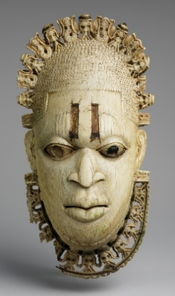
How important was the mother of the Oba?
The kingdom of Benin (in present-day Nigeria) was plunged into a state of turmoil at the end of the fifteenth century when the Oba (king) Ozolua died and left two powerful sons to dispute succession. Oba Ozolua was the son of the founder of the Benin Kingdom – the powerful Oba Ewuare.
His son, Esigie, controlled Benin City, while another son, Arhuaran, was based in the equally important city of Udo, about 20 miles away. The ensuing civil war severely damaged Benin’s power and undermined Benin City’s place at the political and cultural centre of the kingdom.
Esigie ultimately defeated his brother and re-established the unity and military strength of the kingdom. His mother, Idia, received much of the credit for these victories, as her political advice together with her mystical powers were viewed as important elements of Esigie’s success on the battlefield. To reward and honour her, Oba Esigie created a new position within the court called the Iyoba, or queen mother, which gave her significant political privileges, including a separate palace with its own staff.
As mother of the king, Idia and, later, Iyobas had considerable power. Until recent times, the queen mother, who gave birth to the Oba’s first son, had no other children and devoted her life to raising the future ruler of the kingdom. Queen mothers were therefore viewed as crucial to the protection and wellbeing of the Oba and also the kingdom. Indeed, Obas wore carved ivory masks representing their mother, the Iyoba, during ceremonies.
There is an example of a mask of the Iyoba in the British Museum (pictured above). It is believed to picture Idia herself. The top of the mask is decorated with heads representing the Portuguese, symbolising Benin’s alliance with and control over Europeans. Within the court, the queen mother’s political status was equal to that of a senior chief, and she enjoyed the right to order the making of precious works of art for personal and religious use.
Task 4: Answer the questions below on the importance of the queen mother in Benin.
- What happened when Oba Ozolua died?
- Who won the war?
- Why did his mother Idia receive much of the credit?
- What did Oba Esigie do to reward and honour his mother?
- What evidence is there that the Iyoba had significant power?
- What did Obas wear during important ceremonies?
- What is on the ivory mask and what does it symbolise?
Task 5: Imagine that you are a traveller to Benin City in the seventeenth century. Write a diary entry explaining what you have seen.
You might explain:
- Your first views of Benin City from outside of the walls
- A description of the Oba’s palace and what you saw there
- An explanation of who is powerful in Benin, for example the Oba and the Iyoba

