Year 7: Who were the Asante people?
The images are copyright and have no free substitutes.
They would have to be linked from within the document which would probably necessitate redesign.
Image one
https://theindependentghana.com/2020/06/list-of-20-most-popular-towns-in-ghana
Image Two and Three
I have not been able to locate the origins of the two maps
Image Four
www.amazon.co.uk/Lost-Kingdoms-Africa-Gus-Casely-Hayford/dp/0593068149
Title: Who were the Asante people?
LO: Explain how the Asante emerged ‘because of war’.
Task 1: Complete the questions below by looking at the source.
Insert image of statue of Okomfo Anokye, Kumasi: https://independent-travellers.com/ghana/kumasi/128.php

- What can you see in this image?
- What might be happening in this image? Make a hypothesis.
- What can you learn from the fact that there is a statue of this person?
- Where would you go or what would you do to find out more about this image?
Extra information: The man in the image is Okomfo Anokye – a powerful priest and adviser to the first king of the Asante Kingdom. The statue is in the centre of Kumasi, which is the second biggest city in Ghana.

Where did the Asante Kingdom come from?
Task 2: Use the words to fill in the gaps to explain where the Asante Kingdom came from.
Between the tenth and twelfth centuries, the Akan people migrated into the forests of southern Ghana and began to build societies. The Akan people included all the groups that exist in ______ today – the Asante, the Fante and the Ga. The Asante were the _______ of the Akan groups.
Asante means ‘because of war’. This ______ where the Asante Kingdom came from. In the 1600s, the Asante people became a tributary of the Denkyira. A tributary is when you have to pay tribute to another ruler. Tribute is an act meant to show ________ or respect – often it might mean paying another country money. The Asante people began to grow _________ of having to pay tribute to the ________.
In the 1600s, the Asante people became wealthier as they _______ more and more with other African states. In 1701, at the Battle of Feyiase, the Asante, led by Osei Tutu I, defeated the Denkyira and became the ________ group of Akan peoples. This is where the Asante Kingdom began.
Words: reflects, dominant, Denkyira, traded, resentful, Ghana, gratitude, biggest

Where was the Asante Kingdom?
Insert map of the Ashanti (Asante) Empire in the 1800s from:
https://www.culturesofwestafrica.com/history-ashanti-empire-colonization/
Insert map of West Africa from:
www.worldatlas.com/articles/which-countries-are-part-of-western-africa.html

Task 3: Find Ghana on the map above of West Africa, and then find Kumasi on the map of the Ashanti (Asante) Empire. How might the Denkyira, Dagomba and Fante people feel about being conquered by the Asante Kingdom?

Guided reading: Gus Casely-Hayford, The Lost Kingdoms of Africa, pp. 261–262
Subtitle:
The Kingdom of Asante established a new capital, Kumase [Kumasi]. Today it is Ghana’s second city, home to nearly two million people, a sprawling engine of commercial activity. It was here that the first ruler of Asante, Osei Tutu, faced perhaps his biggest challenge – how to keep his new kingdom together. To achieve this he deployed his full strategic imagination and turned to mythology.
Subtitle:
In the centre of Kumase is an intriguing statue. It isn’t a statue to Osei Tutu, the man who founded the Asante kingdom, but his advisor Okomfo Anonkye, Osei Tutu’s loyal priest. The statue depicts the seminal moment in the founding of the mythology of Asante: Okomfo Anokye’s summoning of the legendary Golden Stool of Asante from the heavens. According to tradition the Golden Stool contains the spirit of the Asante kingdom. It was an ornately carved low stool made from solid gold. When Okomfo Anokye brought it down from the sky it settled gently on Osei Tutu’s knees – demonstrating to the gathered crowd that he was the unquestioned authority. Osei Tutu wanted to make a division between government and kings (the Asante king was known as the Asantehene). The Asante kingdom had to be bigger than individual personalities; it had to be about a government and a culture, and the Golden Stool, not the king, would be its symbol.

Task 4:
- Read the text.
- Find and highlight the keywords in the text.
- Come up with a subtitle for each paragraph that sums it up.
- Answer the questions on the text.

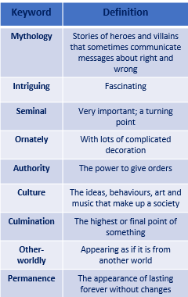

Subtitle:
Historians are not even certain that Okomfo Anokye ever existed. The fact that there is a statue to what may be a mythical event rather than to an actual king shows us how much investment the Asante make in the mythology that surrounds the history. Myths are used by leaders to make sense of events and symbols can help people to understand. With the Asante, fact and myth were mixed to create a powerful blend that made sense to its people. This goes to the heart of the story-telling tradition that is such a vital part of Asante.
Subtitle:
The Golden Stool, and the kingdom, was the culmination of many centuries of cultural development. It brings together many elements; the gold of the forest is represented, the stool is the accepted symbol of authority. The fact that it is ‘other-worldly’ gives it a permanence that is so important in a culture that battles to survive in a tropical rainforest zone. Nothing lasts very long here, even kings, but if the institution of the Golden Stool contains the spirit of the Asante nation, the kingdom may go on forever. Okomfo Anokye was Merlin to Osei Tutu’s King Arthur. He gave Osei Tutu the spiritual power to go alongside Osei Tutu’s military power. After the Golden Stool made Osei Tutu the Asantehene, the king of Asante, the stools belonging to other chiefs were buried or destroyed. Only one stool was important now.
Questions on the text:
- Why was Kumasi important?
- What is the statue of in the centre of Kumasi?
- What, according to tradition, is contained within the Golden Stool?
- Why might Osei Tutu have wanted the Asante Kingdom to be bigger than ‘individual personalities’?
- What are myths and symbols used for?
- What does Gus Casely-Hayford argue was mixed in Asante to ‘create a powerful blend’?
- What does the gold represent in the stool?
- Why is it important that the stool has a ‘permanence’?
- What did Okomfo Anokye give Osei Tutu to go alongside his military power?
- What happened to the stools belonging to other chiefs?
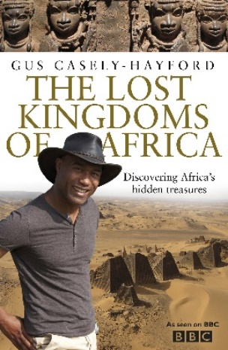
Task 5: Watch historian Gus Casely-Hayford from 22 minutes to 30 minutes and make notes on how Osei Tutu consolidated (strengthened) his power.
https://youtu.be/5RKNMLn3zcA
Task 6: Write a PEAL paragraph explaining how Osei Tutu became the first leader of the Asante Kingdom.

Gus Casely-Hayford, The Lost Kingdoms of Africa (London: Bantam, 2012)

