Year 7: What was the influence of gold and guns in Asante?
Title: What was the influence of gold and guns in Asante?
LO: To describe how gold influenced politics and culture in the Asante Kingdom
Task 1: Answer the questions about the gold Asante bracelet currently in the British Museum.
This is a bracelet with 50 tiny gold keys on it that can now be found in the British Museum in London.
The bracelet was worn during special occasions by the safwahene (translated as a chief or keeper of the keys). The keys didn’t actually work.
- Why do you think important members of the Asante wore gold?
- Why might they carry these golden keys?
- What might the keys represent?
- What questions would you ask about this artefact?

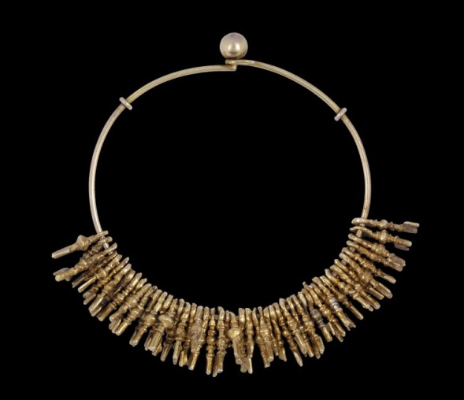
© The Trustees of the British Museum, https://www.britishmuseum.org/collection/object/E_Af1979-01-4652
Task 2: Watch the two clips below and answer the questions.
Watch: The Lost Kingdoms of Africa – Asante with historian Gus Casely-Hayford, 43:49 to 49:00 minutes and answer the questions below. The link is here: https://youtu.be/5RKNMLn3zcA
- Why were civil servants sent from Kumasi?
- Whose gun does Gus Casely-Hayford get to hold?
- What does he say that European firearms were ‘instrumental in’?
- What was the currency of this part of West Africa?
- Casely-Hayford says that ‘taxation didn’t only fund the government; it also ensured….’ what?
- He says that ‘gold was not just money, it was…’ what?
- What happened in 1807 that affected the Asante Kingdom?
- Who were the people of Asante increasingly in contact with?
- What did people start to hoard and bury?

Watch: The Golden Stool: History of Africa with Zeinab Badawi, 12:45 to 18:36 minutes, and answer the questions below. The link is here: https://bit.ly/2VEILrY
- What did the Asante use the rivers to fish for?
- What does ‘Asante’ mean?
- What did the Asante kings use gold to buy?
- What did Okomfo Anokye present Osei Tutu with?
- What does Chief Nana Boakye Ansah say when Zeinab Badawi asks about the kingdom being militaristic?
- What is Chief Nana Boakye Ansah wearing on his sandals and who is allowed to wear it?
Task 3: Read the sources below and then answer the question ‘What was considered important in the Asante Kingdom?’ Think about how guns, gold and slaves were shown to be important.
Source 1: Thomas Bowdich description and drawing
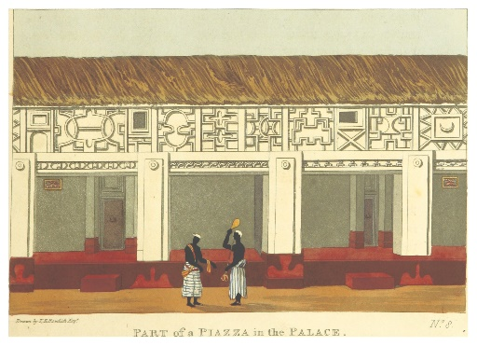
Thomas Bowdich was an English traveller who was sent in 1817 to visit the Asantehene in Kumasi. On his return, he published a book called Mission from Cape Coast Castle to Ashantee. Below is a description of the Asantehene Osei Bonsu’s palace:
‘. . . the royal stool, entirely cased in gold, was displayed under a splendid umbrella, with drums, sankos [harp-lutes], horns and various musical instruments, cased in gold, about the thickness of cartridge paper; large circles of gold hung by scarlet cloth from the swords of state, the sheaths as well as the handles of which were also cased; hatchets of the same were intermixed with them; the breasts of the Ocrahs [soul-washers], and various attendants, were adorned with large stars, stools, crescents, and gossamer wings of solid gold.’
Public domain, British Library
Source 2: Golden weight in the shape of a cartridge belt
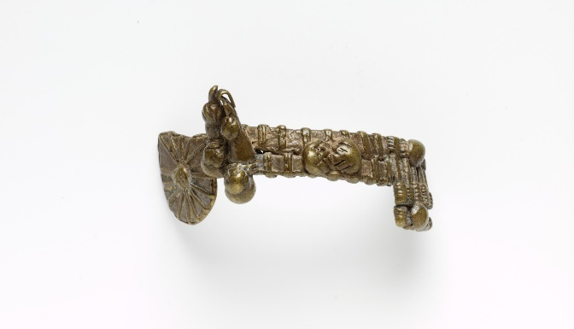
This is a golden weight used to hold things down in the shape of a cartridge belt. A cartridge belt would hold bullets for guns and this cartridge model also has a place for a knife.
© Victoria and Albert Museum, London
A popular Asante saying was ‘The cartridge belt of an Asante warrior has never been known to lack bullets’, meaning that a resourceful person may sometimes get into difficulties but he will always find a way to succeed. This gold weight is currently held in the Victoria and Albert Museum in London.

Source 3: A Fistful of Shells is a history of West African kingdoms by Toby Green, a historian based in London. Extract from pp. 121–125.
‘The boom in demand for gold on the Atlantic coast that came with the Portuguese trades made for many social transformations. New trading towns emerged, and new routes bringing gold from the forests. Gold developed multiple values… For gold was equally important as a symbol of display, social status and ritual power as it was as a currency. The rise of the gold trade led to growing an unequal prosperity. Rich men, the abirempon, expanded their wealth. Children were encouraged to pan for gold on the beach and in the streams from the age of ten. Children hoped in the long term to become “abirempon”.’

Source 4: Trading slaves by Jutta Wimmler
In West African societies trading was usually the business of women, except for slave trading which became a male domain – apparently because Europeans felt uncomfortable dealing with women in matters of importance.
Asante was still mainly trading in gold until the middle of the 1700s, but in the late 1700s slaves became a more important aspect of their trade. The graph shows the number of slaves being sold at Cape Coast Castle. When the Asante won wars against other states, they would sell prisoners to the British at Cape Coast Castle.

