Historical figures on the Central Club Mural

**1** **Akhenaten**

Akhenaten was an Ancient Egyptian pharaoh from around 1353 B.C. He was crowned at Karnak and married to Nefertiti (who is is also depicted on the mural, on the left-hand side of Akhenaten). He was the father of Tutankhamun, although not with Nefertiti. Akhenaten was a revolutionary pharaoh who worshipped the sun-disc Aten as the supreme god and encouraged a new, realistic style of art. He brought about important religious changes to Egypt, ending the worship of multiple gods and worshipping only Aten. Because of the changes that he brought about and the evidence that exists about him, he has been called ‘the first individual in human history’.

**2**  **Queen Amina of Zaria, 1533–c.1610**

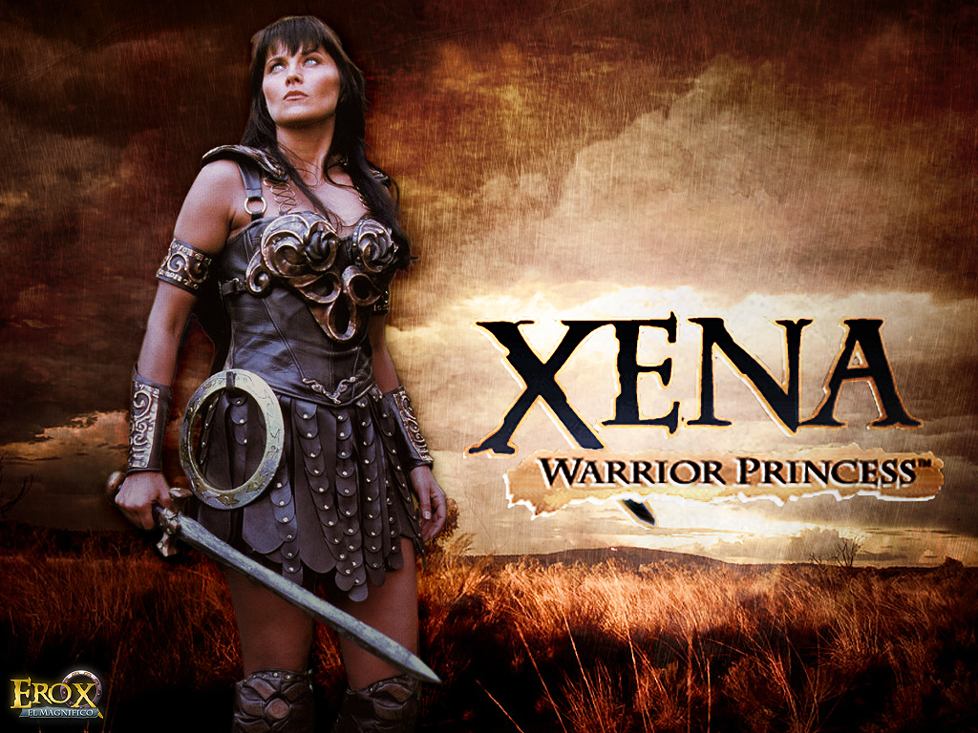

Amina was a Muslim warrior queen (some say princess) of the Zazzau kingdom (in present-day Nigeria). While her brother was king, Amina led the kingdom’s cavalry, taking over from him on his death. While queen, she expanded the kingdom significantly, to the Niger in the south and Kano in the north. She made neighbouring rulers swear loyalty to her and ensured that traders could travel to the Zazzau kingdom safely. While queen, she refused to marry and never had children. She had relationships with men who were then executed so that they could never tell anyone. She was the inspiration for the TV series *Xena Warrior Princess*.

*Source: www.pinterest.co.uk/maryfasch/xena-warrior-princess*

**3**  **Harriet Tubman, c.1822–1913**

Tubman was an enslaved woman in the Southern States of America. She escaped north to freedom, then went back many times, leading 13 separate missions to help more than 300 people along the Underground Railroad and to freedom. During the American Civil War she was a spy for the Union against the Southern States, who wanted to keep slavery. She helped to recruit supporters during the war and was the first woman to lead an armed expedition during the Civil War. After the war, she was an activist (campaigner) for women’s votes.

**4**  **Olaudah Equiano, c.1745–97**

quiano was the first political leader of Britain’s black community. He survived the Middle Passage, travelled widely as an enslaved man owned by a Royal Navy officer and learned to read and write. He was sold on to a merchant, Robert King, and while travelling with him he earned money trading on the side. In three years, he earned enough to buy his freedom. He spent 20 years travelling the world. While in England he wrote *The Interesting Narrative of the Life of Olaudah Equiano, or Gustavus Vassa*, an influential book that persuaded many people to argue for the abolition of slavery. In 1792, he married an Englishwoman and they had two daughters.

**5 Toussaint L’Ouverture, c.1743–1803**

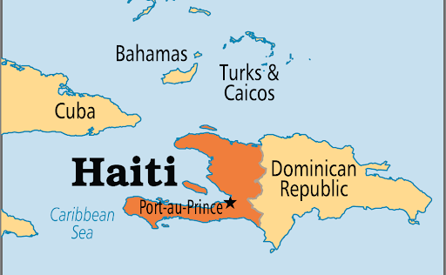

L’Ouverture was a slave on the French colony of Saint-Domingue in the Caribbean. He was inspired by the French Revolution, which was based on the ideas of ‘liberty, equality, fraternity (community)’, and when slaves on Saint-Domingue started a rebellion, L’Overture quickly rose up to prominence. He raised and led an army to victory against the French and the British in Saint-Domingue, which became the independent nation Haiti. In 1794, the French declared freedom and citizenship for all black people in their empire. L‘Ouverture became the leader of Haiti and joined the French to fight against the Spanish. L‘Ouverture introduced a constitution (set of rules and laws) to Haiti and there was a period of stability. However, the new leader of France, Napoleon Bonaparte, decided that L’Ouverture was getting over-ambitious, and L’Ouverture was betrayed, arrested and taken to France, where he died in captivity. Haitians continued to fight for independence, which they did achieve, although the island suffered economically as a result of other countries refusing to trade with an island led by previously enslaved Africans.

*Source: www.lingofacts.com/2017/09/04/official-language-in-haiti*

**6 Sojourner Truth, c.1797–1883**

Truth was born into slavery in New York. She escaped to freedom with her baby daughter and went to court to win back her son, whom she had not been able to bring with her. It was the first successful case of this type in history. She became a famous speaker for abolition and women’s rights, making the famous speech now known as ‘Ain’t I a woman’. She argued for the abolition of the slave trade and for women’s rights.

**The Zulu Kingdom**

A monarchy in Southern Africa that went along the coast of the Indian Ocean.



**7** **King Cetshwayo, c.1826–84**

Cetshwayo was a Zulu king who ruled the Zulu Kingdom at the time of the growth of the British Empire in Africa. Cetshwayo defeated the British at the Battle of Isandlwana, the first encounter between the British Empire and the Zulu Kingdom. Despite the disadvantage of less-advanced weapons, the Zulus overwhelmed the British and defeated them. The defeat meant that the British took a much more aggressive approach to the Zulus. Cetschwayo was captured and exiled to Cape Town in South Africa. He was allowed to visit England and he met Queen Victoria. He was then able to return to Zululand and was reinstated (returned) as king, but there was fighting with other kingdoms that the British created and he died in 1884, possibly poisoned.

*Source: https://en.wikipedia.org/wiki/Zulu_Kingdom*

**8 Marcus Garvey, 1887–1940**

Garvey was a Jamaican-born Black nationalist (belief in independence and unity for Black people). He was an inspirational leader, fighting for civil rights and encouraging Black pride in many countries, including Jamaica, America, Panama and Costa Rica. His Universal Negro Improvement Association (UNIA) provided education, welfare and support for Black businesses. The UNIA also wanted to build a strong and independent Africa, and his Back to Africa movement had a powerful influence on many who came after him. He was arrested for irregularity in his company, which was possibly motivated by his political opponents. He spent time in prison, and then came to London. After he died, his remains were taken back to Jamaica, where he became Jamaica’s first national hero.

**9 Frantz Fanon, 1925–1961**

Fanon was born on the Caribbean island of Martinique. He was an intellectual who wrote classic works on anti-colonialism (against the British Empire); his books *Black Skin, White Masks* and *The Wretched of the Earth* influenced liberation movements from Cuba to Palestine.

**10 Malcolm X, 1925–1965**

**Black Panther Party**

Revolutionary Black nationalist group who believed in independence and unity for Black people. In the USA, the party started by trying to tackle racism by the police in Oakland, and then focused on community projects to support the poor in Black communities.

Malcolm X argued for separation of Black and white people, not integration. His father was influenced by Marcus Garvey. Malcolm X was raised by white foster parents because his mother was too poor to raise him. He spent ten years in jail for selling drugs and other crimes. In prison he converted to Islam, and on his release, he went on to become a major political fighter for Black power and founder of the Muslim Mosque, Inc and the Organisation of Afro-American Unity. By the time of his death, he had changed his views and was arguing for racial tolerance. He was assassinated by members of the Nation of Islam.

**11 Angela Davis 1944–**

Davis was a political activist and Black Panther supporter. She was imprisoned for her alleged part in a shootout at Marin County Hall of Justice, and later acquitted (found not guilty). Davis is now professor of feminist studies at the University of California and a campaigner for the abolition of prisons.

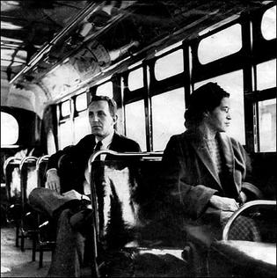

**12 Rosa Parks, 1913–2005**

Parks lived in Montgomery, Alabama while there was segregation of Black and white people, with Black people having fewer right and facilities than white people. Parks is famous for her refusal to give up her seat on a bus to a white passenger in 1955. She was arrested, and the anger at the unfairness of this and how Black people were treated led to the Montgomery Bus Boycott, organised by Martin Luther King among others. For months, all of the Black people in Montgomery refused to use the buses. The bus company nearly went out of business, and segregation on the buses was ended.

*Source: https://www.loc.gov/pictures/item/94505572/*

# 13 Nelson Mandela, 1918–2013

Mandela was the leader of the African National Congress and fought against apartheid, a system of segregation and racism against Black South Africans. He was imprisoned for 27 years for bombing official buildings and communication lines. There was a worldwide campaign arguing for his release, and on his release in 1994 he was elected President in South Africa’s first fully democratic elections. Mandela died in 2013 at the age of 95, probably the world’s most respected elder statesmen.

**14 CLR James, 1901–1989**

James was born in Trinidad in 1901, where he initially became a teacher. He was a historian, novelist and Marxist (Communist) thinker. He argued for political independence for Africa and the Caribbean, which for much of his lifetime were still part of the British Empire. One of his most famous books was about the Haitian Rebellion. He was also a cricketer.

**15 Claudia Jones, 1915–64**

Jones was born in Trinidad in the Caribbean and was a radical activist (campaigner) in many areas of politics. She founded *The West Indian Gazette*, Britain’s first Black newspaper. She set up a Mardi Grasin 1959, which later developed into the Notting Hill Carnival, a huge street festival that takes place in London every year.

**16 Martin Luther King Jr, 1929–1968**

Martin Luther King Jr was a Baptist minister who became the most famous civil rights leader in the United States and was awarded the Nobel Peace Prize in 1964. He led several successful campaigns, including the Montgomery Bus Boycott, and made the famous ‘I have a dream’ speech in 1963. He influenced thousands of African Americans to protest and resist peacefully, despite violence being used against them. He was assassinated in 1968 by a white supremacist; over 100,000 people joined the funeral procession.

**Rastafarianism**

Religious movement that started in Jamaica, believing that Black people are God’s chosen people and will eventually return to their African homeland.

# 17 Haile Selassie, Emperor of Ethiopia, 1892–1975

Selassie was well respected in the world and in African politics – he was a founder member of both the United Nations and the Organisation of African Unity. He began to modernise the monarchy of Ethiopia, but was ultimately removed from the throne, defeated by both political resistance and natural disasters. He is the figurehead of the Rastafari movement.

**18 Bob Marley, 1945–1981**

Marley was a legendary Jamaican singer and songwriter who brought reggae and the Rastafari movement on to the world stage. He blended reggae, ska and rocksteady and created a distinctive vocal and songwriting style. His contribution to music meant that Jamaica’s music and culture became more visible worldwide and made him a global figure in popular culture.

**19 Mary Seacole, 1805–1881**

Seacole volunteered to help Florence Nightingale in the Crimean War but was rejected, despite her proven nursing experience on the Panama Canal. Undaunted, she paid her own way and set up the British Hotel, which dispensed food and medical help to the soldiers. She was given a heroine’s welcome when she returned to Britain.

**20 Terrance ‘Jeff’ Allamby**

Allamby was an activist who was part of the campaign to open the Central Club as a community centre for the local Caribbean community. He was shot and killed in Reading in 1996. He is holding a sign saying ‘la luta continua’, which means ‘the struggle continues’.

**21 Shirley Graham-Paul**

Graham-Paul was born in Jamaica and moved to Slough in her teens. She spent her career working as a nurse and a midwife and has been involved in West Reading carnival. She is a founding member of the Friends of Mary Seacole and has worked for recognition and awareness of the contribution of Seacole to Britain. She was one of the group behind the creation of the Central Club Mural.

**22 Yvonne Huggins**

In the mural, Huggins is pictured holding a list of the people killed in police custody. There was controversy over whether to include this part of the mural, and it was painted over initially. However, one of the artists repainted the names onto the mural.